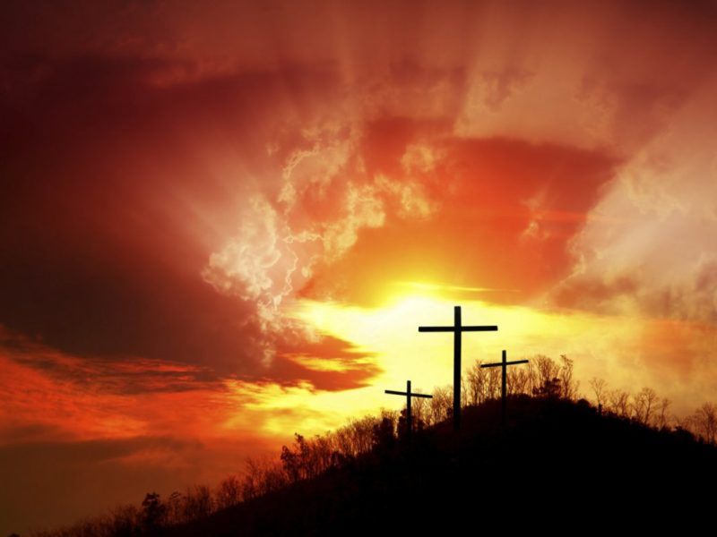
Prepare:
A Calendar of Devotions
for Lent 2021

Covenant Presbyterian Church
Reno, Nevada

“I have said these things to you, that in me you may
have peace. In the world you will have tribulation.
But take heart; I have overcome the world”
- Jesus (John 16:33)

Dear Friends:

Welcome to Covenant Presbyterian Church’s Lent Devotional Guide for 2021.
You’ve heard it a thousand times and in a variety of words and phrases: 2020 has been a uniquely challenging year, a year of anything but peace. When we last produced and presented this annual book of Bible readings and reflections in preparation for Easter, Covid-19 was barely on the horizon. Well, the Day of Coronavirus came as we were using our 2020 daily readings, and it came with a vengeance. And its sun has not yet set. Out-of-control illness is still with us as are controversial regulations, passionate opinions about it all, and daily reminders from most of our media that it is politically correct to live in fear. This Devotional Guide, I hope and pray, will offer us daily reminders that there is a better way to live and good reasons to do so. May it help you find peace.
Our Lord Jesus Christ offered some profound words that help us understand what we are up against here and now. I have said these things to you, that in me you may have peace. In the world you will have tribulation. But take heart; I have overcome the world” – John 16:33.
As part of our preparation for Easter and to help us all have a profitable and fruitful season of Lent this year, we offer our Devotional Book once again as a gift to our family and friends here at Covenant. We divide these readings into three parts: 1. Old Testament Prophecies Pointing to Jesus’ Death and Resurrection, 2. New Testament Commentary on Jesus’ Death and Resurrection, and 3. New Testament Narrative of Jesus’ Death and Resurrection. I am confident that what we will find in these pages will help us each day to understand more deeply the brokenness of this world in which we live and why we encounter troubles. I pray we will also find insight into how Jesus “overcame the world”—obeying His Father all the way to the Cross, expressing His love for us and opening the gates of heaven---and so truly to “take heart” in Him.
I am grateful to those who have helped make this guide a reality for us this year. Your Worship Ministry Team, Staff, Elders and others have worked hard to prepare this Guide for you.
Jesus said something else that I find particularly poignant in this year of unexpected challenges and new fear: “I tell you, my friends, do not fear those who kill the body, and after that have nothing more that they can do. But I will warn you whom to fear: fear him who, after he has killed, has authority to cast into hell. Yes, I tell you, fear him! Are not five sparrows sold for two pennies? And not one of them is forgotten before God. Why, even the hairs of your head are all numbered. Fear not; you are of more value than many sparrows. - Luke 12:4-7
We do not need to live in fear. We might die. We will die. But we are of great value to God. He has told us so. Jesus has shown us so. He died for us. By our faith in Him we will be raised with Him to life eternal. May each day with this Guide help to solidify this faith in you and me, and reveal, in 2021, that there is a great difference between people sincerely and temporarily following the ways of our man-centered Coronaphobic culture and the authentic God-honoring culture-challenging Church of Christ-followers we are called and equipped to be.
Here is a little compare-and-contrast list for you to consider at the outset of this Lenten adventure…

The Word’s 2020-2021 Covid-19 Church The Authentic Church in Every Season
1. Sick (in Body)?... Stay at home (Isolation) 1. Really Sick (in Soul)?... Come here! (Community)
2. What you Might have (a Virus?) must 2. What you Do have (The Good News of Jesus!)
NOT be shared (Uncertainty and Isolation) MUST be shared (Certainty and Community)
3. Governing authorities decide for us (Personal 3. We decide to submit to governing authorities to the
Responsibility Avoided) glory of God (Personal Responsibility Accepted)
4. We must all look and do the same to keep us 4. We must all express our unique gifts and personhood
all safe (Utilitarian Conformity) for God’s glory and purposes (Diversity and Unity)
5. Put on a (literal) Mask for safety (Safety Illusion) 5. It’s safe to take your (figurative) Masks off (Safety!)
6. We’ll keep you safe (Attractive Lie) 6. We’ll teach you not to fear death (Eternal Truth)

May you be blessed by what is offered here by members of the Covenant Presbyterian Church family, a family trying hard to be an authentic church in a difficult world and inviting all to take heart in Jesus who overcame it.
In the peace of Christ Jesus,
Pastor Jay Hull, Lent 2021
2021 Lenten Devotional Booklet – Table of Devotions

PART I: OLD TESTAMENT PROPHECIES POINTING TO JESUS’ DEATH & RESURRECTION

February 17 Psalm 22 “My God, my God, why have you forsaken me?” Kay Blakely
18 Genesis 3:8-15 “But the Lord God called to the man and said Gerry Allen
to him, “Where are you?”
19 Genesis 12:1-3 “…in you all the families of the earth shall be blessed.” Jennifer Oliver
20 Genesis 15:1-21 “When the sun had gone down and it was dark, Mary Anderson
behold, a smoking fire pot and a flaming torch
passed between these pieces. On that day
the Lord made a covenant with Abram…”

22 Isaiah 42:1-9 “Behold my servant, whom I uphold, my chosen, Jay Hull
in whom my soul delights; I have put my Spirit
upon him; he will bring forth justice to the nations.”
23 Isaiah 49:1-7 “I will make you as a light for the nations, that Jake Armer
my salvation may reach to the end of the earth.
24 Isaiah 50:4-11 “Who among you fears the Lord and obeys the Justin Luevano
voice of his servant? Let him who walks in
darkness and has no light trust in the name
of the Lord and rely on his God.”
25 Isaiah 52:13-53:12 “All we like sheep have gone astray; we have Kathy Croghan
turned—every one—to his own way; and
the Lord has laid on him the iniquity of us all.
26 Jeremiah 23:1-6 “In his days Judah will be saved and Israel will Chris Rhodes
live in safety. This is the name by which he
will be called: The Lord Our Righteousness.”
27 Jeremiah 31:31-34 “The time is coming,” declares the Lord, “when Cindy Duncan
I will make a new covenant with the house
of Israel and with the house of Judah.”

March 1 Psalm 2 “The Lord said to me, “You are my Son; Cindy Duncan
today I have begotten you.”
2 Ezekiel 36:16-32 “I will give you a new heart and put a new Ryan Ludwig
spirit in you; I will remove from you your
heart of stone and give you a heart of flesh…”
3 Zechariah 9:9-13 “See, your king comes to you, righteous & having Debbie Barackman
salvation, gentle and riding on a donkey…”
4 Zechariah 12:10-13 “They will look on me, the one they have Debbie Barackman
pierced and they will mourn for him as
one mourns for an only child…”
5 Psalm 118 “The stone the builders rejected has become Dianne Billharz
the capstone…”
6 Exodus 15:1-13 “The Lord is my strength and my song; Kenny Ching
he has become my salvation.”
PART II: NEW TESTAMENT COMMENTARY ON JESUS’ DEATH & RESURRECTION

8 Mark 8:31-38 “And he began to teach them that the Melissa Bullard
Son of Man must suffer many things…
9 Acts 4:1-12 “…there is no other name under heaven given Janet Goodman
among men by which we must be saved.”
10 Romans 5:1-11 “…but God shows his love for us in that while Jim Prosser
we were still sinners, Christ died for us.”
11 I Peter 3:13-22 “For Christ also suffered once for sins, the righteous Preston Yoshioka
for the unrighteous, that he might bring us to God…
12 Hebrews 10:1-25 “But when Christ had offered for all time Dave MacDonald
a single sacrifice for sins, he sat down…”
13 Galatians 2:15-21 “I have been crucified with Christ. It is no longer I Ian Bullard
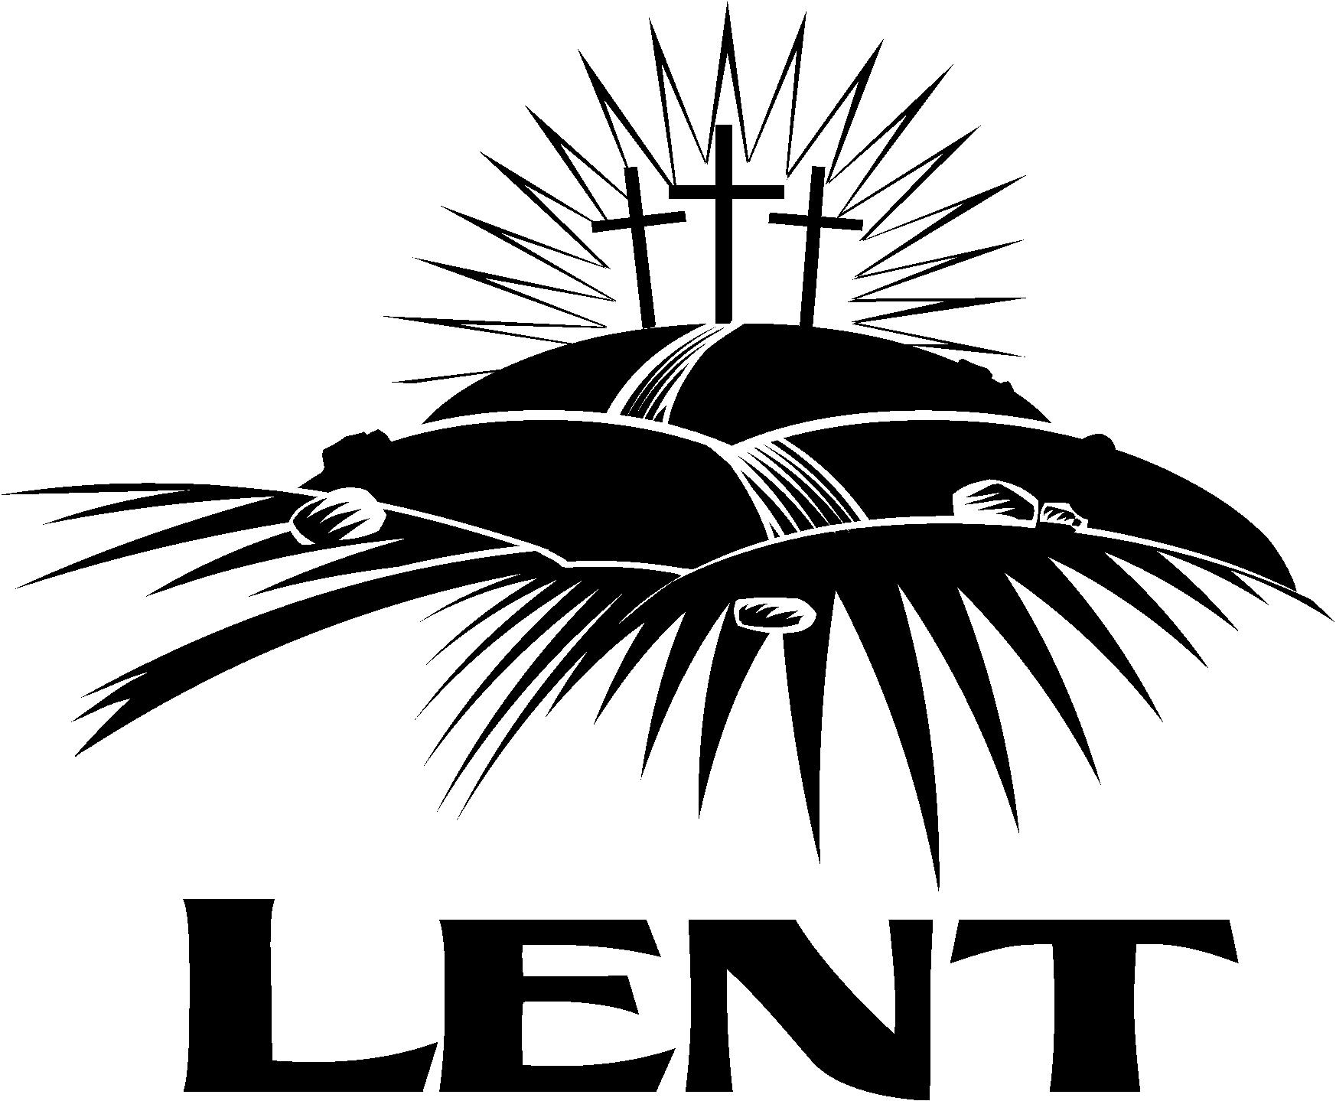
who live, but Christ who lives in me.”

PART THREE: NEW TESTAMENT NARRATIVE OF JESUS’ DEATH & RESURRECTION

15 Matthew 21:1-11 “Hosanna to the Son of David! Blessed is Patti Hemsley
he who comes in the name of the Lord!”
16 Matthew 21:12-17 “And Jesus entered the temple and drove out Jay Hull
all who sold and bought in the temple…”
17 Mark 14:1-11 “She has done what she could; she has Jennifer Oliver
anointed my body beforehand for burial.”
18 Mark 14:12-26 “And he said to them, ‘This is my blood of Dan Carne
the covenant, which is poured out for many.’”
19 Luke 22:39-46 “Father, if you are willing, remove this cup from me. Mark Eshoff
Nevertheless, not my will, but yours, be done.”
20 Luke 22:47-53 “Judas, would you betray the Son of Man…?” Gerry Dunlap

22 Luke 22:54-62 “And Peter remembered the saying of the Lord, Preston Yoshioka
how he had said to him, ‘Before the rooster
crows today, you will deny me three times.’”
23 John 18:19-24 “Is that how you answer the high priest?” Chris Rhodes
24 Matthew 27:1-10 “Then when Judas, his betrayer, saw that Samuel Dueñas
Jesus was condemned, he changed his mind…”
25 John 18:28-40 “Pilate said to him, ‘What is truth?’” Dianne Billharz
26 Matthew 27:15-26 “His blood be on us and on our children!” Ian Bullard
27 John 19:1-16 “The chief priests answered, ‘We have no king but Caesar.’” Jock Ochiltree

29 Matthew 27:27-44 “If you are the Son of God, come down from the cross.” Mac McFarland
30 Luke 23:26-43 “Father, forgive them, for they know not what they do.” Brent Ford
31 Mark 15:33-41 “My God, my God, why have you forsaken me?” Melissa Bullard

April 1 Matthew 27:57-66 “Therefore order the tomb to be made secure Gerry Dunlap
until the third day, lest his disciples go and steal
him away and tell the people, ‘He has risen…’”
2 John 20:1-18 “Jesus said to her, ‘Mary.’” Janet Goodman
3 Matthew 28:16-20 “Go therefore and make disciples of all nations…” Tim Kwon
PART I: OLD TESTAMENT PROPHECIES POINTING TO JESUS’ DEATH & RESURRECTION

FEBRUARY 17 (Ash Wednesday)
“My God, my God, why have you forsaken me?”

Text: Psalm 22
¹ My God, my God, why have you forsaken me? Why are you so far from saving me, so far from the words of my groaning? ² O my God, I cry out by day, but you do not answer, by night, and am not silent. ³ Yet you are enthroned as the Holy One; you are the praise of Israel. ⁴ In you our fathers put their trust; they trusted and you delivered them. ⁵ They cried to you and were saved; in you they trusted and were not disappointed.
⁶ But I am a worm and not a man, scorned by men and despised by the people. ⁷ All who see me mock me; they hurl insults, shaking their heads: ⁸ “He trusts in the Lord; let the Lord rescue him. Let him deliver him, since he delights in him.”
⁹ Yet you brought me out of the womb; you made me trust in you even at my mother’s breast. ¹⁰ From birth I was cast upon you; from my mother’s womb you have been my God. ¹¹ Do not be far from me, for trouble is near and there is no one to help.
¹² Many bulls surround me; strong bulls of Bashan encircle me. ¹³ Roaring lions tearing their prey open their mouths wide against me. ¹⁴ I am poured out like water, and all my bones are out of joint. My heart has turned to wax; it has melted away within me. ¹⁵ My strength is dried up like a potsherd, and my tongue sticks to the roof of my mouth; you lay me in the dust of death. ¹⁶ Dogs have surrounded me; a band of evil men has encircled me, they have pierced my hands and my feet. ¹⁷I can count all my bones; people stare and gloat over me. ¹⁸ They divide my garments among them and cast lots for my clothing.
¹⁹ But you, O Lord, be not far off; O my Strength, come quickly to help me. ²⁰ Deliver my life from the sword, my precious life from the power of the dogs. ²¹ Rescue me from the mouth of the lions; save me from the horns of the wild oxen.
²² I will declare your name to my brothers; in the congregation I will praise you. ²³ You who fear the Lord, praise him! All you descendants of Jacob, honor him! Revere him, all you descendants of Israel! ²⁴ For he has not despised or disdained the suffering of the afflicted one; he has not hidden his face from him but has listened to his cry for help.
²⁵ From you comes the theme of my praise in the great assembly; before those who fear you will I fulfill my vows. ²⁶ The poor will eat and be satisfied; they who seek the Lord will praise him—may your hearts live forever! ²⁷ All the ends of the earth will remember and turn to the Lord, and all the families of the nations will bow down before him, ²⁸ for dominion belongs to the Lord and he rules over the nations.
²⁹ All the rich of the earth will feast and worship; all who go down to the dust will kneel before him—those who cannot keep themselves alive. ³⁰ Posterity will serve him; future generations will be told about the Lord. ³¹ They will proclaim his righteousness to a people yet unborn—for he has done it.

Reflection: The writer of Psalm 22 was David, the second king of Israel. At the time when David wrote this Psalm he must have been in a terrible situation, but clearly some of the laments described could not have applied to David. The physical agony depicted in Psalm 22 is consistent with descriptions of crucifixion. David was not crucified. It was God who guided David as he prophetically composed Psalm 22. Historical and New Testament accounts confirm that Jesus of Nazareth was cruelly crucified. One thousand years after David composed it, Jesus quoted Psalm 22 while hanging on the cross.
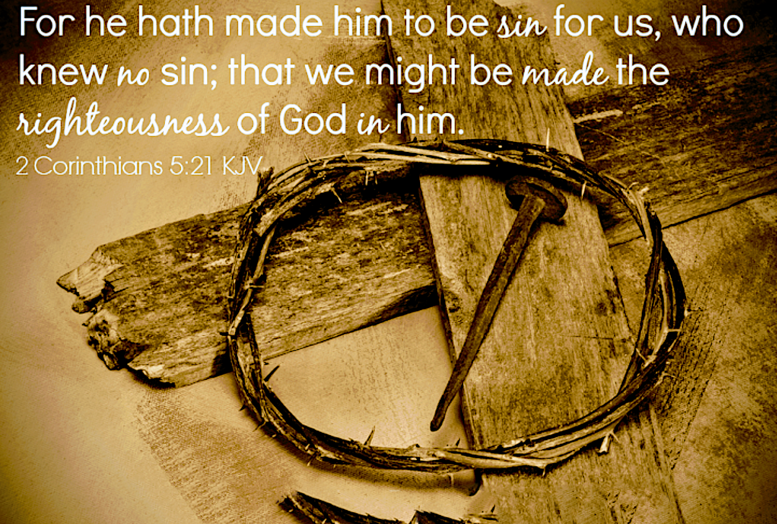
The first words of the Psalm are “My God, My God, why have you forsaken Me?” Jesus was in agony when He quoted those words (Mathew 27:46 and Mark 15:34). The Son of God felt abandoned by His Father. Yet His words acknowledge God as His God. He was clinging to His God in absolute faith. The next 20 verses of Psalm 22 repeatedly complain about desperate circumstances interspersed with verses of comfort remembering God’s holiness and faithfulness, while pleading for God’s deliverance.
Jesus knew all the verses of Psalm 22. Did He recite the entire Psalm as the hours dragged on? Jesus on the cross was so abased as to consider Himself a lowly worm, a reproach to men, mocked and scorned. The physical and emotional suffering described is beyond comprehension. Yet He praises God as the Holy One and reminds God of His love and faithfulness in delivering His Israelite ancestors. Jesus acknowledges God’s love from His birth and pleads that God be near Him.
Verses 21-31 - Quoting Charles Spurgeon, “The same that began the psalm complaining, who was no other than Christ in His humiliation, ends it here triumphing, and it can be no other than Christ in His exultation.” Hebrews 2:12 quotes Psalm 22:22 saying that “Jesus will declare God’s name to His brothers and He will praise God in the congregation.” Jesus’ life and words reveal almighty God to believers. He declares praise and reverence for God. Jesus is Head of the Church. God hears the cries of the afflicted and has not hidden His face from them. He proclaims the sovereignty of God and promises that all the earth and future generations will worship Him. Verse 31 – He has done it! Jesus accomplished what He came to do. He lived the life we should live and died the death we deserve so that all who put their faith in Him would have eternal life.

Response: Remember that this Psalm, though written by David, is about Jesus. Reading Psalm 22 is a perfect beginning for observing the first day of Lent. But more than just reading it, we should prayerfully, reverently, thankfully meditate on the suffering and sacrifice that was required to save believers. Remember all this especially when participating in the Sacrament of Communion. The very best person who ever walked this earth, the sinless Son of God, died a horrible death on a cross so that we might have forgiveness of sin and eternal fellowship with the Triune God. “God made Him who knew no sin to be sin for us, so that in Him we might have the righteousness of God” (2 Cor. 5:21).
Was Jesus forsaken by God? Charles Spurgeon writes that “Jesus is forsaken because our sins had separated between us and our God.” Jesus continues to pray and plead with His Heavenly Father whom He knows is entirely righteous. Remember that God raised Jesus on the third day. When we pray and pray, and our prayers go unanswered, we can know that God is faithful, good and sovereign, and we must continue to exult Him. God hears our prayers and is working His will in a thousand different ways that we cannot know or see.
Suffering is part of life in this broken world. It can be physical, mental or emotional. Jesus suffered even though He was God wrapped in human flesh. How do we react to suffering that comes into our lives? We cling to the Lord and pray for deliverance, reminding ourselves of God’s goodness and faithfulness. 1 Peter 4:19 says: “Therefore, let those also who suffer according to the will of God entrust their souls to a faithful Creator in doing what is right.” Read all 19 verses of chapter 4 for more teaching about suffering in this world.
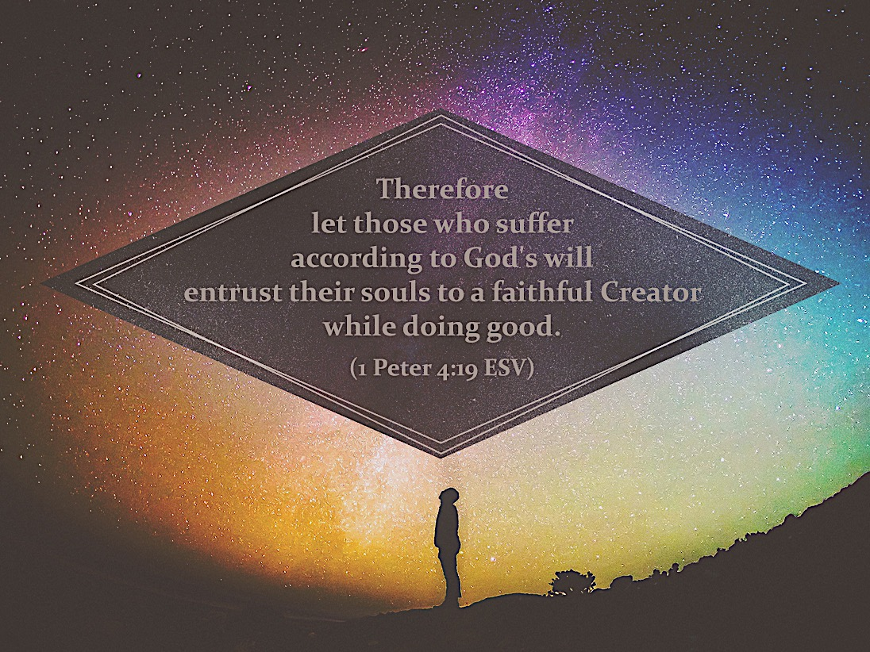
David declared God’s name to his people. He urged them to praise and honor God and told them all the reasons why (verses 22-31.) We should do the same. This Lenten period is the perfect opportunity to tell someone about the love of God expressed through the life, death, and resurrection of Jesus Christ. Give them a copy of this devotion book, and if God moves your heart, then tell them your story of coming to faith. I Peter 3:15 says: “Sanctify Christ as Lord in your hearts, always being ready to make a defense to everyone who asks you to give an account for the hope that is in you, yet with gentleness and reverence.”

Prayer: Dear Father, Lord Jesus, Holy Spirit - Thank You for Psalm 22 where the sacrifice and agony of Jesus is made so clear to us. How deep Your love must be that You would take the punishment for our sin and wash us white as snow by Your blood. Thank You for Your faithfulness and Your promise of eternal life to all who put their trust in You.
- Kay Blakely
FEBRUARY 18
“But the Lord God called to the man and said to him, “Where are you?”

Text: Genesis 3:8-15
⁸ Then the man and his wife heard the sound of the Lord God as he was walking in the garden in the cool of the day, and they hid from the Lord God among the trees of the garden. ⁹ But the Lord God called to the man, “Where are you?”
¹⁰ He answered, “I heard you in the garden, and I was afraid because I was naked; so I hid.”
¹¹ And he said, “Who told you that you were naked? Have you eaten from the tree that I commanded you not to eat from?”
¹² The man said, “The woman you put here with me—she gave me some fruit from the tree, and I ate it.”
¹³ Then the Lord God said to the woman, “What is this you have done?”
The woman said, “The serpent deceived me, and I ate.”
¹⁴ So the Lord God said to the serpent, “Because you have done this,
“Cursed are you above all the livestock and all the wild animals! You will crawl on your belly and
you will eat dust all the days of your life. ¹⁵And I will put enmity between you and the woman, and
between your offspring [literally, “seed”] and hers; he will crush your head, and you will strike his heel.”

Reflection:
When I read these passages, I seem always to have questions, sometimes seemingly without answers.
For instance, why does an all-knowing God ask Adam “where are you?” Maybe he was trying to soften His character so as to get an answer from Adam. I sometimes find myself “hiding” from God or doing things in secret so He won’t find out. But in Psalm 139 we read that God knows our words even before we say them, and He knitted us together in our mother’s womb. So again I ask, how could He not know all my sins and Adam’s even though we try to hide, each in our own way?
Even though found to be naked, Adam tries to put at least some of the blame on God. Perhaps he was feeling a little bolder since God asked where he was hiding. His response to God’s question of “Have you eaten from the tree of which I commanded you not to eat?” was to put the blame first on God and then on the woman. The woman that YOU (emphasis mine) gave to be with me, she gave me from the tree, and I ate. Eve followed Adam’s lead and blamed the serpent. This leaves me wondering why, in Paradise, is a serpent even allowed? Perhaps human will is the answer, what some call “free will,” is the answer. God doesn’t ask us or want us to be robots. He wants us to desire and choose to live a godly life worshipping Him and trying to find His good will for our lives.
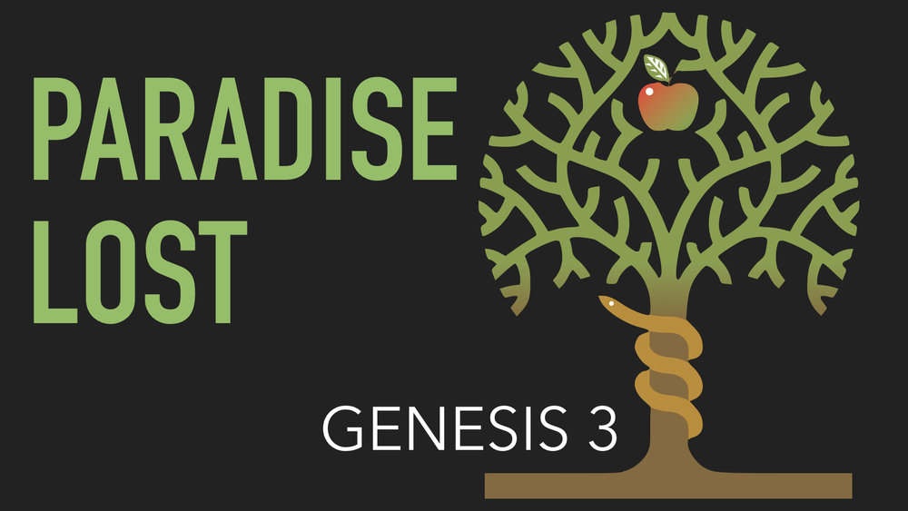
The balance of the passage is about the consequences of our oldest ancestors’ sin. I wonder what would have happened if after eating the apple they went to God and confessed what they had done. But they, like me, and maybe you who are reading this, hid themselves instead. Make no mistake, there is forgiveness for our sins when we confess them, but also consequences. And it is the consequences that teach us 1) that God does in fact know where we are hiding, and 2) that He loves us.

Response:
“Don’t try to hide” seems like the obvious response to this passage followed by “Ask for forgiveness.” However, I think maybe we have such a tendency to minimize our concept of sin, thinking it is either very small or maybe without consequences since in our mind it might not actually be a sin at all—maybe not a good thing to do or say or think, but certainly not our fault! We are so like Adam and Eve. We have become so very good at hiding. Maybe we need to start by asking God to help us to share His clear and accurate view of our sin.

Prayer:
Dear Father, please forgive our sins both hidden and unhidden, and teach us to live our lives in Your Light where all things are made visible, including our sins. In Your precious Son’s name we pray. Amen. - Gerry Allen
FEBRUARY 19
“…in you all the families of the earth shall be blessed.”

Text: Genesis 12:1-3
¹ The Lord had said to Abram, “Leave your country, your people and your father’s household and go to the land I will show you.
² “I will make you into a great nation and I will bless you;
I will make your name great, and you will be a blessing.
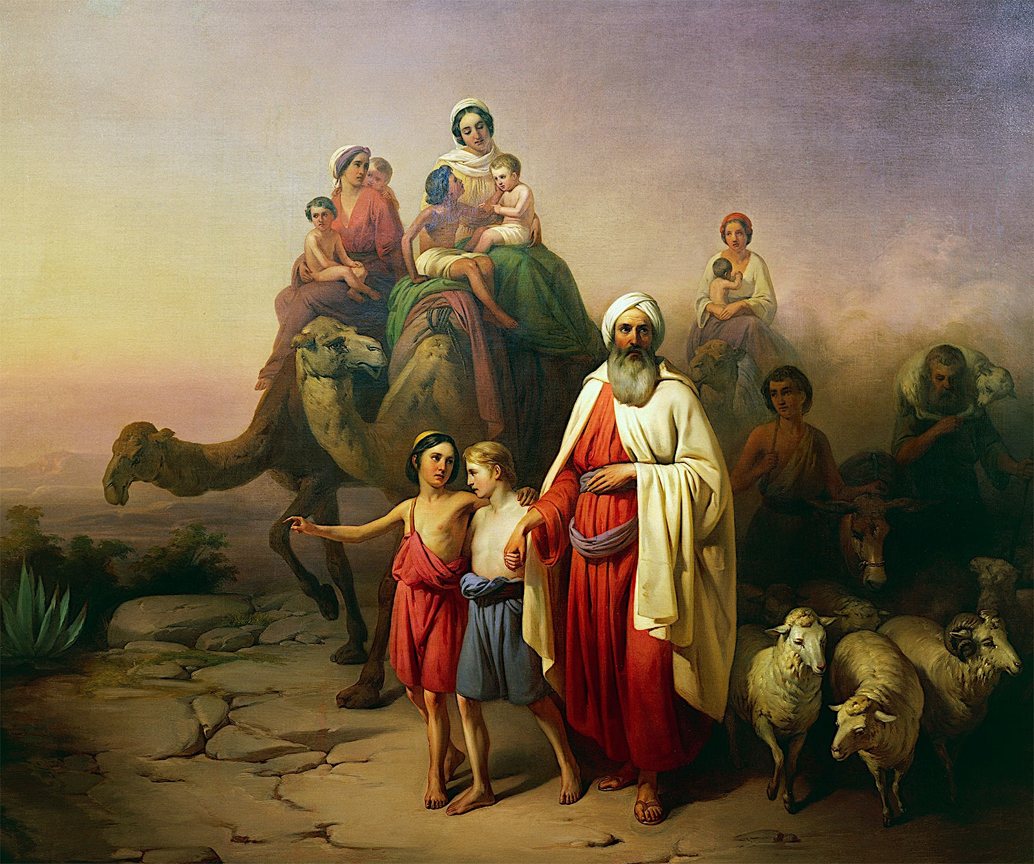
³ I will bless those who bless you, and
whoever curses you I will curse;
and all peoples on earth will be blessed
through you.”

Reflection: These three verses are packed with meaning and concepts that require a dissertation to unpack. My attempts at writing this have seemed to fall so far short in meaning (and comprehension). So, I start with the basics. Here Abram, later to be called Abraham, childless at the age of 75, hears from the Lord the words of Genesis 12: 1-3 to get up and leave his country behind, go to a land the Lord will show him, and receive a great nation full of blessings. Abram’s call comes after the flood at a time when Old Testament scholar Tremper Longman says the world has been “devolved into a pattern of sin, judgment, and tokens of grace… and God now seeks to address the sin problem and reconcile humanity to himself through the person of Abraham…” (Story of God, Bible Commentary: Genesis, 2016).
Abram/Abraham is an unlikely hero turned father of multitudes. When first hearing a call from the Lord, he obeyed, but did linger so his start was not perfect—a relatable quality indeed. As his relationship with the Lord grows so does his obedience. These verses are the beginning of the Abrahamic Covenant which grant land, descendants, blessing, redemption and fulfillment. This covenant is unilateral in that only one of the parties is bound to honor the conditions— God Himself (see Genesis 17). Abraham is the beneficiary of all the above-mentioned covenant provisions. The significance of his obedient and faithful response upon hearing the call is especially that it opens the door to redemption through Jesus. It is worth noting Abraham’s faithfulness when God later calls on him to take his son, Isaac, up Mt. Moriah and offer him as a sacrifice. He agonizes during the three-day journey over what he is called to do but continues onward trusting in God. As we know, the Lord provided the lamb Himself, sparing Isaac. I am not writing about that particular scripture (Genesis 22) here, but Abram’s story is foundational and ties together God’s beautiful artistry for us to unravel and marvel upon.
Today, with the benefit of Biblical context, we can trace the lineage from Abraham to Jesus Christ (the Lamb Himself) and receive the ultimate blessing of salvation that extends throughout all the nations to you and me.

Response: How would you respond if God made other plans for you today? What is God’s call for me, for us? How can we know? Thankfully the Bible is filled with assurances, and below are just three:
- Isaiah 30:21 - Whether you turn to the right or to the left, your ears will hear a voice behind you, saying, This is the way; walk in it.
- Isaiah 48:17b - I am the Lord your God, who teaches you what is best for you, who directs you in the way you should go.
- Proverbs 3:5-6 - Trust in the Lord with all your heart and lean not on your own understanding. In all your ways acknowledge him, and he will make your paths straight.
Our answer comes from time in prayer, time in the presence of God, reading the Bible and listening with discernment; therefore, our response always needs to be rooted in faith and obedience, as Abram’s was. Through a relationship with God we can open ourselves up to His masterful artistry unfolding in our own lives. The Lord’s call very well may not be easy or what we expect, but it will be full of blessings and rewards beyond what we could comprehend.

Prayer: Heavenly Father, I ask for a calling in my life that fulfills Your will. Along with that calling, I ask for ears to hear, a heart full of strength, a mind open to the challenge and the courage to say YES to the one true Lord of my life who wants me to be obedient and faithful. Turn me into a masterpiece for Your Glory! Thank You for your patience, and Your everlasting, unfailing love. I pray this in Jesus’ name. Amen. - Jennifer Oliver

FEBRUARY 20
“When the sun had gone down and it was dark behold, a smoking
fire pot and a flaming torch passed between these pieces.
On that day the Lord made a covenant with Abram…”

Text: Genesis 15:1-21
¹ After this, the word of the Lord came to Abram in a vision:
“Do not be afraid, Abram. I am your shield, your very great reward.”
² But Abram said, “O Sovereign Lord, what can you give me since I remain childless and the one who will inherit my estate is Eliezer of Damascus?” ³ And Abram said, “You have given me no children; so a servant in my household will be my heir.”
⁴ Then the word of the Lord came to him: “This man will not be your heir, but a son coming from your own body will be your heir.” ⁵ He took him outside and said, “Look up at the heavens and count the stars—if indeed you can count them.” Then he said to him, “So shall your offspring be.”
⁶ Abram believed the Lord, and he credited it to him as righteousness.
⁷ He also said to him, “I am the Lord, who brought you out of Ur of the Chaldeans to give you this land to take possession of it.”
⁸ But Abram said, “O Sovereign Lord, how can I know that I will gain possession of it?”
⁹ So the Lord said to him, “Bring me a heifer, a goat and a ram, each three years old, along with a dove and a young pigeon.”
¹⁰ Abram brought all these to him, cut them in two and arranged the halves opposite each other; the birds, however, he did not cut in half. ¹¹ Then birds of prey came down on the carcasses, but Abram drove them away.
¹² As the sun was setting, Abram fell into a deep sleep, and a thick and dreadful darkness came over him. ¹³ Then the Lord said to him, “Know for certain that your descendants will be strangers in a country not their own, and they will be enslaved and mistreated four hundred years. ¹⁴ But I will punish the nation they serve as slaves, and afterward they will come out with great possessions. ¹⁵ You, however, will go to your fathers in peace and be buried at a good old age. ¹⁶ In the fourth generation your descendants will come back here, for the sin of the Amorites has not yet reached its full measure.”
¹⁷ When the sun had set and darkness had fallen, a smoking firepot with a blazing torch appeared & passed between the pieces. ¹⁸ On that day the Lord made a covenant with Abram and said, “To your descendants I give this land, from the river of Egypt to the great river, the Euphrates—¹⁹ the land of the Kenites, Kenizzites, Kadmonites, ²⁰ Hittites, Perizzites, Rephaites, ²¹ Amorites, Canaanites, Girgashites and Jebusites.”
Reflection: When I was reading this chapter about Abram, two things stood out to me. First was Abram’s vacillation between doubt and belief. Abram expressed fear about the political situation around him; expressed doubts about God’s promises and expressed doubts about his own abilities.
Second was God’s responses to Abram. God was very patient and reassuring with Abram. He repeated His promises to Abram. He reassured Abram he would protect him and his family. Then He made the ultimate promise which fulfilled both sides of a covenant and pointed to Christ who paid for our sins.
Afraid
At the very beginning of Chapter 15 God says to Abram in a vision, “Do not be afraid, Abram, I am your shield, your very great reward.”
Why would Abram be afraid?
Abram and his family (except Lot) were living in Canaan (near Hebron) south of Jerusalem and west of the Dead Sea. At that time a war was being fought between the four kings of the Jordan plain cities (south of the Dead Sea) who revolted against King Kedoraomer of Elam (located in southwestern Iran). In response, Kedoraomer and three other kings started a campaign against King Bera of Sodom and the four other Canaanite city-states. This war did not affect Abram and his family until Kedoraomer captured Abram’s nephew Lot along with other peoples and processions. Lot was living near Sodom which was one of the four Jordan plain cities.
In chapter 14 Abram had just carried out a very successful rescue of his nephew Lot and a stunning defeat of King Kedoraomer with just 318 men. He also told King Bera of Sodom he could not have the people he brought back with him after defeating King Kedoraomer.
Melchizedek king of Salem praised God for Abram’s success. “Blessed be Abram by God Most High, Creator of heaven and earth. And praise be to God Most High, who delivered your enemies into your hand.”
So, again, why would Abram be afraid?
Could it be he feared he angered King Bera by refusing to give him the people he wanted? Could Abram feel threatened by Bera? Bera could ally with the other Canaanite city states and overwhelm Abram and his forces. Abram had just defeated King Kedoraomer and taken people and bounty from that king. Could Abram have feared retaliation?
However, God responded to Abram’s fear not with condemnation or retribution but with reassurance that He would protect him against his all his enemies. God further says He is Abram’s “very great reward” which points to Christ and His redeeming grace.
Doubt in God’s Promise
Abram continued the conversation with God asking what God could give him since he remained childless. Who was going to be his heir?
God had said in Gen 12:7 “To your offspring I will give this land.” And again in Gen 13:16 “I will make your offspring like the dust of the earth, so that if anyone could count the dust, then your offspring could be counted.”
Abram addressed God as his “Sovereign Lord” when asking his question. He recognized that God is the absolute supreme power. Abram did not curse God, renounce God, or bargain with God. He did, however, come up with his own solution - a servant in his household would be his heir – as he could not understand how God’s plan was going to work.
God again had patience and kindness with Abram. He credited Abram’s faith as righteousness. He took Abram outside at night and pointed to the sky. 15:5 - “Look up at the sky and count the stars—if indeed you can count them.” Then he said to him, “So shall your offspring be.” And the next verse says this: “Abram believed the Lord, and he credited it to him as righteousness.”
Self Doubt
In chapter 13:14-15 “The Lord said to Abram after Lot had parted from him, ‘Look around from where you are, to the north and south, to the east and west. All the land that you see I will give to you and your offspring forever.’”
Despite God’s repeated promises that Abram would inherit the land of Canaan, Abram asked God how he would know he would possess it. Abram wants assurances. He is well over seventy-five years old with no heir and no children.
God does not reject Abram’s request for answers. Instead God begins a covenant between Himself and Abram that reveals God’s plan for his people. However, Abram does not pass between the halves of the animals, only God does. The promise God has made is entirely dependent on His own will and His own work.
Abram began his conversation with God by asking God how he would know God would keep His promises to him and his descendants. God’s response was a covenant promise that God made of and to Himself for our benefit and His glory.

Response:
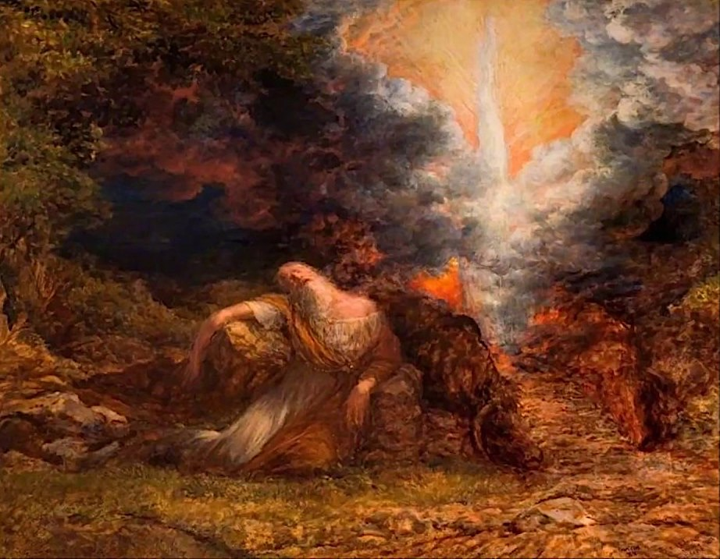
In this world and throughout human history, times have been uncertain and fraught with fear and danger in all aspects of our lives – personal and family, national and political, and international. Strive as we do as humans to solve these problems, we can sometimes lose sight that God is in control of His plan. And built into God’s plan is a promise which we can trust entirely and which gives us hope. As with Abram, we can respectfully ask God how all of this is going to work out or tell Him that we don’t understand. Let us not lose faith and hope in God’s promises and his steadfastness.

Prayer:
Father God thank You for the hope and reassurance that You have given us through Your Son Jesus Christ from before the universe was created. Help us to trust in you in all circumstances, for as John said at the beginning of his gospel: In the beginning was the Word, and the Word was with God, and the Word was God. He was with God in the beginning. Through him all things were made; without him nothing was made that has been made. In him was life, and that life was the light of all mankind. The light shines in the darkness, and the darkness has not overcome it.” All praise, honor and glory to You, Lord God. - Mary Anderson

FEBRUARY 22
“Behold my servant, whom I uphold, my chosen,
in whom my soul delights; I have put my Spirit upon him;
he will bring forth justice to the nations.”

Text: Isaiah 42:1-9
¹ “Here is my servant, whom I uphold, my chosen one in whom I delight; I will put my Spirit on him and he will bring justice to the nations.
² He will not shout or cry out, or raise his voice in the streets.
³ A bruised reed he will not break, and a smoldering wick he will not snuff out. In faithfulness he will bring forth justice; ⁴ he will not falter or be discouraged till he establishes justice on earth. In his law the islands will put their hope.”
⁵ This is what God the Lord says—he who created the heavens and stretched them out, who spread out the earth and all that comes out of it, who gives breath to its people, and life to those who walk on it:
⁶ “I, the Lord, have called you in righteousness; I will take hold of your hand. I will keep you and will make you to be a covenant for the people and a light for the Gentiles, ⁷ to open eyes that are blind, to free captives from prison and to release from the dungeon those who sit in darkness.
⁸ “I am the Lord; that is my name! I will not give my glory to another or my praise to idols.
⁹ See, the former things have taken place, and new things I declare; before they spring into being I announce them to you.”
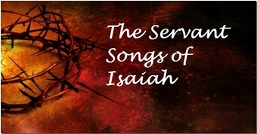
Reflection: Over the next four days, you will be reading what are called the “Servant Songs” of the prophet Isaiah. These are particularly important to us, and at Easter time, because we believe they are prophetic pictures of Jesus Himself written some 700 years before He came to earth and was crucified. Not everyone and not all theologians share this belief. The identity of this “servant” of Isaiah is a matter of sharp debate among Old Testament scholars. There is ambiguity in Isaiah’s descriptions. Is this servant an individual or a group? Jewish interpreters will suggest that Isaiah’s “Servant” is a mysterious redemptive figure, perhaps a ruler like King Hezekiah or maybe a prophet—maybe Isaiah himself—or perhaps Isaiah is referring to the people of Israel as a whole particularly when they would be taken into exile. There is evidence that by New Testament times, Isaiah’s “Servant” was seen by Jewish interpreters as an individual who would act as God’s agent to bring about the restoration of God’s people—a (or The) Messiah. So, application of these texts to Messiah Jesus is not historically unreasonable.
The problem comes with Isaiah’s further prophetic revelation that this figure would be a “Suffering Servant.” The Jews were expecting God’s Anointed One to be a mighty warrior, a triumphant world-changing force lifting Israel and putting down all her enemies. Suffering? This did not fit the profile.
Some would argue that it is in the New Testament, with its abundant quoting of Isaiah’s Servant Songs, that the notion of Triumphant Messiah and Suffering Servant were brought together. There, suddenly, the early Christians found these two figures to be one and the same person: Jesus of Nazareth. And thus the basic Christian belief in Christ’s atoning work through His own vicarious and redemptive suffering is clearly presented with the help of the 8th-century BC Prophet Isaiah.
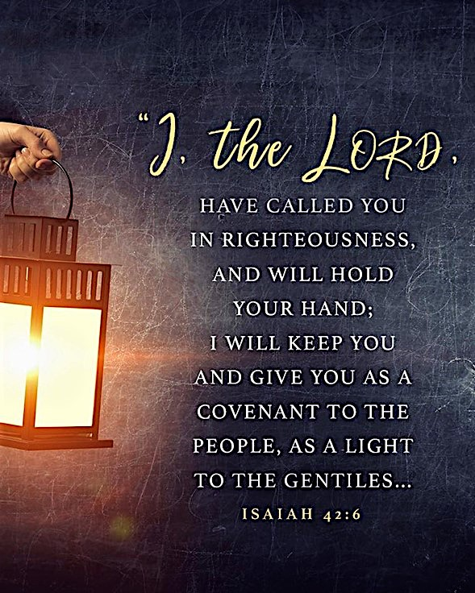
In the first of these Songs, we are introduced to this mysterious, coming servant-redeemer who would delight the Lord, possess God’s Spirit and bring universal justice (42:1). He would endure suffering without crying out to people around him for rescue (v.2), tend to the weak rather than take advantage of them (v.3), and keep going until his work was accomplished (v.4). Because of the importance of right relationships (with God and with one another - v.6), he would be called by God with whom he would enjoy intimacy and empowerment as he demonstrated the promise-keeping character of God, provided supernatural insight for all people, and brought release for those living in bondage and ignorance (vv.6-7). All of this would be an expression of the unique and eternal glory of God and a manifestation of something radically new and renewing come to earth (vv.8-9). It all sounds like an accurate and informative overview of the person and work of God’s Son, our Savior, Jesus the Messiah. And Isaiah himself gives good reason for us to understand these words as nothing less than a predictive picture of our Lord and Savior, our Mighty King and Suffering Servant, for straight from the mouth of God to our ears he says, “…new things I declare; before they spring into being I announce them to you.”

Response: Meditate for a while this allusion to Isaiah’s Suffering Servant from Mark 10:42-47… How does the life of Jesus bring comfort to you in the midst of your struggles and challenge you in your daily decisions?
- …whoever would be great among you must be your servant, and whoever would be first among you must be slave of all. For even the Son of Man came not to be served but to serve, and to give his life as a ransom for many.

Prayer: Lord God, I thank You that You recognized the problem of unrighteousness in my life and in the lives of all my fellow human beings—we simply cannot live consistently in right relationship to You and to one another. Thank You, Lord Jesus, that you came to earth to do something about that horrific state of affairs and that You accomplished Your work. Help me to follow You in living my life in service to others for Your glory, for You are Lord and worthy of all praise. Amen. - Jay Hull
FEBRUARY 23
“I will make you as a light for the nations, that my
salvation may reach to the end of the earth.

Text: Isaiah 49:1-7
¹ “Listen to me, you islands; hear this, you distant nations: Before I was born the Lord called me; from my birth he has made mention of my name.
² He made my mouth like a sharpened sword, in the shadow of his hand he hid me; he made me into a polished arrow and concealed me in his quiver.
³ He said to me, “You are my servant, Israel, in whom I will display my splendor.”
⁴ But I said, “I have labored to no purpose; I have spent my strength in vain and for nothing. Yet what is due me is in the Lord’s hand, and my reward is with my God.”
⁵ And now the Lord says—he who formed me in the womb to be his servant to bring Jacob back to him and gather Israel to himself, for I am honored in the eyes of the Lord and my God has been my strength—
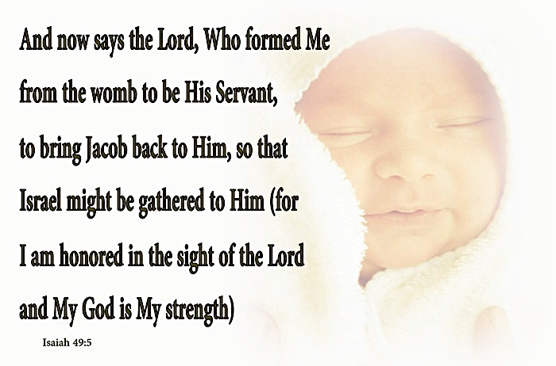
⁶ he says: “It is too small a thing for you to be my servant to restore the tribes of Jacob and bring back those of Israel I have kept. I will also make you a light for the Gentiles, that you may bring my salvation to the ends of the earth.”
⁷ This is what the Lord says—the Redeemer and Holy One of Israel—to him who was despised and abhorred by the nation, to the servant of rulers:
“Kings will see you and rise up, princes will see and bow down, because of the Lord, who is faithful, the Holy One of Israel, who has chosen you.”

Refection: Even in crisis, Isaiah reminds us that it is God who is in control, and it is God in whom we put our faith and trust. And our Mission as God’s church is to take the message of salvation to anyone we are able to share with.
Looking at the “big picture” of Isaiah, Israel, God’s people to the north, have been conquered by the Assyrians. Judah, God’s people to the south, are under similar threat (and later their kingdom and God’s temple will be destroyed and they will be taken in chains to a foreign land, Babylon). However, they must remember now and in the future that they are still God’s people and that they still need to keep their faith.
In the mist of this turmoil Isaiah gives words of hope… He tells the “servant” that the “Servant” doesn’t choose whether or not they want to be a follower of God, God makes that decision before we are even born: “Before I was born the Lord called me; from my mother’s womb he has spoken my name.”
It is God’s choice to use whomever He wants for His purposes. Sometimes we don’t even know we are chosen until the time comes when God points us in a direction to act: “…and he has made my mouth like a sharp sword; in the shadow of his hand, he has hidden me: and he has made me a polished arrow and concealed me in his quiver.”
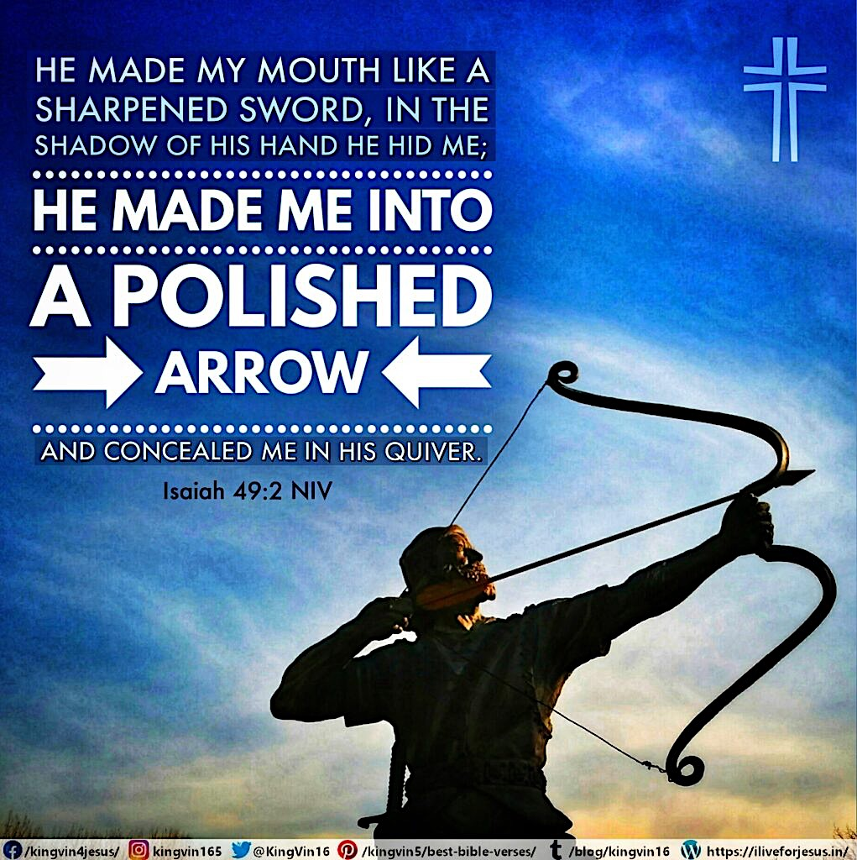
To be made like a sharpened sword and a polished arrow implies that the Servant is equipped for every contest. However, we will not be used for military battle but as disciples of Christ with precision proclaiming His salvation whether it be sharing up close and personal (like how you would use a sword) or proclaiming from a distance (like you would use a polished arrow).
Isaiah then points us toward the coming of Jesus Christ: “…and he said to me, ‘You are my servant, Israel, in whom I will display my splendor.” In our obedience to God we will be glorified through the grace of Jesus Christ.
The servants are assured that God is with them no matter what their life circumstances. Even though they have been defeated, whether due to their own faults or external foes, salvation and life everlasting is still with God and through the coming of Jesus Christ. In faith there is the assurance of good things to come!
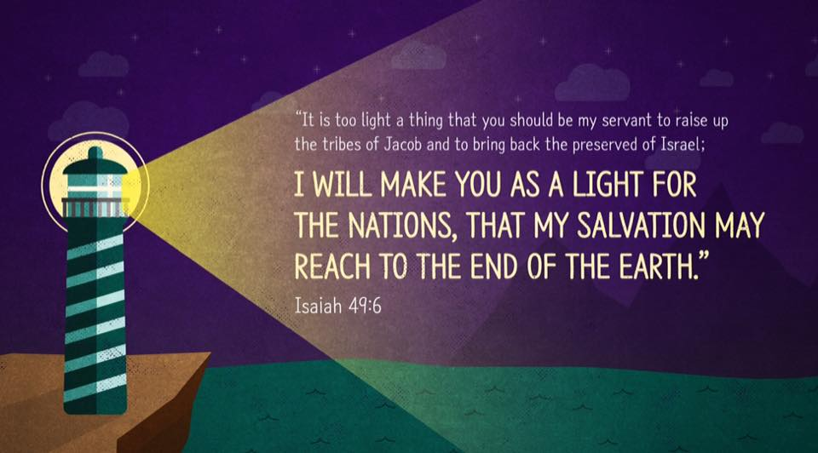
Next Isaiah tells the Servant(s) that their task is to proclaim the way of Yahweh. To get people of God back to God: “He who formed me in the womb to be his servant, to bring Jacob back to him, and gather Israel to himself, I am honored in the eyes of the Lord, and my God has become my strength.” The servant responds with how honored he is that he has been chosen for such a task, that he is glorified in this ‘mission’ and truly believes God will give him the knowledge and strength to complete the task. However, Isaiah proceeds to tell them that their task is not just the bringing of God’s people back to God. They must also take the proclamation of God’s salvation to the Gentiles and to the ends of the earth: “It is too small of a thing for you to be my servant to restore the tribes of Jacob and bring those of Israel I have kept. I will also make you a light for the Gentiles, that my salvation may reach to the ends of the earth.”
And God finally tells them that no matter how badly they have been treated in the past, they are the righteous and they will prevail. Salvation will be with them: “Redeemer of Israel, and Holy One of Israel, to him who was despised and abhorred by the nation, to the servant of rulers: Kings will see you and stand up, princes will see you and bow down, because of the Lord who is faithful, the Holy One of Israel, who has chosen you”

Response: These are very troubling times. Our country, it seems, as well as the world, is in a downward spiral. Much like the Israelites must have been thinking, so many years ago, we wonder what’s next? Isaiah teaches us that whatever is to come, it will be up to God and will happen under His sovereign will. The prophet also tells me that my first response, come what may, should be to turn to God… Put it all in God’s hands… And try to remember that my main purpose in life was chosen for me before I was even born… It was God’s choice before it was mine, that I am a Christian. And, as He told his people long ago, I am to carry the message of hope and salvation I have to anyone that He puts in my path. And, instructed by verse 5, I will do well to know that I am honored to a Christian as I carry that good message of Jesus Christ.
Will we get past Covid? We will if God wants us to (And I believe He is helping us to do so). Will our Government get straightened out and stop all the infighting? It will if God chooses and acts in His power in the hearts and minds of people made ready to do His will. It all starts and ends with God. In the meantime, it could only help our situation if we would each do our part by sharing here in Reno and all around the world the love of God and the salvation and righteousness of Jesus Christ.

Prayer: Heavenly Father, Thank You! Thank You for choosing me. Thank You for sending Your Son Jesus Christ to teach the world about how we should live and treat one another. And, thank You for giving your Son’s life so that we may have eternal salvation. God, please show me how to always wear Jesus on my sleeve, to let anyone and everyone know that I am a Christian and to rejoice in the knowledge that You chose me. Help show me how to always be open and available to talk to anyone that You might also have chosen, someone You might be drawing closer to You, someone wanting to learn more about the salvation that is ours in Jesus Christ. In Jesus’ name I pray… Amen.
- Jake Armer

-------------------------------------------------------------------------------

We are silent at the beginning of the day because God should have the first word,
and we are silent before going to sleep because the last word also belongs to God.
- Dietrich Bonhoeffer
FEBRUARY 24
“Who among you fears the Lord and obeys the voice of his servant?
Let him who walks in darkness and has no light trust
in the name of the Lord and rely on his God.”

Text: Isaiah 50:4-11
⁴ “The Sovereign Lord has given me an instructed tongue, to know the word that sustains the weary. He wakens me morning by morning, wakens my ear to listen like one being taught.
⁵ The Sovereign Lord has opened my ears, and I have not been rebellious; I have not drawn back.
⁶ I offered my back to those who beat me, my cheeks to those who pulled out my beard; I did not hide my face from mocking and spitting.
⁷ Because the Sovereign Lord helps me, I will not be disgraced. Therefore have I set my face like flint, and I know I will not be put to shame.
⁸ He who vindicates me is near. Who then will bring charges against me? Let us face each other! Who is my accuser? Let him confront me!
⁹ It is the Sovereign Lord who helps me. Who is he that will condemn me? They will all wear out like a garment; the moths will eat them up.
¹⁰ Who among you fears the Lord and obeys the word of his servant? Let him who walks in the dark, who has no light, trust in the name of the Lord and rely on his God.
¹¹ But now, all you who light fires and provide yourselves with flaming torches, go, walk in the light of your fires and of the torches you have set ablaze. This is what you shall receive from my hand: You will lie down in torment."

Reflection: There are three things that stuck out to me in reading this passage: the servant heart of the Messiah, the courage of the Messiah, and the challenge of the Messiah to us so that we may submit to the Lord as did He.
God’s great and powerful love is shown throughout verses 4 and 5 in the Messiah’s willingness to serve and submit, as we see him trust his God-given ability to speak wisely of God to those who are weary. We also see this willing submission as Jesus spends his day to day life in fellowship with God as “He awakens me morning by morning.”
So how then does this submission play itself out in the life of the Messiah? Through courage! In verses 6-9 we are sent through a scene that shows just a glimpse of the horrors and sufferings that Christ had to face. From the plucking of the beard to spitting, shaming and mocking, we are offered only a small taste of the hardships leading to the crucifixion. Yet God’s care and love is shown through the courage of Christ! Despite knowing all that the Messiah was going to face, he knew that the “Lord God will help” him while he set his face like flint so that nothing, not even pain, would turn him from his enduring faith to God. The Messiah knows that he has no need to be ashamed and shall not be condemned.
So, as we get closer to Good Friday and Easter, we must hear the challenge placed upon us by Christ in verses 10-11. Fear the Lord and obey the Messiah! Walk in the path of Light! Trust in God, find your courage in Him! Avoid walking in the fire created by your own sparks, so you may avoid torment placed upon you by the hand of the Lord.

Response: Our world has been extremely divided over the past few years. Whether it be political, religious, or social issues, we are divided. Inspired by Isaiah and his Messiah, Jesus, I would encourage us all to stay true to the word of God! Let us find our courage in Him. And let us be faithful servants, like Him, even in the midst of trial and tribulation.

Prayer: Let us pray after the Psalmist these words given to us in Psalm 1… Lord, how blessed is the man who walks not in the counsel of the wicked, nor stands in the way of sinners, nor sits in the seat of scoffers; but his delight is in the law of the Lord, and on his law he meditates day and night. He is like a tree planted by streams of water that yields its fruit in its season, and its leaf does not wither. In all that he does, he prospers.
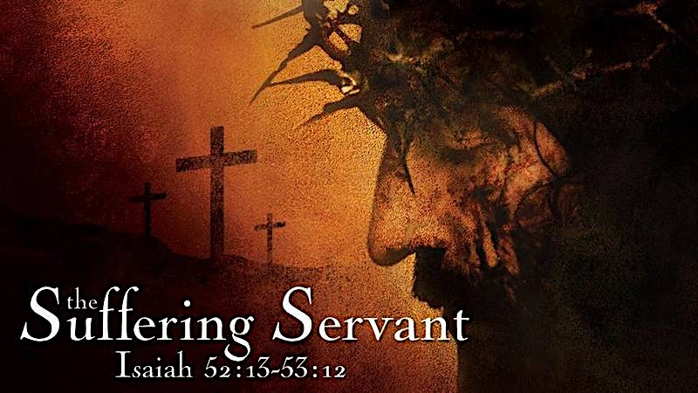
And Lord, You have warned us that the wicked are not so, but are like chaff that the wind drives away. Therefore the wicked will not stand in the judgment, nor sinners in the congregation of the righteous; for You, Lord, know the way of the righteous, but the way of the wicked will perish.
Lord Jesus, You were, You are, that “blessed man.” Help me to follow You with real faith and courage. Amen. - Justin Luevano

FEBRUARY 25
“All we like sheep have gone astray; we have turned—every one—to his
own way; and the Lord has laid on him the iniquity of us all.”

Text: Isaiah 52:13-53:12
¹³ See, my servant will act wisely; he will be raised and lifted up and highly exalted.
¹⁴ Just as there were many who were appalled at him—his appearance was so disfigured beyond that of any man and his form marred beyond human likeness—¹⁵ so will he sprinkle many nations, and kings will shut their mouths because of him. For what they were not told, they will see, and what they have not heard, they will understand.
53 ¹ Who has believed our message and to whom has the arm of the Lord been revealed?
² He grew up before him like a tender shoot, and like a root out of dry ground. He had no beauty or majesty to attract us to him, nothing in his appearance that we should desire him.
³ He was despised and rejected by men, a man of sorrows, and familiar with suffering. Like one from whom men hide their faces he was despised, and we esteemed him not.
⁴ Surely he took up our infirmities and carried our sorrows, yet we considered him stricken by God, smitten by him, and afflicted.
⁵ But he was pierced for our transgressions, he was crushed for our iniquities; the punishment that brought us peace was upon him, and by his wounds we are healed.
⁶ We all, like sheep, have gone astray, each of us has turned to his own way; and the Lord has laid on him the iniquity of us all.
⁷ He was oppressed and afflicted, yet he did not open his mouth; he was led like a lamb to the slaughter, and as a sheep before her shearers is silent, so he did not open his mouth.
⁸ By oppression and judgment he was taken away. And who can speak of his descendants? For he was cut off from the land of the living; for the transgression of my people he was stricken.
⁹ He was assigned a grave with the wicked, and with the rich in his death, though he had done no violence, nor was any deceit in his mouth.
¹⁰ Yet it was the Lord’s will to crush him and cause him to suffer, and though the Lord makes his life a guilt offering, he will see his offspring and prolong his days, and the will of the Lord will prosper in his hand.
¹¹ After the suffering of his soul, he will see the light of life and be satisfied; by his knowledge my righteous servant will justify many, and he will bear their iniquities.
¹² Therefore I will give him a portion among the great, and he will divide the spoils with the strong,
because he poured out his life unto death, and was numbered with the transgressors. For he bore the sin of many, and made intercession for the transgressors.
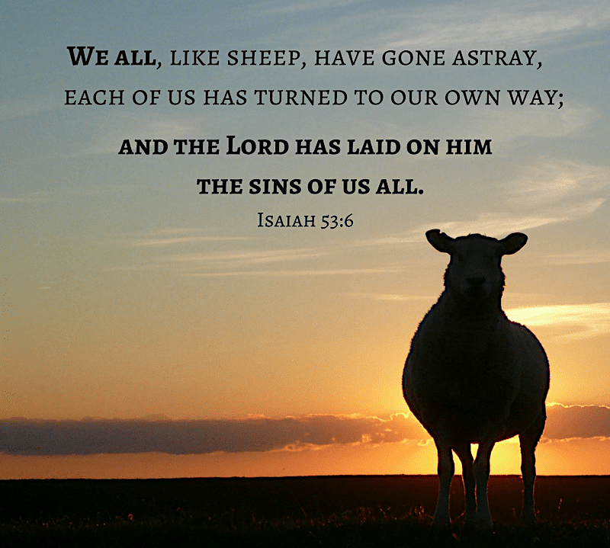
Reflection: This is a beautiful and powerful passage. It is really the heart of the Christian message of redemption and salvation, presented in striking poetry. Isaiah’s name means “The Lord Saves”, and this passage paints a striking picture of the one God sent to save his people from our sins.
As I read this passage there were some concepts that leapt out at me.
So Shall He Sprinkle Many Nations
Sprinkle is an interesting word choice and gave me pause. I first thought it had to do with rain. It didn’t quite make sense until I did a search of it in Bible references. In many Old Testament references the blood of the sacrifice is sprinkled about the altar, and Moses even sprinkled it on the people in Exodus 24:8. In any case, it does relate more to blood sacrifice than rain. “So shall he sprinkle” the blood of his sacrifice upon future generations that they might be healed. Jesus’ sacrifice benefits us forever.
Sorrows and Sheep
Jesus was a man of sorrows. He was rejected by those he came to help. He knew the baseness of mankind; he experienced it firsthand. He knew our natural state was to be separated from God. How could he be content, knowing all that? He paid the ultimate price for sins he did not commit, so that “by his wounds we are healed”. And who did he do this for? He did it for us, who are accurately described as sheep. His depth of knowledge of the human condition and his unfailing love for us contrasts sharply with our ignorance of our own condition and our inability to stay on the path. Sheep are not the brightest of animals, which is why they need shepherds constantly to keep them together and safe. So, what is our thankful response to Christ’s great sacrifice? “We like sheep have gone astray, we have turned-everyone-to his own way”. Even though we stray from the path, the man of sorrows paid the price for our sins, and leads us back to God.
Sins, Transgressions and Iniquities
I never really paid attention to the difference in these words. After some research here is a quick run down of the differences. Sin is anything that falls short of the glory of God, which in our case is an almost constant condition. Some sins are intentional and some unintentional, but they are sins, nonetheless. Transgressions are disobedience of God’s laws; again, sometimes they are intentional, and other times unintentional. Iniquities are intentional sin, usually with some forethought. In our modern-day legal lingo, transgressions would be manslaughter, while iniquities would be premeditated murder. Both are sins. While we as humans find an essential difference in these definitions, God does not. All sins separate us from God. Through Christ’s atoning sacrifice—when he “bore the sin of many”, was “stricken… pierced for our transgressions” and was “crushed for our iniquities”—“we are healed.”

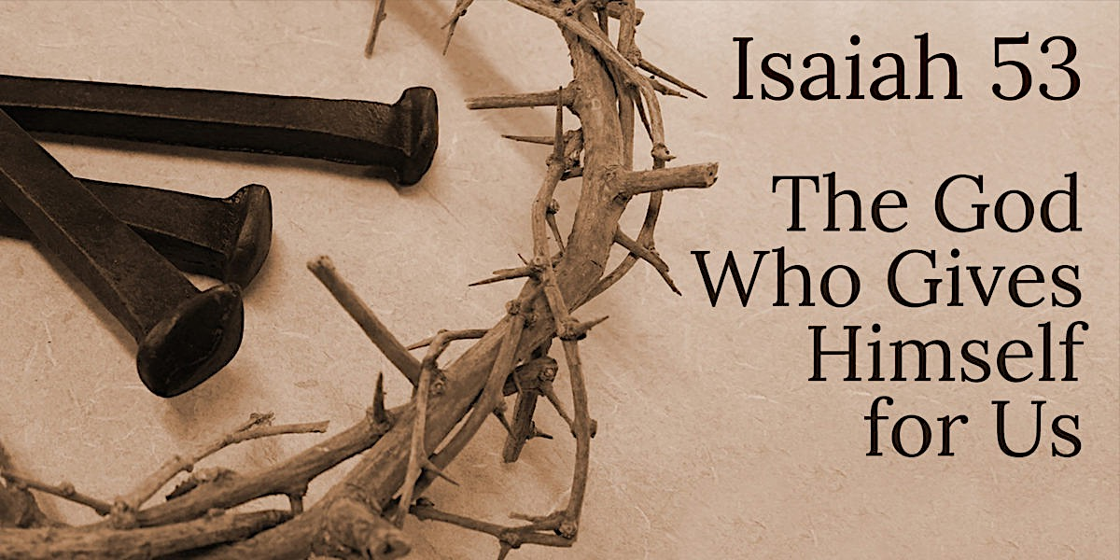
Response: Lent is a sober time of self-reflection. And it is sobering to realize how we all are really in a constant state of sinfulness. Sometimes, briefly, I have thought that I really wasn’t much of a sinner. I recently had two personal revelations of sin. First was in my women’s bible Study of the Sermon on the Mount. I always thought I was “safe” on the sixth commandment “Thou shall not murder”; it turns out sinful anger is included in that. Secondly, upon taking a gander in the Westminster Larger Catechism of the sixth commandment, after listing all things specifically related to the act of murder, it goes on to include, “sinful anger, hatred, envy, desire of revenge, all excessive passions, distracting cares, immoderate use of meat, drink, labor and recreation; provoking words, oppression, quarreling, striking, wounding, and whatsoever else tends to the destruction of the life on any.” It was sobering and convicting to say the least.
Today reflect specifically on your unintentional sins and ask God for forgiveness and then thank God for sending his son to be led “like a lamb… to the slaughter” so that we may be “accounted righteous”.

Prayer:
Gracious and loving God, help me to see all my sins. Help me to know when I stray from Your will. Help me to be aware of when my thoughts and actions harm others and distance me from You. As I become aware of my sin, please help me also to know of Your forgiveness. Help me to be sorry, but also deeply thankful that you sent Jesus, to die a terrible death, that my sins would be forgiven, and I would be able to stand righteous before You now and forever. In Jesus’ holy and precious name. Amen. - Kathy Croughan
FEBRUARY 26
“In his days Judah will be saved and Israel will live in safety. This is
the name by which he will be called: The Lord Our Righteousness.”

Text: Jeremiah 23:1-6
¹ “Woe to the shepherds who are destroying and scattering the sheep of my pasture!” declares the Lord. ² Therefore this is what the Lord, the God of Israel, says to the shepherds who tend my people: “Because you have scattered my flock and driven them away and have not bestowed care on them, I will bestow punishment on you for the evil you have done,” declares the Lord. ³ “I myself will gather the remnant of my flock out of all the countries where I have driven them and will bring them back to their pasture, where they will be fruitful and increase in number. ⁴ I will place shepherds over them who will tend them, and they will no longer be afraid or terrified, nor will any be missing,” declares the Lord.
⁵ “The days are coming,” declares the Lord, “when I will raise up to David a righteous Branch, a King who will reign wisely and do what is just and right in the land.
⁶ In his days Judah will be saved and Israel will live in safety. This is the name by which he will be called: The Lord Our Righteousness.

Reflection: A recurring theme in the Bible is that of sheep and shepherds. Shepherds are often cast in the role of heroes such as David the young shepherd boy who killed Goliath, or even God Himself as we see in the opening of Psalm 23, “The Lord is my Shepherd.” Sometimes shepherds are evil and work against Gods sheep instead of for them. In Jeramiah 23:1-6 we see a stern warning to the bad shepherds and a promise of a Good Shepherd to come.
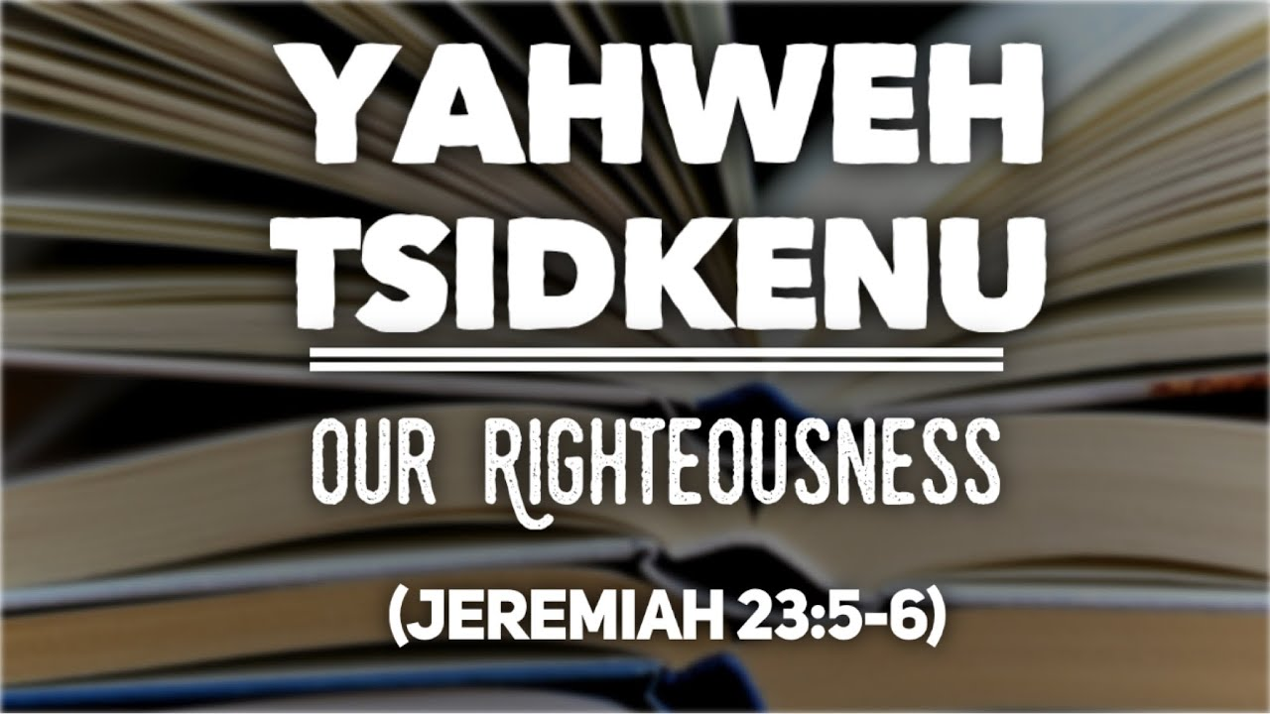
Through the prophet Jeremiah, God holds the leaders of His people accountable for their wickedness. He says they are shepherds who have abandoned their sheep allowing them to be scattered. God says that He will hold them accountable for their evil deeds. He will also gather the scattered sheep back to himself and bless them. He will give them faithful leaders to care for them, and there will eventually be a king from the line of David who will rule with wisdom, justice, and righteousness. The name by which he will be called is “The Lord is our righteousness.” In English this sounds more like a title rather than a name. In Hebrew it is Yahweh-Tsidkenu, which is a name for God that appears twice in scripture, both times in Jeremiah. The literal translation is “God is Justice.” Today we know this promised king is Jesus.
Jesus is the Good Shepherd. He gathers the scattered sheep from among the nations to Himself into the Church. He attends to us both physically and spiritually. Above all He meets our needs in the face of God’s justice. Because our Savior is righteous in every way possible He can take upon Himself the wrath we deserve under the law. In Jeremiah 23:1-6 we see that when Yahweh is angry He always has the best solution to the problem. Thankfully that solution is always Jesus.

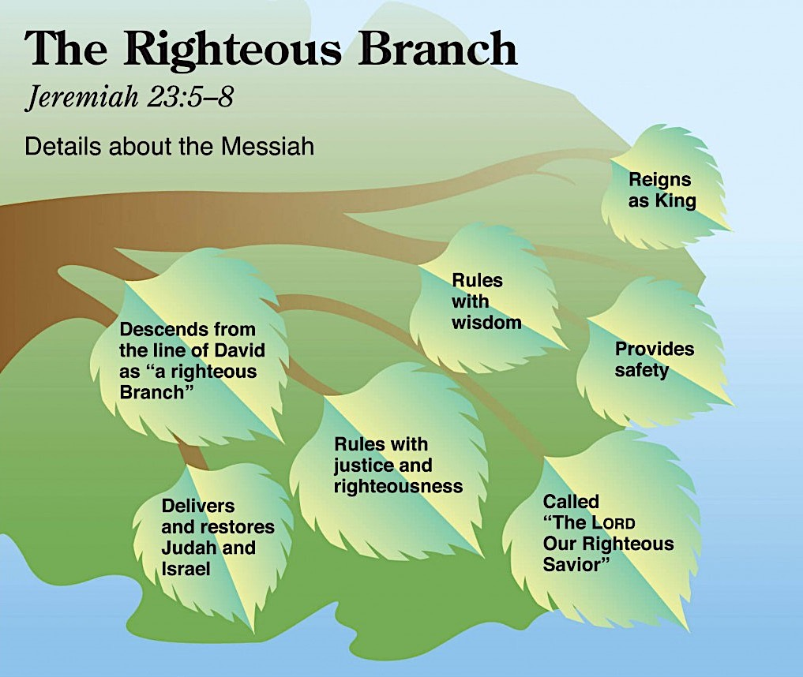
Response: As we approach Easter we can ponder what it means to be like sheep. We often think of them as not very intelligent and needing a shepherd to keep them moving in the right direction. I know from personal experience that they can also be very mean if they don’t get their own way. We live in a very mean world where leaders we should be able to trust don’t care for their flocks very well. In order to live according to God’s truth we need to turn our hearts and minds to Jesus to meet our every need.

Prayer: Jesus, we pray for Your Holy Spirit to lead us through the obstacles of this life. We know You are the Good Shepherd and that a Good Shepherd lays down His life for His Flock. Thank You for taking justice upon Yourself all the way to the grave. Empower us to lead our lives dedicated to You. Amen. - Chris Rhodes

FEBRUARY 27
“The time is coming,” declares the Lord, “when I will make a new
covenant with the house of Israel and with the house of Judah.”

Text: Jeremiah 31:31-34
³¹ “The time is coming,” declares the Lord, “when I will make a new covenant with the house of Israel and with the house of Judah.
³² It will not be like the covenant I made with their forefathers when I took them by the hand to lead them out of Egypt, because they broke my covenant, though I was a husband to them,” declares the Lord.
³³ “This is the covenant I will make with the house of Israel after that time,” declares the Lord.
“I will put my law in their minds and write it on their hearts.
I will be their God, and they will be my people.
³⁴ No longer will a man teach his neighbor, or a man his brother, saying, ‘Know the Lord,’ because they will all know me, from the least of them to the greatest,” declares the Lord.
“For I will forgive their wickedness and will remember their sins no more.”

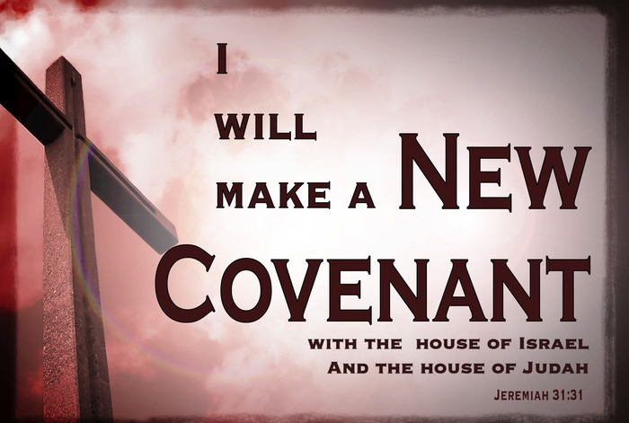
Reflection: Recently I watched on the news as people in another country were engaged in a protest over the issue of abortion—not against abortion but against a law making it illegal. I watched in awe and felt great sorrow. These poor people were screaming for their right to kill their own children. I was mortified. Mortified because that is how ugly sin is, and mortified because that is me too. My sin, all sin, is just as ugly and mortifying. Yes, that image broke my heart and the intensity to which I experienced it is only a portion of how grievous sin is to God. At times, I really believe that I get a sense of the Spirit’s sorrow. We all fall short and part of what we do during Lent is bring those failings to God. And we bring our gratitude and devotion. Yes, God is a God of love, and Jesus is love in action, but we cannot talk about His love without talking about His justice. We cannot celebrate His goodness without respect for His authority.
Law written on paper may or may not have meaning to people. In our postmodern society we have what is referred to as Relativism, where people argue that there is not one absolute truth. The relativist believes that truth is what is true for each individual. This seems reasonable to people because there isn’t anything written in their minds and hearts, because parents aren’t raising children in the Church, because God is seen as a man-made option rather than a bigger-than-life-itself necessity. Naturally, we then have people confused with their Identity, purpose and meaning as a result.
I heard someone say once that the biggest fall they ever took was 18 inches. As I looked at them puzzled, they pointed to their head and said, “the fall from my head to my heart,” and pointed to their chest. It is when truth enters in through our hearts that it permeates our whole being. You know that you know that you know.
I don’t expect that I can give a lot of new insight into these verses of Jeremiah. The gospel of Jesus Christ springs to life from them. Yet, in studying them, I find new things illuminated. I learned this is the only time in the Old Testaments that this term “new covenant” is used. and that words such as not anymore or not like emphasize a discontinuation from the past. The Old Covenant didn’t function as a way to salvation, but rather it brought condemnation because we as natural people naturally fail. We fail completely. We write God out of our hearts and lives and things like Relativism into them.
“There is no one righteous, not even one; there is no one who understands;
there is no one who seeks God. All have turned away, they have together
become worthless; there is no one who does good, not even one.” - Romans 3:10-12
An awareness of sin is what we have and desperately try to relativize. With the New Covenant we are also given an awareness of Jesus. God writes on our hearts and make us aware of an innocent person taking our place and receiving our penalty for sin. Go back to Jeremiah chapter 11 and read the indictment against us. The future looks bleak from back there.
God unites the north and the south with His promise of a New Covenant into the “one house of Israel” (Israel and Judah reunited).
I can’t help but wonder if people feared this a bit with the picture in their minds of God burning the tablets with the Ten Commandments. I wonder would they have thought there would be a type of painful tattooing on their hearts? That metaphor is found in Jeremiah 17 where the people’s hearts are described as being so hard that the instrument needed to change them would be the hardest writing instrument.
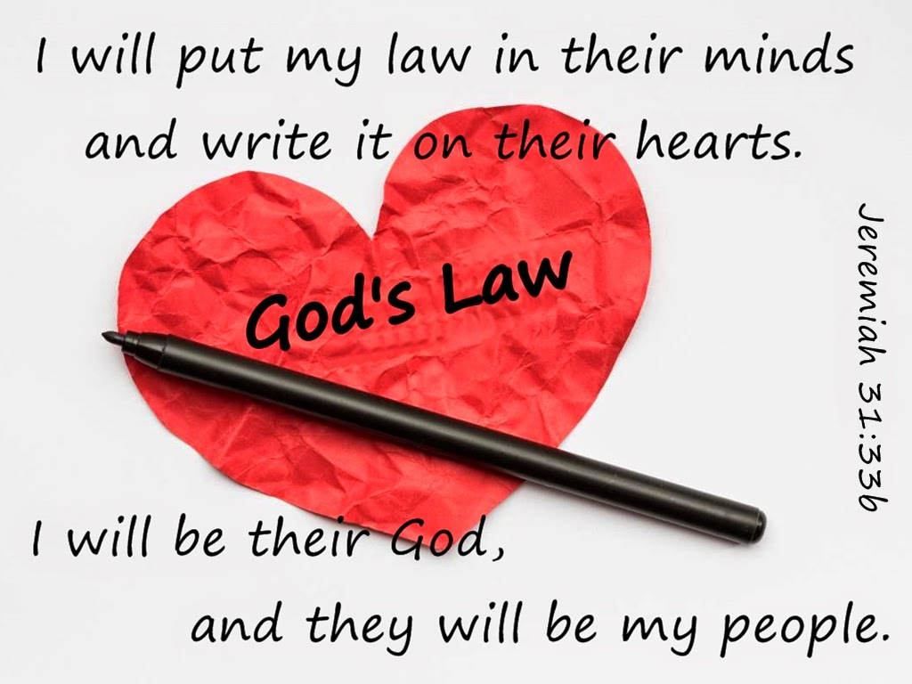
How merciful is God! How long-suffering and gracious is God! We get a fresh start each day because of God’s gracious gift of pardon. It’s a gift: It cannot be earned. Through Jesus, we can be forgiven once and for all. It is what is New under the sun.

Response: I try to place myself into some of these Bible stories and truths and wonder what it must have been like and if believing faith was the same then as it is now. We respond by believing and telling others of a miraculous Savior and that Easter is the most hopeful day of the year. Without Easter, there is no life. But there is Easter!

Prayer: Thank You, Jesus, for being our hope! Pour hope into the lives of those feeling hopeless. Send us where Your faithful messengers of hope are needed. Help us to respond to Your Spirit. In Jesus name. Amen. – Cindy Duncan

MARCH 1
“The Lord said to me, “You are my Son; today I have begotten you.”

Text: Psalm 2
¹ Why do the nations conspire and the peoples plot in vain?
² The kings of the earth take their stand and the rulers gather together against the Lord and against his Anointed One.
³ “Let us break their chains,” they say, “and throw off their fetters.”
⁴ The One enthroned in heaven laughs; the Lord scoffs at them.
⁵ Then he rebukes them in his anger and terrifies them in his wrath, saying,
⁶ “I have installed my King on Zion, my holy hill.”
⁷ I will proclaim the decree of the Lord: He said to me, “You are my Son; today I have become your Father.
⁸ Ask of me, and I will make the nations your inheritance, the ends of the earth your possession.
⁹ You will rule them with an iron scepter; you will dash them to pieces like pottery.”
¹⁰ Therefore, you kings, be wise; be warned, you rulers of the earth.
¹¹ Serve the Lord with fear and rejoice with trembling.
¹² Kiss the Son, lest he be angry and you be destroyed in your way, for his wrath can flare up in a moment. Blessed are all who take refuge in him.

Reflection: A professor I had in a Psalms class claimed that he believed the psalms were put in the order in which they exist intentionally. Psalm 1 can be seen as a book-end of sorts for really it is about the Word of God—the importance of meditating on the Word day and night, the blessing that comes from that, and the Lord who is watching over it. And Psalm 150 is then the other intended book-end. In the same way, Psalm 2 is a book-end for the Messianic and/or prophetic psalms, that speak to or of Jesus and His time to come. Also, some believe that Psalm one and two were meant to be read together.
Psalm 2 and the other prophetic psalms are also referred to as Royal Psalms that speak to the role of kings in the worship of Yahweh. Psalm 2 is not identified as a psalm of David although some still think it was written by Israel’s “sweet Psalmist-King.” They see it as a Davidic psalm because David’s reign had begun under divine sponsorship, and he had victories over neighboring people as written in verses 9-11. David was definitely mighty but not to the extent of these verses. King David did not reach the “ends of the earth.” There were still powers of the Nile, Euphrates and Tigris, and they were not in allegiance to David.
A messianic interpretation for Psalm 2 is best, best when it is understood as an oracle or poem written to express confidence or give homage to one of the royal lines, or kings, at the time of their accession. For this reason, this psalm may have been used only once. This psalm speaks of the promise of the Davidic kingship and points forward. Gods’ decree is proclaimed in this psalm, His decree to install His rule over the ends of earth.
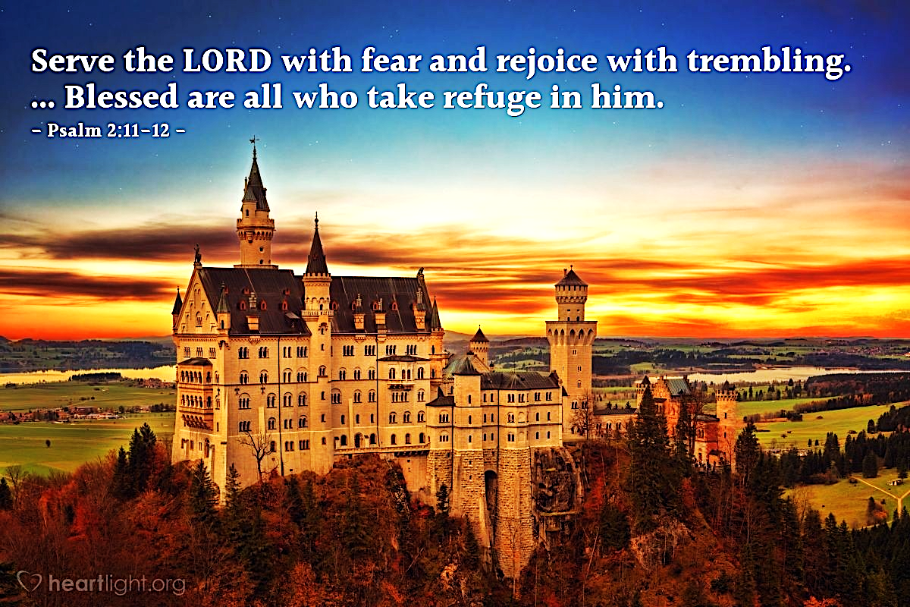
Psalm 2 also speaks to the mercy of God toward us. His decree points to the future, and at the same time it is for now. Jesus is already installed. This Lent season, we reflect upon and speak about the Lord and His obedience and submission to His Heavenly Father. We are called to be wise and so to submit to the Son of God as He give us more and more opportunities to do just that. The kiss is a way of symbolically honoring Jesus and acknowledging that He is the Way to God. Those who do not “kiss” or receive the Son as their King have no way of coming to the Father. Salvation can only be found in and through Jesus Christ. There is nothing anyone can do or be apart from this reality that will provide an alternative route to salvation and life, and that is a good thing, for there really is a Savior of the world. As I personally reflect on this psalm, I share with you the words to the hymn I hear in my spirit. “Jesus paid it all; all to Him I owe. Sin had left a crimson stain, He washed it white as snow.”

Reflection: During Lent, we are reflecting and preparing for Easter and imitating Jesus’ sacrifice and withdrawal into the desert for 40 days. It is difficult to ponder the suffering He endured, and I don’t think we have any idea of all that transpired on that cross, but I believe we can stand and be in awe of the fact that this is motivated by love; His love.

Prayer: Lord, King Jesus, Your kingdom come, Your will be done, on earth as it is in Heaven. Lord, though it seems to tarry, we wait for it. It is worth it, and You are worthy of all our devotion and praise. Thank you.
- Cindy Duncan

MARCH 2
“I will give you a new heart and put a new spirit in you; I will remove
from you your heart of stone and give you a heart of flesh…”

Text: Ezekiel 36:16-32
¹⁶ Again the word of the Lord came to me: ¹⁷ “Son of man, when the people of Israel were living in their own land, they defiled it by their conduct and their actions. Their conduct was like a woman’s monthly uncleanness in my sight. ¹⁸ So I poured out my wrath on them because they had shed blood in the land and because they had defiled it with their idols. ¹⁹ I dispersed them among the nations, and they were scattered through the countries; I judged them according to their conduct and their actions. ²⁰ And wherever they went among the nations they profaned my holy name, for it was said of them, ‘These are the Lord’s people, and yet they had to leave his land.’ ²¹ I had concern for my holy name, which the house of Israel profaned among the nations where they had gone.
²² “Therefore say to the house of Israel, ‘This is what the Sovereign Lord says: It is not for your sake, O house of Israel, that I am going to do these things, but for the sake of my holy name, which you have profaned among the nations where you have gone. ²³ I will show the holiness of my great name, which has been profaned among the nations, the name you have profaned among them. Then the nations will know that I am the Lord, declares the Sovereign Lord, when I show myself holy through you before their eyes.
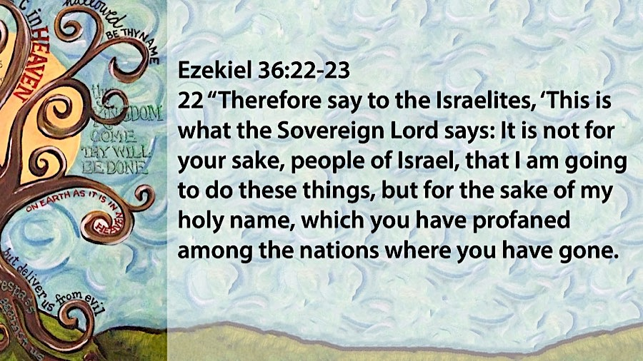
²⁴ “ ‘For I will take you out of the nations; I will gather you from all the countries and bring you back into your own land. ²⁵ I will sprinkle clean water on you, and you will be clean; I will cleanse you from all your impurities and from all your idols. ²⁶ I will give you a new heart and put a new spirit in you; I will remove from you your heart of stone and give you a heart of flesh. ²⁷ And I will put my Spirit in you and move you to follow my decrees and be careful to keep my laws. ²⁸ You will live in the land I gave your forefathers; you will be my people, and I will be your God. ²⁹ I will save you from all your uncleanness. I will call for the grain and make it plentiful and will not bring famine upon you. ³⁰ I will increase the fruit of the trees and the crops of the field, so that you will no longer suffer disgrace among the nations because of famine. ³¹ Then you will remember your evil ways and wicked deeds, and you will loathe yourselves for your sins and detestable practices. ³² I want you to know that I am not doing this for your sake, declares the Sovereign Lord. Be ashamed and disgraced for your conduct, O house of Israel!

Reflection: I remember fondly doing projects for school with my dad. It often included me telling him what was required and then me staying out of his way as he would create a masterpiece that I could turn in and earn the credit. Over the years he created an awesome Washington Monument out of a piece of 4x4 lumber, a banjo out of half a water bottle and some rubber bands and a bridge out of match sticks. On occasions we’d get in trouble for his over influence, especially during pinewood derby races where he would “bend” the rules, but most of the time I always appreciated him doing my work. I know that my dad didn’t do it to be dishonest or cheat, but he did it because he loved me. I find myself falling into the same trap at times with my children. I try and let them complete projects on their own and stand on the side to just give input, but it is so hard not to just yell “Get out of the way. I’ll do it!”
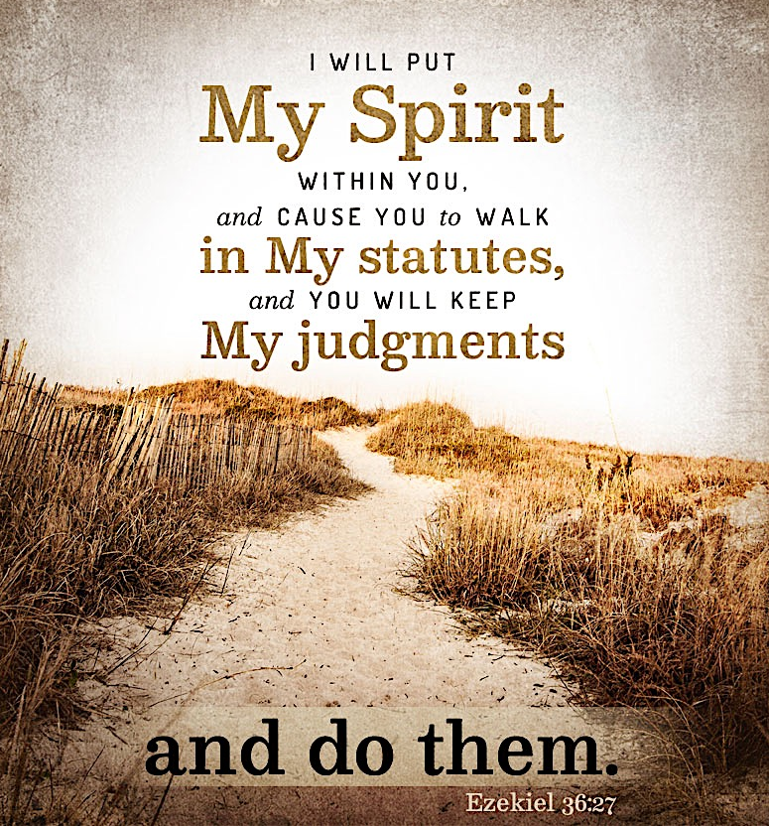
Anthropomorphism is a term used when we give human characteristics, emotions, and behaviors to non-human things; for example Mickey Mouse or Lightening McQueen. People tend to do this when we are trying to understand God and his actions. I can’t help myself to wonder if God ever gets frustrated much like a parent does and tries to take over. In our passage God says through Ezekiel, “I will…” multiple times. For example: “I will show holiness,” “I will take you out of the nations,” “I will gather you from all the countries,” “I will sprinkle clean water on you” “I will cleanse you” et cetera. I can’t help but wonder if God is being the caring adult that is simply saying to his children “Get out of the way. I’ll do it!”
The difference is that God’s people couldn’t do it; even when they tried. The Israelites messed up horribly and God steps in, cleans them up and sets them aside so they can watch him do the work… correctly.

Response: Reread the passage, underline how often God says “I will” and ask yourself if these are things you think you could do on your own. Now go back and recognize how often it says “you will.” Like the Israelites, we can’t do life on our own up to God’s standards of excellence and health either. We can’t stop the spread of disease… We can’t fix the world through politics… We can’t fulfill whatever agenda we think is best… God needs to do it, not only for our sake, but for His. All honor and glory be to Him, not to us, not to our wisdom, not to our strength.

Prayer: God, thank You for taking over and doing it for me. Only You can cleanse me. Only You can make me clean. Only You can give me the new heart and new spirit I need. - Ryan Ludwig
MARCH 3
“See, your king comes to you, righteous and having salvation,
gentle and riding on a donkey…”

Text: Zechariah 9:9-13
⁹ Rejoice greatly, O Daughter of Zion! Shout, Daughter of Jerusalem! See, your king comes to you, righteous and having salvation, gentle and riding on a donkey, on a colt, the foal of a donkey.
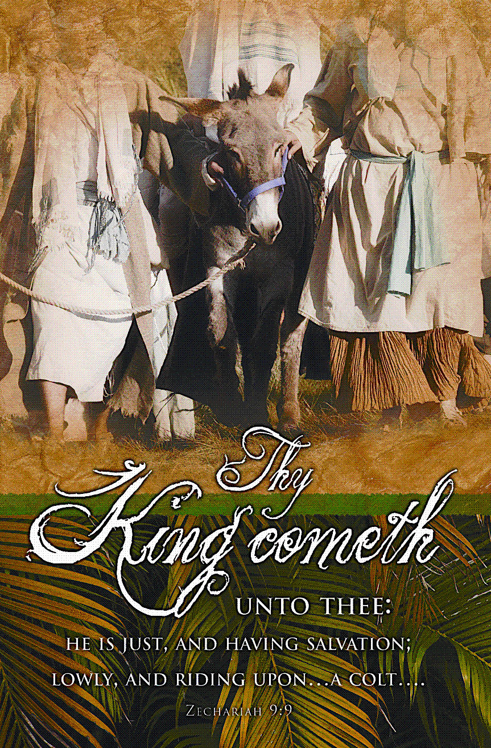
¹⁰ I will take away the chariots from Ephraim and the war-horses from Jerusalem, and the battle bow will be broken. He will proclaim peace to the nations. His rule will extend from sea to sea and from the River to the ends of the earth.
¹¹ As for you, because of the blood of my covenant with you, I will free your prisoners from the waterless pit.
¹² Return to your fortress, O prisoners of hope; even now I announce that I will restore twice as much to you.
¹³ I will bend Judah as I bend my bow and fill it with Ephraim. I will rouse your sons, O Zion, against your sons, O Greece, and make you like a warrior’s sword.

Reflection: One of the most charming and surprising Palm Sunday celebrations I ever saw was children pulling a wheeled wooden donkey with a seated Jesus down the church’s center aisle as they sang out their “Hosannas.” The scriptural account of Jesus entering Jerusalem sitting on a donkey, recorded in Matthew 21:8-11, indeed shows him thronged by his followers shouting their “Hosannas” while spreading their cloaks and cut branches before him. It is a happy and tumultuous scene, but do we know all it meant?
Jesus viewed this triumphal entry as a highly significant act, a fulfillment of Zechariah’s prophecy proclaimed over 500 years earlier. When Jesus sent his disciples to find the donkey and her colt, he quoted a portion of today’s passage. What did it mean for Jesus to enter Jerusalem in this manner? The people of Jerusalem, poetically called “daughter of Zion” in Zechariah, recognized that Jesus was entering in majesty—spreading cloaks was royal homage and a donkey was the mount reserved for kings. The crowd acclaimed him as “the Son of David”, the title repeatedly given the promised Messiah in the Old Testament. Their “Hosannas” were the Hebrew word for “save.” We see the Jewish crowd excitedly hailing the arrival of their Messiah, but what were their expectations?
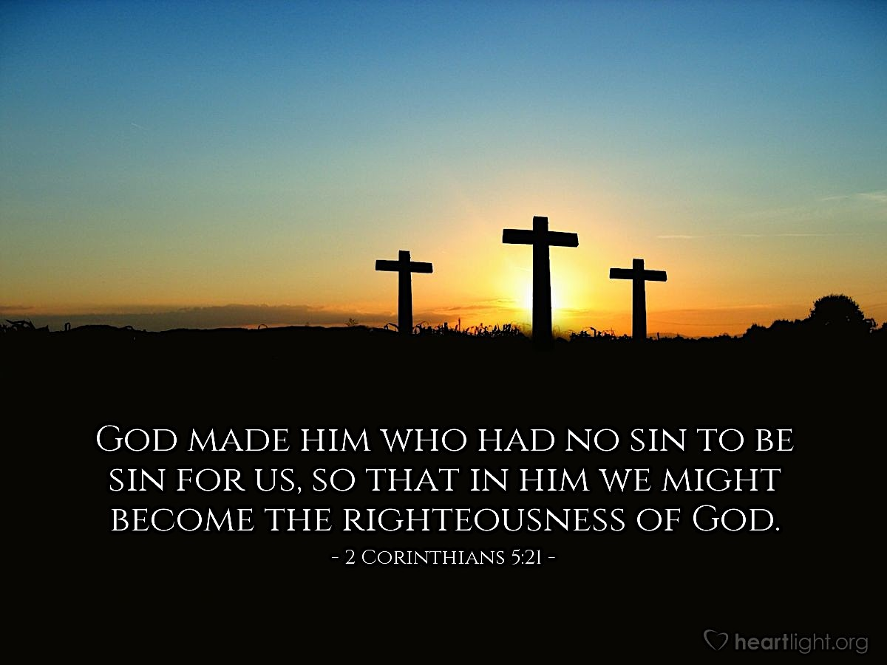
The radical reversal of the cries within the span of Holy Week from “Hosanna” to “Crucify him!” shows that they wanted a Messiah who would free them from the yoke of Rome. They clamored for a king who would rule a kingdom more glorious than that of King David. But their Messiah was not the conquering warrior king they craved. Zechariah describes him as humble, mounted on a donkey, rather than a war horse. This promised king will cut off instruments of war—the chariot, war horse, battle bow—and will instead speak peace to the nations. On Palm Sunday Jesus entered Jerusalem righteous and having salvation, as Zechariah predicted; but, as the events of the Passion revealed, his perfect righteousness was necessary so that he could be the only acceptable sacrifice in our place. His costly death on the cross, the fulfillment of the blood of the covenant ceremony in Exodus 24:8, makes all who believe righteous before a Holy God. “God made him who had no sin to be sin for us, so that in him we might become the righteousness of God” (II Cor 5:21). The mission of Messiah Jesus was not merely political conquest and peace for only one nation, but a cosmic event—a coming New Heaven and New Earth and “peace to all those on whom God’s favor rests” as the angels sang at his birth.

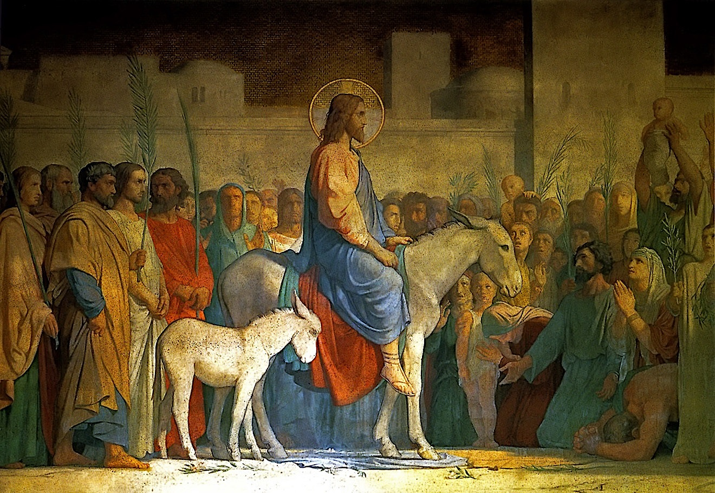
Response: May we cease trying to mold Jesus into our limited expectations but worship him in his true majesty. May God help us this Lenten season to meditate on all King Jesus accomplished to bring us peace with God. May we long ever more for the day when “his rule shall be from sea to sea, and from the River to the ends of the earth”.

Prayer: Thank you, Jesus, for coming as our humble king to make the way for us to be subjects in Your heavenly kingdom. May we, through the power and direction of Your Holy Spirit, be faithfully seeking to advance Your kingdom. Amen.
- Debbie Barackman

MARCH 4
“They will look on me, the one they have pierced, and they will
mourn for him as one mourns for an only child…”

Text: Zechariah 12:10-13
¹⁰ “And I will pour out on the house of David and the inhabitants of Jerusalem a spirit of grace and supplication. They will look on me, the one they have pierced, and they will mourn for him as one mourns for an only child, and grieve bitterly for him as one grieves for a firstborn son. ¹¹ On that day the weeping in Jerusalem will be great, like the weeping of Hadad Rimmon in the plain of Megiddo. ¹² The land will mourn, each clan by itself, with their wives by themselves: the clan of the house of David and their wives, the clan of the house of Nathan and their wives, ¹³ the clan of the house of Levi and their wives, the clan of Shimei and their wives, ¹⁴ and all the rest of the clans and their wives.

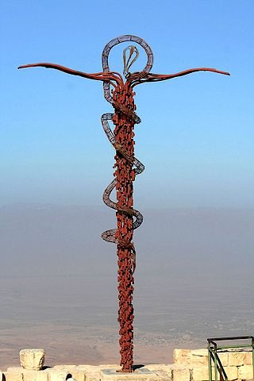
Reflection: The apocalyptic visions given to the prophet Zechariah intertwine predictions of near events affecting the Jewish nation and distant events in God’s unfolding plan of salvation. Thus, the first verse in this passage telescopes the spirit of repentance that God will send Jerusalem’s inhabitants in Zechariah’s time with the voice of the crucified Messiah: “When they look on me, on him whom they have pierced, they shall mourn for him”.
The gospel writers quote chapters 9-14 of Zechariah more than any other biblical passages to show that the predicted suffering and death of the Messiah was fulfilled by Jesus Christ. Verse 10 of chapter 12 reveals that the Messiah’s pierced hands and feet will draw mournful repentance for sins from those in whom God’s Spirit moves. Jesus commends such mourning for sin in the Beatitudes in Matthew 5, “Blessed are those who mourn, for they shall be comforted”. When Jesus met privately with the seeking Pharisee Nicodemus, he taught him the necessity of seeing with faith: “No one can see the kingdom of God unless he is born again.” Jesus used the episode in the wilderness when the Israelites had been bitten by venomous snakes to drive this truth home. Healing came only to those who looked up in faith to the snake effigy that God commanded Moses to display on a pole. So, too, Jesus says, recorded in John 3:13, “Just as Moses lifted up the snake in the desert, so the Son of Man must be lifted up, that everyone that believes in him may have eternal life.”
Philippians 2:6-11 contains what may be an early church hymn which ends with the phrase that “at the name of Jesus every knee should bow, in heaven and on earth and under the earth, and every tongue confess that Jesus Christ is Lord, to the glory of God the Father”. All humanity will see and acknowledge the pierced savior on the Day of Judgement. The redeemed will cry out in worship, “in the LORD alone are righteousness and strength”; but all who have raged against God will also see him and be put to shame, as Isaiah 45:24 prophesies. These contrasting joyful and sober certainties should inspire us to redouble our efforts to share the Good News of the gospel to those around us.
The Bronze Serpent Monument in Israel Today

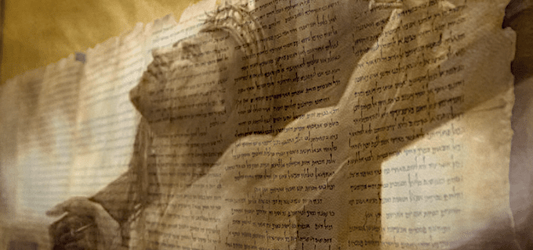
Response: May we all by faith look on the pierced form of Christ and mourn for our sins which led to His suffering on our behalf. Like the disciple Thomas, may our unbelief be transformed to belief when we contemplate the wounds Christ suffered unto death to secure our salvation. Praise God for the believing hosts who have cried out with Thomas, “My Lord and my God!”

Prayer: Dear Heavenly Father, Thank You for creating Your great plan of salvation which our savior Jesus, pierced for our sins, accomplished in order to redeem a people for Yourself. Lord, I am humbled and grateful to be included in Your family by Jesus’ sacrifice of Himself on my behalf. May Your Holy Spirit quickly send a spirit of mournful repentance to my heart for my daily sins. Amen. - Debbie Barackman

MARCH 5
“The stone the builders rejected has become the capstone…”

Text: Psalm 118
¹ Give thanks to the Lord, for he is good; his love endures forever. ² Let Israel say: “His love endures forever.” ³ Let the house of Aaron say: “His love endures forever.” ⁴ Let those who fear the Lord say: “His love endures forever.”
⁵ In my anguish I cried to the Lord, and he answered by setting me free. ⁶ The Lord is with me; I will not be afraid. What can man do to me? ⁷ The Lord is with me; he is my helper. I will look in triumph on my enemies.
⁸ It is better to take refuge in the Lord than to trust in man. ⁹ It is better to take refuge in the Lord than to trust in princes.
¹⁰ All the nations surrounded me, but in the name of the Lord I cut them off. ¹¹ They surrounded me on every side, but in the name of the Lord I cut them off. ¹² They swarmed around me like bees, but they died out as quickly as burning thorns; in the name of the Lord I cut them off. ¹³ I was pushed back and about to fall, but the Lord helped me. ¹⁴ The Lord is my strength and my song; he has become my salvation.
¹⁵ Shouts of joy and victory resound in the tents of the righteous: “The Lord’s right hand has done mighty things! ¹⁶ The Lord’s right hand is lifted high; the Lord’s right hand has done mighty things!”
¹⁷ I will not die but live, and will proclaim what the Lord has done. ¹⁸ The Lord has chastened me severely, but he has not given me over to death.
¹⁹ Open for me the gates of righteousness; I will enter and give thanks to the Lord. ²⁰ This is the gate of the Lord through which the righteous may enter.
²¹ I will give you thanks, for you answered me; you have become my salvation.
²² The stone the builders rejected has become the capstone; ²³ the Lord has done this, and it is marvelous in our eyes.
²⁴ This is the day the Lord has made; let us rejoice and be glad in it.
²⁵ O Lord, save us; O Lord, grant us success.
²⁶ Blessed is he who comes in the name of the Lord. From the house of the Lord we bless you.
²⁷ The Lord is God, and he has made his light shine upon us. With boughs in hand, join in the festal procession up to the horns of the altar.
²⁸ You are my God, and I will give you thanks; you are my God, and I will exalt you.
²⁹ Give thanks to the Lord, for he is good; his love endures forever.

Reflection: When I first read this NIV version of verse 22, I noticed “capstone” instead of “cornerstone.” They are not the same thing and most versions use “cornerstone.” When the verse is quoted in Matthew 21:42, the Greek has “head of the corner” which can be interpreted either way and refers to Christ either way.
A cornerstone is the first stone laid in the foundation of a building. If it is not perfectly measured, shaped and aligned in all three dimensions the building could be tilted, corners could meet at an odd angle, or perhaps not meet at all. As the cornerstone of God’s new covenant, Jesus is perfect in all His dimensions and able to bear the weight of the building above Him. The “building” is an analogy for the church, referred to in I Peter 2:4 as a “spiritual house.” We are the “living stones” God uses to construct it.
I Corinthians 3:11 says, “For no one can lay a foundation other than that which is laid, which is Jesus Christ.” He alone is the true, perfect foundation for the work of God in our lives and in the world.
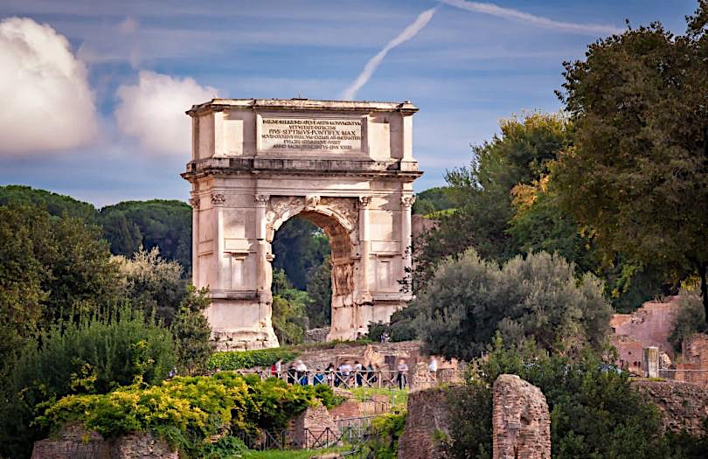
A capstone is the last stone used, often in the top of an arch, also called a keystone. It exerts pressure on both sides of an arch to keep it from falling down. The Romans invented triumphal arches, large structures spanning a road that were incorporated in triumphal processions. One of the most famous is the arch of Titus in Rome, built in AD 71 by the emperor Domitian to celebrate the victory of Titus over Jerusalem. Jesus’ resurrection and His triumph over death is a far greater victory than any conqueror ever accomplished. Paul writes in II Corinthians 2:14, “Thanks be to God, who in Christ always leads us in triumphal procession” and in I Corinthians 15:57, “Thanks be to God, who gives us the victory through our Lord Jesus Christ.” In the battle with death Jesus dies, Jesus rises, and Jesus wins! The capstone, the final touch, the ultimate victor, is Jesus himself.

Response: It is an honor to lay a cornerstone and often the person so honored has his name and the date chiseled on that stone. The cornerstone of the Rift Valley International Academy in Kenya was laid by president Theodore Roosevelt and has his name on it, something the staff made sure we noticed when we visited the academy. The stone with its Roosevelt name was a source of pride for the school. We honor God by making Jesus the foundation for our lives and having Him engrave “Christian” on our hearts. His blueprints are in Matthew 7:24: “Everyone who hears these words of mine and does them will be like a wise man who built his house on the rock.” I Corinthians 3:12 speaks of building on His foundation with gold, silver, precious stones, wood, hay, or stubble. It is a challenge (certainly not always successful) to make sure each thing I “build” is precious in God’s sight, worthy of the foundation, and not cardboard, plastic bottles, and rusty old cans. It may cost more in resources, time, thought, or effort, but Jesus deserves only the best and most beautiful, and the only way to accomplish that is to know His words and do them.
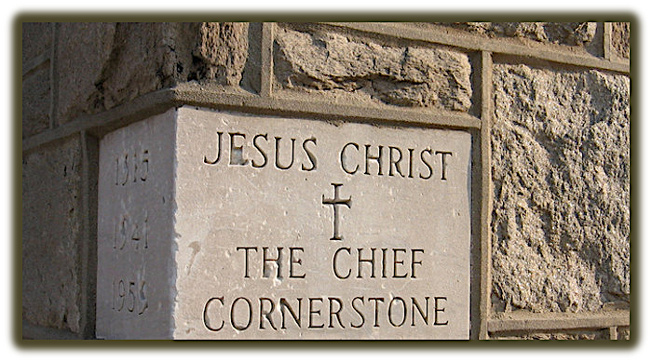
Jesus says in Revelation 22:13, “I am the Alpha and the Omega, the first and the last, the beginning and the end.” He is the cornerstone and the capstone, not just of our lives but of God’s whole plan of redemption. “Therefore…let us run with endurance the race that is set before us, looking to Jesus, the founder and perfecter of our faith” (Hebrews 12:1-2).

Prayer: Heavenly Father, thank You for giving us a Foundation that is big enough, strong enough, and absolutely perfect to support whatever You choose to build. Please chisel off the bumps and sand my rough spots so I fit well into the place You have for me. Make me aware that it is Your doing so I do not complain. Even as Jesus brought glory to Your name, may it also be true of us who are called by His name. Thank You again for Your love and blessings. In Jesus’ name, Amen. - Dianne Billharz
MARCH 6
“The Lord is my strength and my song; he has become my salvation.”

Text: Exodus 15:1-13
15 Then Moses and the Israelites sang this song to the Lord:
“I will sing to the Lord, for he is highly exalted. The horse and its rider he has hurled into the sea.
² The Lord is my strength and my song; he has become my salvation.
He is my God, and I will praise him, my father’s God, and I will exalt him.
³ The Lord is a warrior; the Lord is his name.
⁴ Pharaoh’s chariots and his army he has hurled into the sea. The best of Pharaoh’s officers are drowned in
the Red Sea. ⁵The deep waters have covered them; they sank to the depths like a stone.
⁶ “Your right hand, O Lord, was majestic in power. Your right hand, O Lord, shattered the enemy.
⁷ In the greatness of your majesty you threw down those who opposed you.
You unleashed your burning anger; it consumed them like stubble.
⁸ By the blast of your nostrils the waters piled up. The surging waters stood firm like a wall;
the deep waters congealed in the heart of the sea.
⁹ “The enemy boasted, ‘I will pursue, I will overtake them. I will divide the spoils; I will gorge myself on
them. I will draw my sword and my hand will destroy them.’
¹⁰ But you blew with your breath, and the sea covered them. They sank like lead in the mighty waters.
¹¹ “Who among the gods is like you, O Lord? Who is like you—majestic in holiness, awesome in glory,
working wonders? ¹² You stretched out your right hand and the earth swallowed them.
¹³“In your unfailing love you will lead the people you have redeemed.
In your strength you will guide them to your holy dwelling.

Reflection: This song celebrates God’s dramatic victory over the enemies of His people. Israel had been in bondage to Egypt for 400 years, where they spent their days making bricks and being stung by the lash of the whip. Their sons were born under the threat of murder. They were slaves, forced to serve a cruel and powerful master, Pharaoh. And like those Israelites, all of us are still born into the bondage to sin and death.
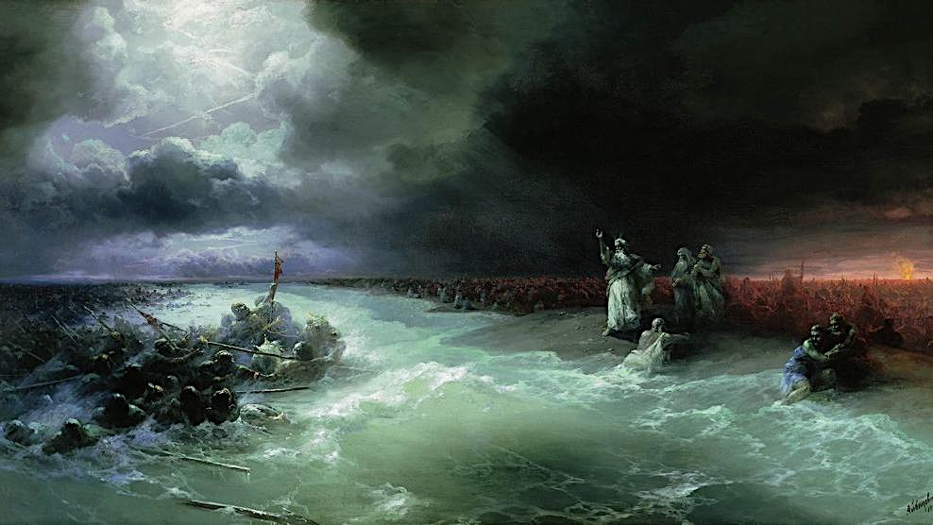
But God heard the groaning of the Israelites, and He still hears the groans of those who are in bondage today. God is full of love and tenderness for the afflicted, whether they are in literal chains or spiritual chains, whether a slave to Pharaoh or a slave to sin. And not only does He hear our cries of distress, but He promises to act on our behalf. God loves His people with an everlasting love, but He is full of burning anger toward their enemies. As He became the salvation of the Israelites, He becomes our salvation when we place our faith in Him.
Now, the people of God should be forewarned. The path of salvation is not easy, and the enemies of God are fearsome. As the Israelites stumbled out into the desert on foot, the Egyptians pursued them with chariots and war horses, intending to kill, steal, and destroy. When God’s people see their enemies descending upon them with flashing swords and blood lust in their eyes, it is natural to be afraid.
Ivan Alvazovsky, The Waters of the Red Sea, 1891
Yet, though God’s people may naturally be afraid of their vicious enemies, still, they should take hope in God and continue in the path of their salvation. The horse, the chariot, and the sword are strong enemies – but the LORD is even stronger. The LORD is not threatened in the least by chariots or swords: He commands the oceans and the winds. The enemies of God are strong, but God is infinitely stronger.
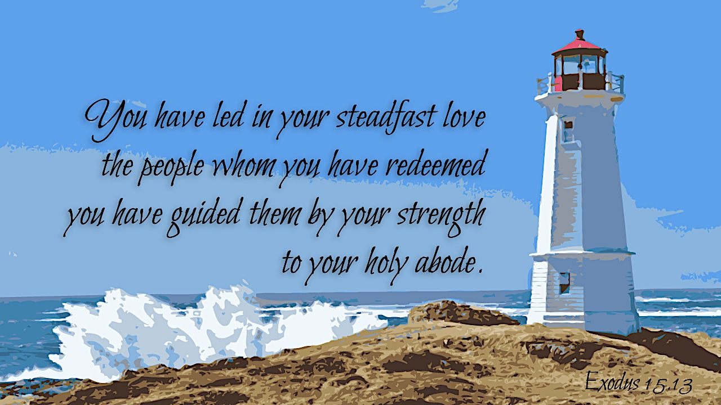
And God will utterly destroy His enemies. A horse may be bearing down upon the stumbling child of God, but the LORD will hurl it into the sea. The adversary and his sword may strike fear into our hearts, but they will sink into the waters and drown before they claim our lives. God glorifies Himself by crushing His adversaries and saving His children. Moreover, as He crushed the Egyptians who pursued the Israelites, He has also crushed sin and death on behalf of all His children through the life, death, and resurrection of Jesus Christ.
It is in God’s nature to save those who trust in Him, and He is a warrior and will fight on your behalf. He has already overcome our greatest enemies, sin and death, but He will continue to hear our cries for salvation from whatever enemies threaten us today. It is natural to be afraid of our enemies; they are fierce, and they are strong. But God is much stronger, and if we call out to Him and follow Him – soon enough we will find ourselves singing songs of His salvation.

Response: What enemies do you face today?

Prayer: Father, be a warrior again for me today, and defeat my enemies like You did the Egyptians! Amen.
- Kenny Ching

------------------------------------------------------------------------------------------------------

He might have reared a palace at a word,
Who sometimes had not where to lay his head:
Time was, and He who nourished crowds with bread
Would not one meal unto Himself afford:
Twelve legions girded with angelic sword
Were at his beck, the scorned and buffeted:
He healed another’s scratch, his own side bled,
Side, feet, and hands, with cruel piercings gored.
Oh wonderful the wonders left undone!
And scarce less wonderful than those He wrought;
Oh self-restraint, passing all human thought,
To have all power, and be as having none;
Oh self-denying Love, which felt alone
For needs of others, never for its own!
- Richard Chenevix Trench (1807-1886)

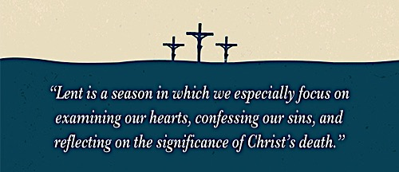
PART II: NEW TESTAMENT COMMENTARY ON JESUS’ DEATH & RESURRECTION
MARCH 8
“And he began to teach them that the Son of Man
must suffer many things…

Text: Mark 8:31-38
³¹ He [Jesus] then began to teach them that the Son of Man must suffer many things and be rejected by the elders, chief priests and teachers of the law, and that he must be killed and after three days rise again. ³² He spoke plainly about this, and Peter took him aside and began to rebuke him.
³³ But when Jesus turned and looked at his disciples, he rebuked Peter. “Get behind me, Satan!” he said. “You do not have in mind the things of God, but the things of men.”
³⁴ Then he called the crowd to him along with his disciples and said: “If anyone would come after me, he must deny himself and take up his cross and follow me. ³⁵ For whoever wants to save his life will lose it, but whoever loses his life for me and for the gospel will save it. ³⁶ What good is it for a man to gain the whole world, yet forfeit his soul? ³⁷ Or what can a man give in exchange for his soul? ³⁸ If anyone is ashamed of me and my words in this adulterous and sinful generation, the Son of Man will be ashamed of him when he comes in his Father’s glory with the holy angels.”

Reflection: One of the things that becomes apparent the more we learn as Christians is that God’s thoughts are not our thoughts and His ways are not our ways (Isaiah 55:8-9). Part of the Christian life is learning truths that renew our minds and turn us from our natural ways so that we can follow Jesus. We can see Jesus teaching this in Mark 8:31-38, where what is clear is that His disciples did not have a clear picture of what it meant that He was the Savior of the world and what it meant to be His disciples.
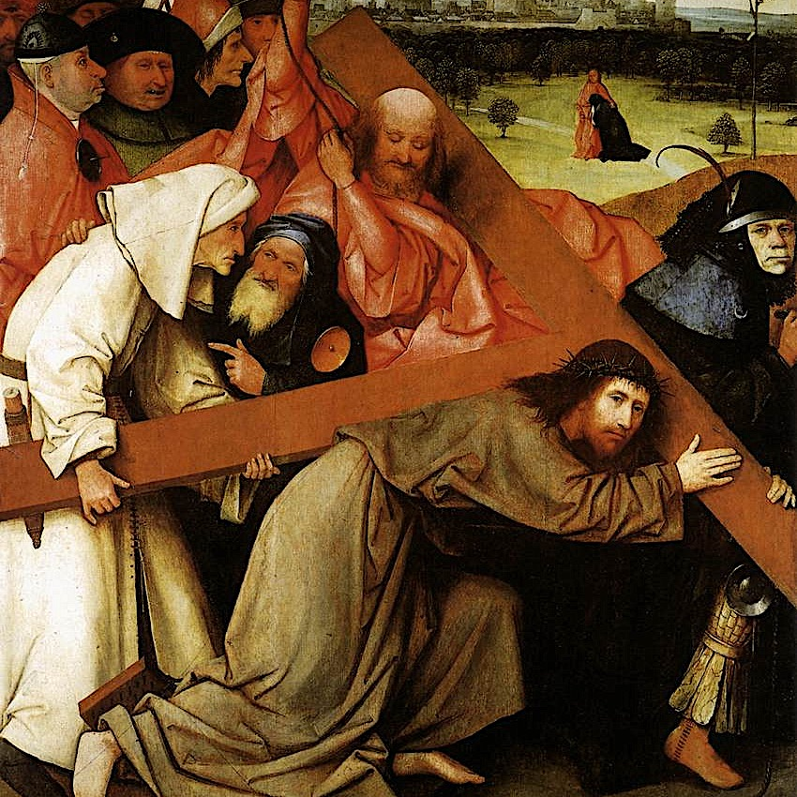
The salvation that Jesus accomplished involved suffering on multiple levels, which the disciples did not expect. Peter tells Jesus in the verses just prior to our text for today that He is the Messiah. Yet, according to C.D.C. Howard in Dictionary of Jesus and the Gospels, Peter’s confession is “incomplete… because it refuses to accept the idea of suffering” (p.81). Jesus talks about being “rejected by the elders, the leading priests, and the teachers of religious law”; that is, highly esteemed religious leaders among Jesus’s own people are going to reject Him to the point that they demand He be killed (Mark 8:31). He knew during His whole earthly ministry that He would come to know intimately both physical and emotional suffering: pain, sadness, rejection, torture, and ultimately, death. The disciples seem to have expected a political savior, one who was going to be triumphant and victorious in the power structures of society, freeing them from Roman rule. Humans like their heroes to be strong, confident, undefeatable. And yet Jesus’s model shows us a different picture. He became victorious through suffering; His peoples’ hearts have to be made right with God before things on earth will be made right.
Second, as disciples of Jesus, we are called to follow His example, denying ourselves out of love for Him and others and submitting to whatever may come: rejection, humiliation, suffering, or even death. In the Dictionary of Jesus and the Gospels, J. B. Green writes, “Though Peter confesses Him as Christ, he is unprepared for subsequent talk of suffering and death…. According to Jesus, if the way of the Christ is the way of suffering, so is the way of discipleship.” (p.158) Jesus must suffer to save us, and in Mark 8, Jesus tells us that truly to follow Him we must be prepared to suffer as well. After rebuking Peter vehemently, telling him that he doesn’t understand God’s ways, Jesus says, “If anyone would come after me, let him deny himself and take up his cross and follow me.” (Mark 8:34) The New Living Translation writes “deny himself” as “turn from your selfish ways.” Jesus goes on to say that those who focus too much on guarding and protecting their own life, their own way of doing things, the natural bent of their psyches, will actually lose their souls in the end. We have an innate desire to save our lives, but He informs us that the way to do this is by giving them up for His sake and the sake of the gospel. We must be willing to sacrifice our selfish desires, willingly taking up whatever cross comes into our life—a mental picture that must have been shocking and upsetting for the disciples, who knew crucifixion as a horrendous and utterly disgraceful way to be humiliated and then executed.
Heironymous Bosch, Christ
Carrying the Cross, 1506
Jesus, in His call to have us give up our own selfish ways of being and living, is not asking us to do something that He Himself did not do. He is our Savior, but He is also the perfect example of servanthood. He came to lay down His life for us. Somehow, even though He was already perfect, He learned obedience to God through His suffering. When God calls us to do something that is difficult, in worship of Him or service to others, He is teaching us obedience too, and we are following in the footsteps of Christ.

Response: When we have to give up our own desires in order to serve others, we are living as Jesus lived. We must be willing to do the difficult things God calls us to, loving and serving those around us, and confessing Christ before them. Even though these attitudes and actions may be hard to the point of utter humiliation, rejection, or death, as the Cross represented for the disciples, Jesus promises us that we are wise to give up earthly glory and comfort to follow Him, for He is saving our souls.

Prayer: Dear Lord, please increase my faith and trust in You as I follow You. Help me to look to You constantly to renew my mind, and please change my heart so that I am filled with Your love. Help me to be willing to set myself aside and always willing to confess You before others. Thank You that You have been such a gracious and merciful Savior, and thank You for correcting our wrong thoughts when we don’t understand Your ways. - Melissa Bullard

[Works Cited: Green, Joel B., Scot McKnight, and I. Howard Marshall, editors.
Dictionary of Jesus and the Gospels. IVP Academic, 2013. ]

MARCH 9
“…there is no other name under heaven given
among men by which we must be saved.”

Text: Acts 4:1-12
The priests and the captain of the temple guard and the Sadducees came up to Peter and John while they were speaking to the people. ² They were greatly disturbed because the apostles were teaching the people and proclaiming in Jesus the resurrection of the dead. ³ They seized Peter and John, and because it was evening, they put them in jail until the next day. ⁴ But many who heard the message believed, and the number of men grew to about five thousand.
⁵ The next day the rulers, elders and teachers of the law met in Jerusalem. ⁶ Annas the high priest was there, and so were Caiaphas, John, Alexander and the other men of the high priest’s family. ⁷ They had Peter and John brought before them and began to question them: “By what power or what name did you do this?”
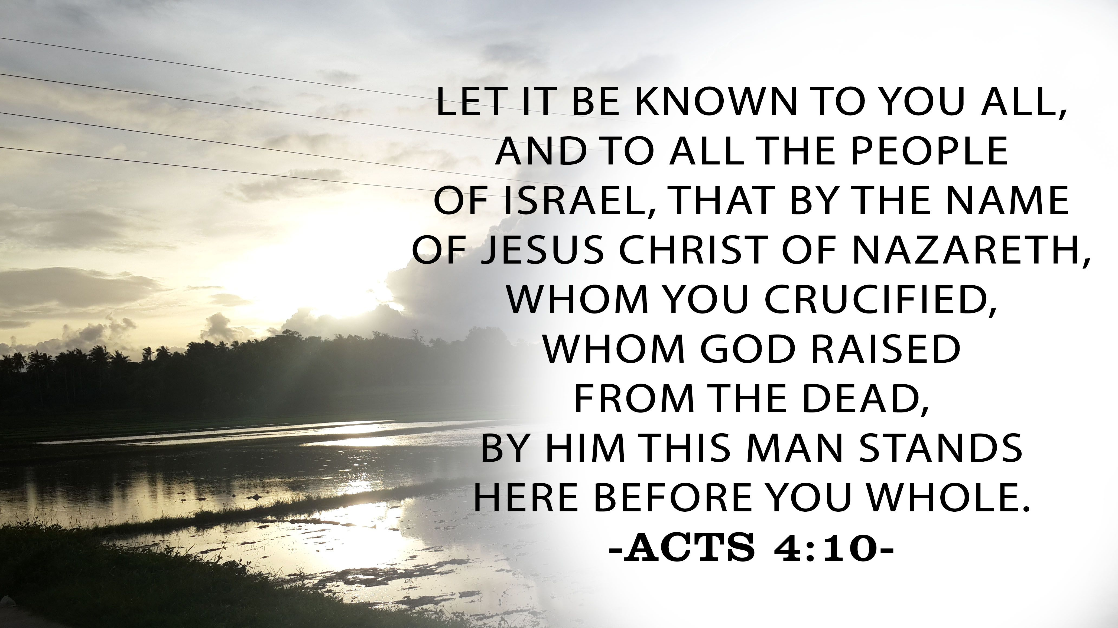
⁸ Then Peter, filled with the Holy Spirit, said to them: “Rulers and elders of the people! ⁹ If we are being called to account today for an act of kindness shown to a cripple and are asked how he was healed, ¹⁰ then know this, you and all the people of Israel: It is by the name of Jesus Christ of Nazareth, whom you crucified but whom God raised from the dead, that this man stands before you healed. ¹¹ He is “ ‘the stone you builders rejected, which has become the capstone.’
¹² Salvation is found in no one else, for there is no other name under heaven given to men by which we must be saved.”

Reflection: Today’s scripture picks up a story mid-stream. A lame beggar had asked Peter and John for money. They had none, but instead shared what they did have – faith in the name of Jesus. By Jesus’ name the man was miraculously healed, and he immediately shared his healing with the people all around the Temple. This caused quite a stir, and the people asked Peter and John about the miracle, giving the apostles a chance to proclaim the name of Jesus and the Gospel. This is what made the religious authorities angry enough to arrest the two apostles.
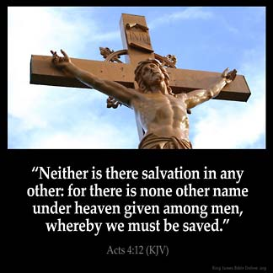
Most probably these authorities were the same religious leaders who had asked Jesus the same question they put to Peter and John, “By what authority are you doing these things?” (see Lk 20:2) Peter gave them the same answer as Jesus had given, and that further annoyed the authorities. But Peter did not stop at naming the name of Jesus. He called out the authorities’ connection with Jesus – they had crucified Him. He called out the evidence that these religious leaders had been wrong – Jesus was resurrected. The healing the crowd had just witnessed was evidence of the power of Jesus’ name. Peter drives home his point by referring to the same Psalm (118:2) that Jesus had given these same authorities when they had questioned him. In pushing their authority by confrontation, the religious leaders got more than they asked for – they got a condemnation and the proclamation of salvation. They, those charged with keeping the scriptures and shepherding the peoples’ relationship with God, had totally missed what the scriptures said, and worse, had missed the Messiah in their midst. Yet God had overcome the cruel death of Jesus, and his followers were now proclaiming Jesus’ name as the only avenue of salvation, not only for the Jews, but for all people under heaven.

Response: Out of a (likely routine) trip to the Temple to pray and as a result of responding to a need just as Jesus had taught them, the apostles found themselves in unexpected and adverse circumstances (being jailed overnight). But this gave them a direct audience with the religious authorities and a chance to proclaim Jesus’ name not only to the authorities but also to the crowds. Jesus told the apostles they would be brought before authorities and that the Holy Spirit would give them the words to say in such circumstances. I have no doubt that Peter’s ability to answer the rulers in the same manner and using the same scriptures as Jesus used, was inspired by the Holy Spirit. I hope that, when faced by difficult circumstances, I can be as open to the leading of the Spirit, and as quick to give credit to Jesus as Peter was. I know I cannot be that way without God’s power, help and leading.

Prayer: Dear God of all power, lead me by Your Spirit. When I find myself in adverse circumstances, lead me to call on Your name. Lead me to share that name with those who see my faith and have questions. Bring to my mind the scriptures that You desire me to speak to others so that Your Word may challenge them to carefully consider their relationship to You. Let me not overlook or shy away from an opportunity You have provided for me to give glory to Your name. It is in that precious Name of Jesus that I ask these things. Amen. - Janet Goodman

MARCH 10
“…but God shows his love for us in that while we were still sinners,
Christ died for us.”

Text: Romans 5:1-11
Therefore, since we have been justified through faith, we have peace with God through our Lord Jesus Christ, ² through whom we have gained access by faith into this grace in which we now stand. And we rejoice in the hope of the glory of God. ³ Not only so, but we also rejoice in our sufferings, because we know that suffering produces perseverance; ⁴ perseverance, character; and character, hope. ⁵ And hope does not disappoint us, because God has poured out his love into our hearts by the Holy Spirit, whom he has given us.
⁶ You see, at just the right time, when we were still powerless, Christ died for the ungodly. ⁷ Very rarely will anyone die for a righteous man, though for a good man someone might possibly dare to die. ⁸ But God demonstrates his own love for us in this: While we were still sinners, Christ died for us.
⁹ Since we have now been justified by his blood, how much more shall we be saved from God’s wrath through him! ¹⁰ For if, when we were God’s enemies, we were reconciled to him through the death of his Son, how much more, having been reconciled, shall we be saved through his life! ¹¹ Not only is this so, but we also rejoice in God through our Lord Jesus Christ, through whom we have now received reconciliation.
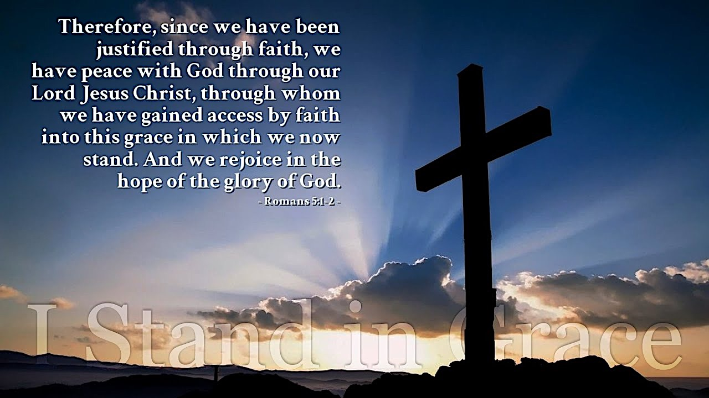
Reflection: It is hard to believe God would accept me into Heaven.
Such a belief comes with a solid foundation (I have not done anything I can boast about and claim I thus deserve this wonderful destiny. All I have is my faith.) Ah, but by God’s grace, and according to His Word, my faith is enough!
By our faith we are brought into the grace of Almighty God. We probably all could say we have a lot of room for improvement (…for all have sinned and fall short of the glory of God… – Romans 3:23). I am often reminded that I am not doing what I believe is God’s will for me. I also believe whenever I am not doing what God wants that is sin. This definition is broad, but it is also very specific since it is what God wants for each of us individually.
When we have not followed God’s plan for our lives there are often consequences that we must pay. Many would say they are suffering. It is hard to look on these events and rejoice, but we know this produces perseverance. As we press on through difficult events we, with God, are building our character. And our character produces hope. And hope does not disappoint.
I remember many years ago when I decided God was opening a way for me to go to nursing school. I sought out an advisor. She said I could petition to have my older credits accepted, but would probably only have 3 accepted. I told Jeanette, my wife, if I did not get all 6 God did not want me to be in the program. To my advisor’s shock all 6 were approved. Finishing this program was difficult. Many times, I felt I was suffering. I can now look back and say I made it through school, and so I am more well-equipped to say in present trials “I guess I can make it through this difficult time, too.” I am probably not qualified to say my character was changed by school, but many people who supported me emotionally through this rough time said I changed. If we accept that this experience changed my character, I am sure I have a hope that is real because I know God is the only way I made it through school. I was working part time, and my wife was working part time, and we had an 18-month-old son and a 6-month-old son. It definitely was the Holy Spirit who got me and us through so many hard times in those days.
I know I am a sinner, but Christ died for me when I did not deserve help… He stepped in and helped me. As the Bible says, someone might die for a good man, but Christ died for us while we were still sinners. This gives us great hope because Christ’s blood washes away our sin in God’s sight, sparing us from the wrath that our sin deserves.
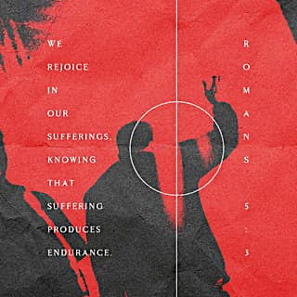
It is hard to believe God could accept someone like me into Heaven, but that is what the Bible says. Since the Bible is God’s word, we can rest assured God accepts us despite our struggles and failures.

Response: I am not sure what trials you have faced or yet will face, but I do know the trials I have been through are times when I see the biggest growth in me. I often pray, “God show me what I am going through this for.” For me, usually not at that moment, but soon I realize how this hard situation helps me to grow. I then see God’s hand in helping me grow.

Prayer: I would encourage anyone going through difficult times to know they produce perseverance. Perseverance produces character. Character produces hope. I do hope all experiences both difficult and easy help you to grow in your knowledge of God. May we all look for God in our difficult times
and remember to talk to Him (prayer). - Jim Prosser
MARCH 11
“For Christ also suffered once for sins, the righteous for the unrighteous,
that he might bring us to God, being put to death in the flesh but
made alive in the spirit…”

Text: 1 Peter 3:13-22
¹³ Who is going to harm you if you are eager to do good? ¹⁴ But even if you should suffer for what is right, you are blessed. “Do not fear what they fear; do not be frightened.” ¹⁵ But in your hearts set apart Christ as Lord. Always be prepared to give an answer to everyone who asks you to give the reason for the hope that you have. But do this with gentleness and respect, ¹⁶ keeping a clear conscience, so that those who speak maliciously against your good behavior in Christ may be ashamed of their slander. ¹⁷ It is better, if it is God’s will, to suffer for doing good than for doing evil. ¹⁸ For Christ died for sins once for all, the righteous for the unrighteous, to bring you to God. He was put to death in the body but made alive by the Spirit, ¹⁹ through whom also he went and preached to the spirits in prison ²⁰ who disobeyed long ago when God waited patiently in the days of Noah while the ark was being built. In it only a few people, eight in all, were saved through water, ²¹ and this water symbolizes baptism that now saves you also—not the removal of dirt from the body but the pledge of a good conscience toward God. It saves you by the resurrection of Jesus Christ, ²² who has gone into heaven and is at God’s right hand—with angels, authorities and powers in submission to him.

Reflection: Are you prepared to suffer for Christ? This is the note that I wrote in the margin of my Bible for this passage many years ago. It is a reminder to myself that while I’ve enjoyed a very blessed life, this blessing is temporary and could change at any moment. Suffering, slander, persecution, and death for Christ’s sake is not the most welcome topic when discussing the realities of Christian life. Christians in the United States have been overly blessed for a long period of time. Because of the state of wealth and prosperity in this country, I wonder if many of us would be prepared to suffer for Christ. We say the words, but if push comes to shove would we be ready? Would I be ready? It’s a thought that haunts my own conscience. Would I be ready to give up my creature comforts? Would I be ready to lose everything, my dignity, my possessions, my family, my life - for Christ sake?
The first-century Christians experienced extreme persecution. From a historical perspective Peter’s writing was before Christianity became the State religion of Rome, before Constantine. There is a small debate concerning when this letter was written. Some scholars believe it was written in the time of Nero, some scholars say during the time of Domitian. Either way, both of these Roman Emperors were known for their cruelty to Christians. In Eusebius’s Church History he writes that Christians were heavily persecuted by Domitian. Domitian brought “slanderous accusations against Christians.” Domitian is also credited with banishing the Apostle John to the island of Patmos where John received his visions recorded in the Book of Revelation.
Today, we in the United States often hear of the persecution Christians face in the Middle East, Egypt, China, India, and other places. While we hear about their suffering, it’s another thing to experience it. On August 13, 2013 an angry mob in Malawi ransacked, looted, and burned an evangelical church. On the same day in Cairo, Egypt a Franciscan school was torched and three nuns were paraded in the streets where they were assaulted. In China, crackdowns on Christian gatherings make it harder and harder for Christian to practice their faith communally. Bibles are banned in many countries with the punishment for owning one being severe. John Piper says of our modern Christian world that “Christianity was born in a world of totalitarianism… it was not strange to be persecuted. What is strange historically, is that we are not.”
Reflect on us today: we can generally gather freely without governments, principalities, or higher powers standing in our way. We can walk into any bookstore or Walmart and freely purchase a Bible without conflict. We can choose different types of Bibles with over 100 different English translations. If you can think of a type of Bible you want, you can probably get it. We have an embarrassment of riches. The time we’ve been given to learn and to have God’s word written on our hearts, has been a tremendous multigenerational blessing. Church history, however, and Peter warn us that this doesn’t last. We should expect and prepare ourselves for suffering and persecution.
So, what are we to do should the tides turn? Peter gives us a succinct but powerful set of instructions to prepare for the suffering for our faith and for Christ that may come…
- Do not fear… “But even if you should suffer for righteousness’ sake, you will be blessed. Have no fear of them, nor be troubled.” (v14) Jesus in the Sermon on the Mount says “Blessed are those who are persecuted because of righteousness, for theirs is the kingdom of heaven” (Matt. 5:10). Though times may seem tough, you have the assurance of God by your side.
- Put God at the center of your life… “…but in your hearts honor Christ the Lord as holy” (v15a). Having Christ in your heart helps you to know WHY and WHO you trust. In my marginal notes I wrote “who would I be more afraid of God or Man? Putting things into perspective in my life, if I claim to be a Christian, then Christ comes first, not myself.” The more I remind myself of that and align myself with God as my center, the more I can get my heart pointed in the right direction towards God. Then the more firmly I can stand in my faith when persecution comes.
- Prepare your defense in gentleness and respect… “Always being prepared to make a defense to anyone who asks you for a reason for the hope that is in you; yet do it with gentleness and respect” (v15b)
The Greek word used for “defense” in this passage is apologia. It is where we get the English word “apology.” This is a legal term which means to give a legal defense, not simply an I’m sorry. We should be ready to communicate what we believe and why we believe it to someone else. But we are to do so with gentleness and respect and not confrontationally. No one has ever convinced someone by making him an enemy. We must not confuse arguing with answering. We are to do so respectfully. We listen to those yet to believe. We show respect to them. We treat them kindly, much like Jesus did. He listened to those who would accuse him and gave a response (John 8:1-11; Luke 20:27-40). We are to be known by our love for one another (John 13:35).
- Demonstrate your faith… Having a good conscience, so that, when you are slandered, those who revile your good behavior in Christ may be put to shame. For it is better to suffer for doing good, if that should be God’s will, than for doing evil. (v16,17)
In my marginal notes I wrote “live your life so that the only way you can be slandered is for your accuser to lie.” One word to sum it up is to live with integrity. Keep your word. Seek and speak truth. Be gentle. Do good works. Be compassionate. Share. No backbiting. Practice what you preach. I know that I fail at all of this at times, try as I might; but I also know that good behavior is a reflection of how God wants his people to act. Don’t give people a reason to slander Christ and Christianity because of your behavior. Actions speak louder than words.
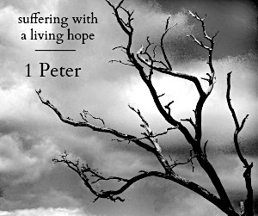
- Remember Christ and his sacrifice for you… For Christ also suffered once for sins, the righteous for the unrighteous, that he might bring us to God, being put to death in the flesh but made alive in the spirit. (v18)
In my marginal notes I wrote “How can we betray so great a salvation?” This is my question to myself, given all that may happen to us in the future, even in the face of death, how I can look upon the Word of God, both the physical book in my hand and the Logos, and not realize that though I may die in the flesh I will live in the spirit. Matthew 10:28 gives us wise instruction “And do not fear those who kill the body but cannot kill the soul. Rather fear him who can destroy both body and soul in hell.” Christ suffered for us. He died in the most humiliating, painful, and grotesque way. He did this so that He might bring us to God. When the time comes, how can I not choose to suffer for Him and for His glory?

Response: As I wrote earlier, it’s one thing to hear about suffering, it’s another to experience it. It’s easy to communicate the things that Peter says here. I can say the words. But will I be ready when the time comes to stand firm for my faith? I pray that I can and I will. One of the dangers we all face as Christians is an overconfidence in our faith. For most of us our faith has never been tested to an extreme. We’ve lived comfortably and take for granted this time we’ve been given. I pray that we all take time to reflect on this, to know that Christ suffered and died for us. We will and have been called to bear our cross, to suffer if necessary as Christ has. I pray that we ground ourselves now while we have the time and are not under great pressure. I pray that we also remember that death wasn’t the end. Jesus rose! “Kristos Anesti!” He burst the bars of death and triumphed o’er the grave! Hallelujah! May we remember that and pray for each other to stay ever faithful even in the face of persecution.

Prayer: Our Father and our God, during this season we remember the death, burial, and resurrection of Your Son, and we rejoice. Yet we too often fail to acknowledge the suffering and persecution Your Son endured to save us. You have chosen for Yourself a people. Your word tells us over and over again how those whom You choose will suffer for Your sake. Help us to build our faith and trust in You so when that time comes we can be steadfast, immovable, always abounding in Your work, knowing that our labor and suffering is not in vain. In Jesus name, Amen.
- Preston Yoshioka
MARCH 12
“But when Christ had offered for all time a single sacrifice
for sins, he sat down at the right hand of God…”

Text: Hebrews 10:1-25
¹ The law is only a shadow of the good things that are coming—not the realities themselves. For this reason it can never, by the same sacrifices repeated endlessly year after year, make perfect those who draw near to worship. ² If it could, would they not have stopped being offered? For the worshipers would have been cleansed once for all, and would no longer have felt guilty for their sins. ³ But those sacrifices are an annual reminder of sins, ⁴ because it is impossible for the blood of bulls and goats to take away sins.
⁵ Therefore, when Christ came into the world, he said: “Sacrifice and offering you did not desire, but a body you prepared for me; ⁶ with burnt offerings and sin offerings you were not pleased.
⁷ Then I said, ‘Here I am—it is written about me in the scroll—I have come to do your will, O God.’ ”
⁸ First he said, “Sacrifices and offerings, burnt offerings and sin offerings you did not desire, nor were you pleased with them” (although the law required them to be made). ⁹ Then he said, “Here I am, I have come to do your will.” He sets aside the first to establish the second. ¹⁰ And by that will, we have been made holy through the sacrifice of the body of Jesus Christ once for all.
¹¹ Day after day every priest stands and performs his religious duties; again and again he offers the same sacrifices, which can never take away sins. ¹² But when this priest had offered for all time one sacrifice for sins, he sat down at the right hand of God. ¹³ Since that time he waits for his enemies to be made his footstool, ¹⁴ because by one sacrifice he has made perfect forever those who are being made holy.
¹⁵ The Holy Spirit also testifies to us about this. First he says:
¹⁶ “This is the covenant I will make with them after that time, says the Lord. I will put my laws in their
hearts, and I will write them on their minds.”
¹⁷ Then he adds: “Their sins and lawless acts I will remember no more.”
¹⁸ And where these have been forgiven, there is no longer any sacrifice for sin.
¹⁹ Therefore, brothers, since we have confidence to enter the Most Holy Place by the blood of Jesus, ²⁰ by a new and living way opened for us through the curtain, that is, his body, ²¹ and since we have a great priest over the house of God, ²² let us draw near to God with a sincere heart in full assurance of faith, having our hearts sprinkled to cleanse us from a guilty conscience and having our bodies washed with pure water. ²³ Let us hold unswervingly to the hope we profess, for he who promised is faithful. ²⁴ And let us consider how we may spur one another on toward love and good deeds. ²⁵ Let us not give up meeting together, as some are in the habit of doing, but let us encourage one another—and all the more as you see the Day approaching.

Reflection: The letter to the Hebrews was probably written in the late first century, specifically directed to people of Jewish background who would have been fully acquainted with the ongoing practice of sacrifices and offerings carried out at Herod’s Temple in Jerusalem. Historically, the timing would have been during Roman occupation of Judea, but prior to 70 A.D.
The verses under consideration for today cover three subjects: 1. Contrast between the Old Covenant and the New, 2. Our confidence in God, and 3. Exhortations to believers.
The original covenant, made with Abraham and amplified by God’s promises made to Moses, was only a preview of a better covenant yet to be made known. The ongoing animal sacrifices were only a preview of the real thing. Bulls and goats are wonderful in their way, but no real substitute for a man: only a real man, the Man of God’s own choosing was qualified to be the unblemished (i.e., without the blemish of sin) sacrifice freely offered on my behalf. Only Jesus the Anointed One, empowered by His obedience to the will of the One who sent Him, was able to bring the Old Covenant to completion through the sacrifice of His own fully human body.
Therefore, with confidence in God’s intention to draw me to Himself, I can approach His throne in prayer. (As in 2 Peter 3:9, God “ . . . is not willing that any should perish, but that all should come to repentance.”) Fear and guilt are gone, put away as far as the east is from the west, and will not even be remembered by our God. Whereas under the Old Covenant, God said to Moses, “…no one may see Me and live.” (Exodus 33:20); under the New, we have the promise of entering God’s rest (Hebrews 4:11) and the promise “…they will see His face.” (Rev 22:4).
Energized and emboldened by the New Covenant in Christ’s blood, we are urged to draw near to God; urged to cling to the hope God calls us to; urged toward action in carrying out God’s will in the here and now; urged to keep on coming together (even if only by Zoom and YouTube) and urged to encourage each other by example.

Response: As for a response, I’m coming up short. What can I add to the completed work of Christ? Even while still nailed, He said, “It is finished.” What can I say? Sticking my oar in the water only makes waves.
But the idea of encouraging others reminds me of a long-ago rock-climbing experience.
The occasion was a practice climbing excursion with the Bruin Mountaineers of UCLA at a place called Tahquitz Rock near Mt. San Jacinto. The route, just one very short pitch, is called the “Orange Peel” because it consists of a bare expanse of rock, quite smooth except for very minor irregularities resembling the peel of an orange. The climb starts from a level bench of granite, but the first few moves are dauntingly steep, with the steepness diminishing only as one would climb higher. There are no footholds, no handholds, and no cracks where one might place a cam or a piton for aid; and it’s done without a belay. As a rank beginner, I was unsure of what I could or could not accomplish, and I pondered long whether I should even make the attempt.
It looked like I might acquire a lot of “road rash” if I got part way up only to skid off.
But as I saw others doing it, seemingly with ease, I was emboldened to give it my best shot and take my chances. And it turned out to be easier than it looked. All I had to do was stand up straight, keep my weight over my feet, keep my eyes on the horizon, and just go for it.
And here’s the point. Like living the Christian life? When others see you and me doing it, are they encouraged to give it a try? Are other Christ-followers encouraged to shape up and dig deep? Are some others, not yet acquainted with that person called Jesus, attracted to Him by our example? I hope so. Our God can bring blessing out of actions undertaken by you and me, even bringing a blessing out of Tahquitz Rock.

Prayer: Father God, Lord Jesus, thank You for listening in. Thank You for knowing my thoughts even before I think them. Thank You for snatching me up, as a brand from the burning, figuratively trailing wisps of smoke and continually astonished at my good fortune and Your great mercy that I did nothing to earn. Thank You for making blessings out of even the ugliness of our all-too-human situation.
Thank You for the covenant brought to completion and for Your promises of greater blessings yet to come. In the precious name of Jesus, Amen. – Dave MacDonald

MARCH 13
“I have been crucified with Christ. It is no longer I who live,
but Christ who lives in me.”
Text: Galatians 2:15-21
¹⁵ “We who are Jews by birth and not ‘Gentile sinners’ ¹⁶ know that a man is not justified by observing the law, but by faith in Jesus Christ. So we, too, have put our faith in Christ Jesus that we may be justified by faith in Christ and not by observing the law, because by observing the law no one will be justified.
¹⁷ “If, while we seek to be justified in Christ, it becomes evident that we ourselves are sinners, does that mean that Christ promotes sin? Absolutely not! ¹⁸ If I rebuild what I destroyed, I prove that I am a lawbreaker. ¹⁹ For through the law I died to the law so that I might live for God. ²⁰ I have been crucified with Christ and I no longer live, but Christ lives in me. The life I live in the body, I live by faith in the Son of God, who loved me and gave himself for me. ²¹ I do not set aside the grace of God, for if righteousness could be gained through the law, Christ died for nothing!”

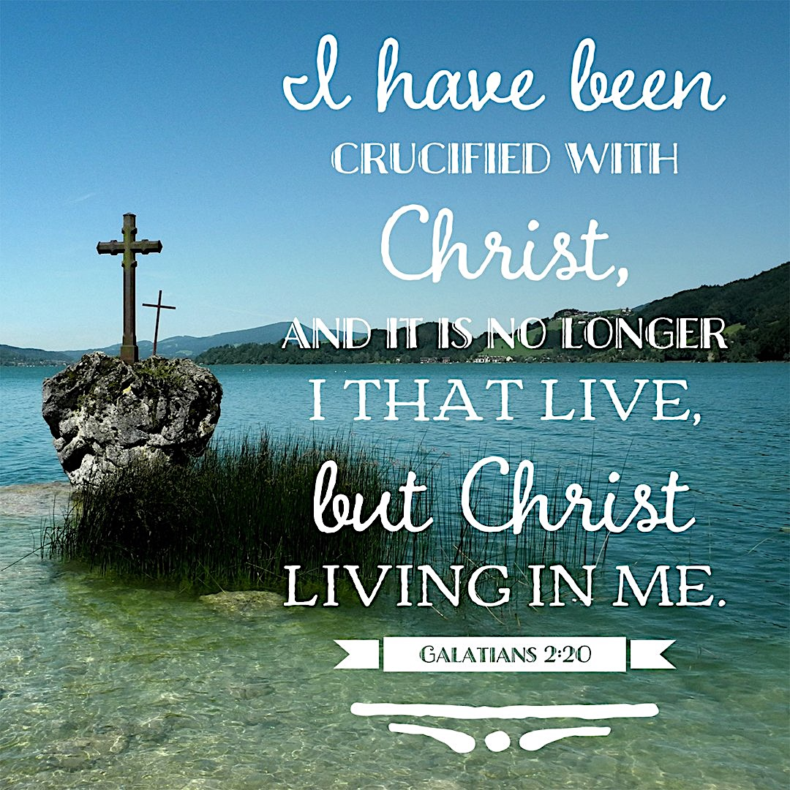
Reflection: Have you ever found yourself in a bad place where you never thought you would be? How did you get there? Odds are, it wasn’t overnight; typically we wander slowly toward things that entice us from a distance. Even if we have the foresight to recognize potential destruction from far off, we believe that we have the wherewithal not to be drawn too close. At this point, the trap has been laid; it’s only a matter of time before we justify our way to within striking distance.
What goes on in our minds that makes us think that we are invincible? Could it be pride that makes us believe that we can remain in control? Are we arrogant enough to believe that we can gratify our sinful desires instead of mortifying them? In contrast, we are called no longer to live according to the flesh; we are called, by the power of the Holy Spirit, to put to death the deeds of the body. Only then will we truly live.
It is for freedom we have been set free, and so we are enabled to shed the cumbersome, destructive, deadly yoke of sin. Each week when we come together as a church, we are reminded to hear and believe the good news that, because of what Christ has done, we are forgiven.

Response: It’s interesting that we need to be reminded so often that we are both no longer condemned but also that we are not saved by our own works. It is God alone who saves. There is nothing we can add to our salvation, and our vain attempts to do so simply add more sin for which we need God’s saving grace.
We must remind ourselves daily of the reality of our new life in Christ. Also, we should surround ourselves with people who can encourage us, and who we can encourage to live as though our old lives are gone and our new life is here now. This will help keep us at a healthy distance from temptation.

Prayer: Father, thank You for saving me. Help me to walk in Your light so that I do not stumble. Jesus, thank You that when You died on the cross, sin and death were defeated. Holy Spirit, thank You for being ever-present in my life. Give me the desire and Your power to mortify my sin and live free from the bondage of my old life.
- Ian Bullard

-----------------------------------------------

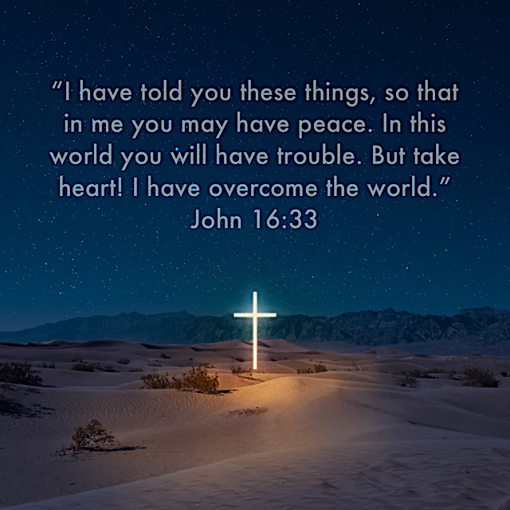
How can you live with the terrifying thought that the hurricane has become human, that the fire has become flesh, that life itself became life and walked in our midst? Christianity either means that, or it means nothing. It is either the most devastating disclosure of the deepest reality of the world, or it is a sham, a nonsense, a bit of deceitful playacting. Most of us, unable to cope with saying either of those things, condemn ourselves to live in the shallow world in between.
– N. T. Wright

PART THREE: NEW TESTAMENT NARRATIVE OF JESUS’ DEATH & RESURRECTION

MARCH 15
“Hosanna to the Son of David! Blessed is he
who comes in the name of the Lord!”

Text: Matthew 21:1-11
¹ As they approached Jerusalem and came to Bethphage on the Mount of Olives, Jesus sent two disciples, ² saying to them, “Go to the village ahead of you, and at once you will find a donkey tied there, with her colt by her. Untie them and bring them to me. ³ If anyone says anything to you, tell him that the Lord needs them, and he will send them right away.”
⁴ This took place to fulfill what was spoken through the prophet:
⁵ “Say to the Daughter of Zion,
‘See, your king comes to you, gentle and riding on a donkey,
on a colt, the foal of a donkey.’ ”
⁶ The disciples went and did as Jesus had instructed them. ⁷ They brought the donkey and the colt, placed their cloaks on them, and Jesus sat on them. ⁸ A very large crowd spread their cloaks on the road, while others cut branches from the trees and spread them on the road. ⁹ The crowds that went ahead of him and those that followed shouted,
“Hosanna to the Son of David!”
“Blessed is he who comes in the name of the Lord!”
“Hosanna in the highest!”
¹⁰ When Jesus entered Jerusalem, the whole city was stirred and asked, “Who is this?”
¹¹ The crowds answered, “This is Jesus, the prophet from Nazareth in Galilee.”

Reflection: Today’s passage marks the beginning of the final climactic week in the earthly ministry of Jesus Christ. Matthew devotes a fourth of his gospel to these days that were planned before the foundation of the world, and our salvation from sin and wrath depends on them and how we respond to the One they reveal.
More than his fellow gospel writers, Matthew emphasized “Christ as King” but in this passage we see He was a King like no other.
Let’s briefly look at the scene: Jesus is in Bethany, about 2 miles from Jerusalem. It is the time of the Passover feasts. The city is bursting with people (estimates based on a census from the time suggest 2.6 million people might have been present!). Jesus arranges to ride into the holy city in an unprecedented tableau suggesting a coronation.
Some have suggested the vast and enthusiastic crowds swept Jesus up into something that caught Him off guard. NO! He initiates every detail – just as He controlled every element of His own ministry with complete sovereignty and to fulfill both His Father’s will and the words of the prophets.
What a King we see presented to the Jews and to all the world! From our vantage point, post-Resurrection, we can hardly endure seeing our Lord of lords, the King of kings, the Creator and conqueror of the world, God’s one true Son before whom all will one day bow, riding on a lowly donkey’s colt to an appointment with piercing suffering and ultimate sacrifice. But that’s the gentle, humble king described by Zechariah and other prophets over 500 years before His birth. And so, King Jesus had a coronation like no other.
I think the heart of this passage—and its value in our own relationship as subjects of the King—lies in understanding the different and mostly-flawed perceptions of His kingship.
Oh, truly the people were filled with exuberant joy as they made a pathway for Jesus strewn with scraps of clothing and fresh-cut branches. They accompanied His progress by singing passages from the Psalms. Even those caught up in the ecstasy who knew little of this Jesus were crying out: Word had spread of His teachings, of miracles and of the authority He exuded. Most were convinced this Galilean was the long-awaited Messiah. Others seem to have tagged along, caught up in the festive atmosphere (v 10). But whatever motivated them, they collectively cried out to acknowledge and welcome this man on a donkey, this unusual King. “Blessed!” “Hosanna!” “Save!”
Despite the merry surface atmosphere, the scene has tragic undertones because most, focused on their own desires, missed the heart of Jesus.
The crowds very much wanted and expected a military Messiah. Sword in hand, he would rise up and overthrow Rome’s heavy occupation of their land. John McArthur (in a 1983 sermon entitled “The Humble Coronation of Christ”) said, “Listen! He did not come to make war with Rome on behalf of the Jews, but to make peace with God for man. You see, you have to take Jesus for who He is, not for who you want Him to be.”
THIS is what indicts those in the crowd (as well as you and me and humanity in general). Mankind is plagued and condemned by a self-centered worldview fed by sin and the preoccupation with superficial wants and wishes and skewed philosophies.
MacArthur again: “They wanted a Jesus of their own devising. They [we!] want a Jesus of their own invention. They want a Jesus who comes and says. “I’m going to solve all your problems. I’m going to deliver you from all your enemies. I’m going to make life wonderful for you.”
The coronation crowds were much more focused on how Jesus could break their earthly bondage (Rome was the current adversary). They weren’t looking for the Someone able to solve their brokenness, to heal their sin problem. Their desire for a Conquering King blinded them so thoroughly they could not see the gentle and suffering Servant King before them. So, their unsatisfied longings and growing disappointment with the Jesus they welcomed on Palm Sunday led only days later to angry cries of “Crucify Him!”
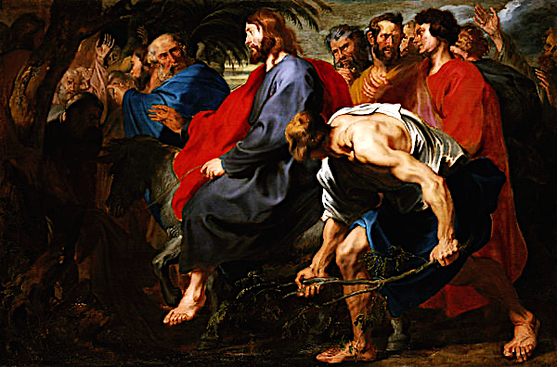
It is easy to condemn these people for their blindness and eventual rejection of the promised Messiah and true King. But John (12:16) tells us even the disciples who had walked closely with Jesus didn’t understand many aspects of God’s plan until later. “’Oh, now I understand why He got on that donkey’s colt. Now I understand why it had to be that day (when sacrificial lambs were being procured for the Passover feast). Oh, now it’s all clear why He came in humiliation’… But see, they didn’t even understand the cross till the Spirit of God revealed it to them. And if the disciples were confused, you can imagine how much more so were the rest of the crowd.” (MacArthur) And how much more so today’s lost ones who still need to hear about Jesus!

Response: Where are you today? Do you embrace the King? Or do you find yourself craving what James Boice called the ‘materialistic kingdom: health, wealth, happiness, here and now, give it to me – and fast”? He asks, “ Are you willing to face the reality of your sinfulness and emptiness and estrangement from God? Are you ready for Him to confront that in your life? So, how is it with you?”
Anthony van Dyck, Entry of Christ into Jerusalem, 1617
I hope you have trusted Jesus for salvation. The most important thing of all the things you count as important is to get straight with who Jesus is in your life. Is He your King? Do you know Him as God’s Son, the One who longs to lift you from darkness, to suffuse your life with light and truth, to save you? Do you believe He loves you with a love beyond your comprehension? He does… He came to rescue you. He came to give His life as a ransom. (See Mt 20:28)
If you do believe, do not let an authentic relationship with Jesus pass you by. “Even today many people call themselves Christians but have not pressed far enough in Jesus’ teachings to understand the real character of His lordship or His demands on their lives… It is the disciples who truly submit to Christ’s will – those who read His kingship in light of the cross –who will carry out His purposes in the world.” (IVP Commentary on the NT)
Recognize and affirm Him for the One He really is. Make time for Him - you will most reliably meet Him through frequent Bible reading, prayer and tenacious submission to HIS sovereign timing, plans, will and Person.
PS: Jesus entered Jerusalem as a Servant King riding on a lowly foal. But a second, more glorious, coronation awaits! Consider the scene in Revelation 5:5, 8-14 when John, Jesus’ beloved disciple and author of Revelation, wept convulsively because no one was found worthy to open the sealed scroll: “Then one of the elders said to me, “Do not weep! See, the Lion of the tribe of Judah, the Root of David, has triumphed. He is able to open the scroll and its seven seals…”
And when he had taken it, the four living creatures and the twenty-four elders fell down before the Lamb. Each one had a harp and they were holding golden bowls full of incense, which are the prayers of God’s people. And they sang a new song, saying: “You are worthy to take the scroll and to open its seals, because you were slain, and with your blood you purchased for God persons from every tribe and language and people and nation. You have made them to be a kingdom and priests to serve our God, and they will reign on the earth.”
Then I looked and heard the voice of many angels, numbering thousands upon thousands, and ten thousand times ten thousand. They encircled the throne and the living creatures and the elders. In a loud voice they were saying: “Worthy is the Lamb, who was slain, to receive power and wealth and wisdom and strength and honor and glory and praise!” Then I heard every creature in heaven and on earth and under the earth and on the sea, and all that is in them, saying: “To him who sits on the throne and to the Lamb be praise and honor and glory and power, for ever and ever!” The four living creatures said, “Amen,” and the elders fell down and worshiped.

Prayer: Holy and Eternal King Jesus! One moment we shout our love with joy and the next we doubt and demand, cajole and direct. We struggle to lay down our expectations, desires, requirements and fears. We want to believe all You bring into our lives is for our good and Your glory – but “self” too often gets in the way. Help us grow in the recognition of Your Kingship, to submit at the foot of Your cross, and then to rest in the knowledge we are loved citizens in Your eternal kingdom. For those friends and family members who still refuse even to pick up a palm branch, help us remember we once were there, languishing and lost. Stimulate us to persevere in sharing the good news of Your love and salvation with those both close and those “from every tribe and language and people and nation.” Amen! - Patti Hemsley

-----------------------------------------------------------------------------

Stricken, smitten, and afflicted, see him dying on the tree!
‘Tis the Christ by man rejected; yes, my soul, ‘tis he, ‘tis he!
‘Tis the long-expected Prophet, David’s son, yet David’s Lord;
By his Son, God now has spoken: ‘Tis the true and faithful Word.

Tell me, ye who hear him groaning, was there ever grief like his?
Friends thro’ fear his cause disowning, foes insulting his distress;
Many hands were raised to wound him, none would interpose to save;
But the deepest stroke that pierced him was the stroke that Justice gave.

Ye who think of sin but lightly nor suppose the evil great
Here may view its nature rightly, here its guilt may estimate.
Mark the sacrifice appointed, see who bears the awful load;
‘Tis the Word, the Lord’s Anointed, Son of Man and Son of God.

Here we have a firm foundation, here the refuge of the lost;
Christ’s the Rock. Of our salvation, his the name of which we boast.
Lamb of God, for sinners wounded, sacrifice to cancel guilt!
None shall ever be confounded who on him their hope have built.

- Hymn: “Stricken, Smitten and Afflicted” by Thomas Kelly (1804)

MARCH 16
“And Jesus entered the temple and drove out
all who sold and bought in the temple…”

Text: Matthew 21:12-17
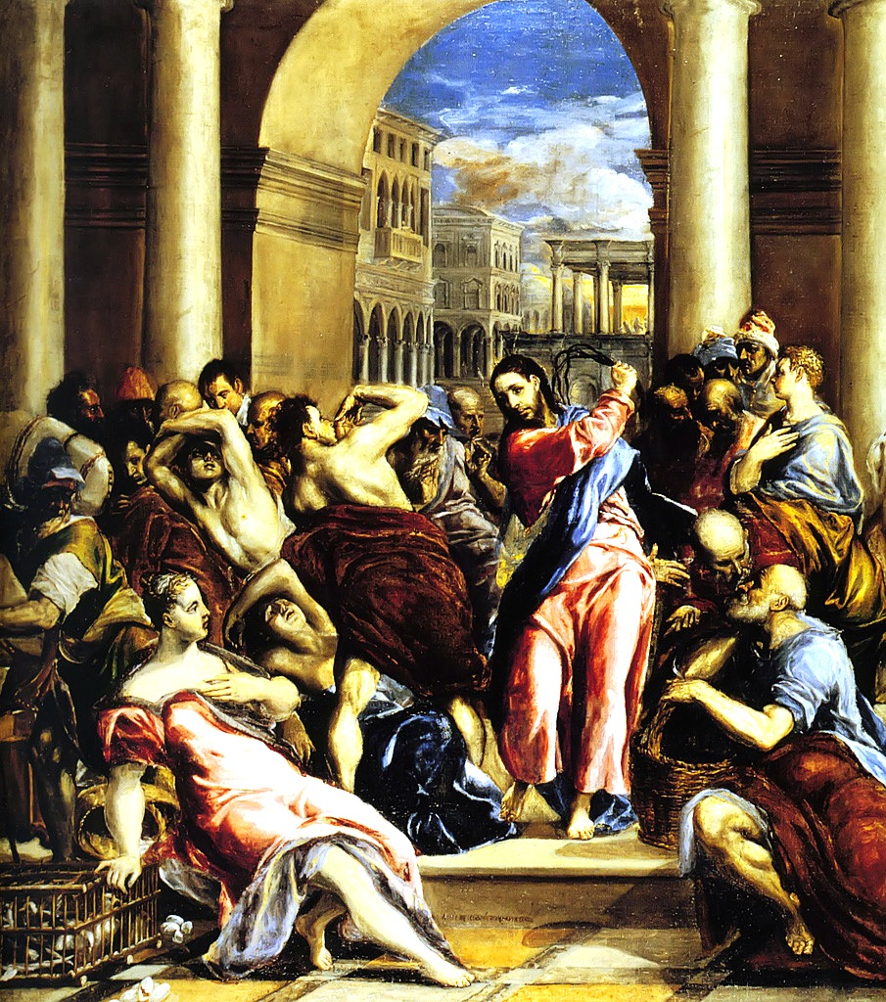
¹² Jesus entered the temple area and drove out all who were buying and selling there. He overturned the tables of the money changers and the benches of those selling doves. ¹³ “It is written,” he said to them, “ ‘My house will be called a house of prayer,’ but you are making it a ‘den of robbers.’”
¹⁴ The blind and the lame came to him at the temple, and he healed them. ¹⁵ But when the chief priests and the teachers of the law saw the wonderful things he did and the children shouting in the temple area, “Hosanna to the Son of David,” they were indignant.
¹⁶ “Do you hear what these children are saying?” they asked him.
“Yes,” replied Jesus, “have you never read,
“ ‘From the lips of children and infants you have ordained praise’?”
¹⁷ And he left them and went out of the city to Bethany, where he spent the night.

Reflection: The Temple, that unique building in Jerusalem built by human hands according to the instructions of Almighty God, served a good purpose for God and His people. It was a good place, but not good enough. It was a singularly holy place on earth where God took up residence in a special way among His covenant people. The story of Solomon building the original Temple, told in 1 Kings chapters 5-8, includes an amazing narrative of the physical manifestation of God coming into His house: …a cloud filled the house of the Lord, so that the priests could not stand to minister because of the cloud, for the glory of the Lord filled the house of the Lord (1 Kings 8:10-11). It was the place where heaven and earth came together, where God and His people would meet (But it wasn’t good enough to keep them together). It was the special place where God’s people could offer their best ritual sacrifices to God to make things right again between them (But things here were never made right enough. The Temple was simply not good enough to accomplish this.). It was The holy place where the holiness of God was made manifest for His people (But it also showed, over and over, that “holy” was not a description that fit them at all). And so, it was, in the end, a place of covenant hope rather than fulfillment that pointed with divine power to Something or Someone else beyond itself.
El Greco, Jesus Purifies
the Temple, c. 1570
After, and in response to, centuries of covenant violations, faithlessness and disobedience, the presence of God left the Jerusalem Temple. The prophet Ezekiel articulated this devastating reality in a prophetic vision found in Ezekiel chapter 10. Next the Babylonians destroyed the Temple building and took God’s people into exile. Later, under Persian rule, the Jews were able to return and rebuild their Temple, but there is no description in this Period of Restoration under Ezra, Nehemiah and others of God the Lord returning and taking up residence once again in the new building.
When did God again enter His Temple?... Matthew 21:12ff! Jesus entered the temple area and drove out all who were buying and selling there. He overturned the tables of the money changers and the benches of those selling doves. “It is written,” he said to them, “‘My house will be called a house of prayer,’ but you are making it a ‘den of robbers.’”
We tend to look upon this text mostly as an enacted word of judgment against the religious leaders of Jesus’ day, and so it is, but in light of the whole history of God’s Temple it goes much deeper and strikes a wondrously redemptive vein of truth.
“Hosanna to the Son of David!” The children announce Jesus as the Messiah right there in the Temple. The priests and scribes are livid, but those little ones are on to something huge. Jesus says they are simply fulfilling the words of Psalm 8 which also tells us such praise from children’s lips is ordained by God because of His enemies (in this case the priests and scribes!).
Yes, people had irretrievably corrupted the very place set up by God for their redemptive activity with Him. They had made God’s holy place their own self-serving “den of robbers.” And then Jesus entered.
Jesus, that one-and-only person born in Bethlehem through the miracle partnership between God and humanity in the person of the Virgin Mary, had a good purpose, a mission to fulfill for His Heavenly Father and for His people. And He was good enough. He was a singularly holy person who was in fact God Himself taking up residence in human flesh and living among His people. God and humanity met once-and-for-all in Him. He was good enough for this. He would now be the place, the Person, where God and His people would meet from now on. He was good enough for this. In Him, by Him, the full and final sacrifice would be made and the holiness of God would manifest itself in a full and final way overpowering by sheer grace the unholiness of humanity. Jesus was good enough to get this done. He was the fulfillment of the Old Covenant and the inaugurator of the New Covenant in His blood. He was the realization of His people’s deepest hopes. He was the Someone toward which the old Temple was always pointing.
When Jesus walked into the Jerusalem Temple on that fateful day sometime around 33 AD, He was not merely there to point out the ugly corruption. He was announcing something far more disturbing to those who loved their religion and were somewhat less passionate about God Himself: Your Temple-centered beliefs and practices are over. Their purpose is now fulfilled. The building is no longer necessary (You will lament inconsolably its destruction by the Romans in 70 AD, but your tears will be for an obsolete edifice.) And He was enacting, by divine authority, something far more beautiful to those truly seeking to know, to love, to serve God Himself: I Am He. And I myself am now for you everything you sought, but never quite found, in this place. I take the place, as its ultimate fulfillment, of this Temple.
Jesus believed that Israel’s God was in the process of judging and redeeming his people, not just as one such incident among many but as the climax of Israel’s history. This judgment would take the form of destruction by Rome. It would not be followed by the rebuilding of a new physical Temple. It would be followed by the establishment of the messianic community focused on Jesus himself, a strange new entity that would replace the Temple once and for all… No longer would the Temple in Jerusalem be the place where heaven and earth met. From now on, heaven and earth would meet in and through the person of the “one like a son of man”, who after his suffering would be vindicated, and would be seen “coming with the clouds of heaven” to be enthroned beside the “Ancient of Days.” . – N. T. Wright & Michael Bird, The New Testament in Its World, p.211, 213

Response: Read this additional quote from Wright & Bird, and consider how we today may tend sometimes to think of ourselves and our churches as more important than Jesus or to see Him as an annoyance to the things we would like to see and do in our churches. Where do you see such tendencies in your own church? How can you help turn things in a more faithful and Christ-honoring direction?
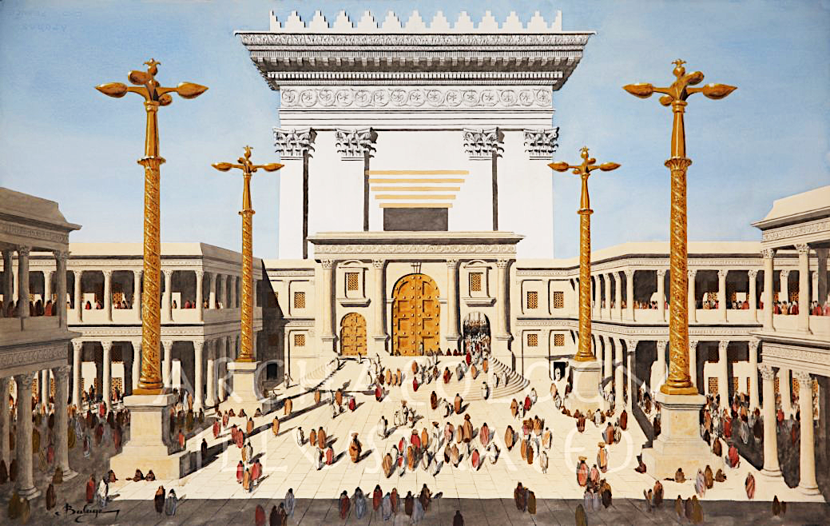
The destruction of the Temple would mean God’s judgment upon it; it would also be the vindication of Jesus as the prophet who exposed the futility of its function and the corruption of its leadership. Jesus spoke and acted like one who believed that he could replace the Temple because he himself was greater than it. No surprise, then, that Jesus’ action in the Temple was the event that turned the members of the Jerusalem aristocracy resolutely against him, and turned their wishes for his death into a calculated effort to orchestrate it (p.213).

Prayer: Lord Jesus, help me to seek God by seeking You, to know God by knowing You, to find the security and significance I long for in the security and significance You knew here on earth in Your eternal love relationship with God as His Eternal Son and in Your completed work through which I am enabled and invited to enter into that very relationship. May all that my church offers—all the religious places I cherish, duties I value and activities I enjoy—bring You honor, lead me closer to You and never trespass into the center of things where only You belong. In Your name and for Your sake I pray. Amen. - Jay Hull
The Jerusalem Temple in Jesus’ Day
MARCH 17
“She has done what she could; she has
anointed my body beforehand for burial.”

Text: Mark 14:1-11
¹Now the Passover and the Feast of Unleavened Bread were only two days away, and the chief priests and the teachers of the law were looking for some sly way to arrest Jesus and kill him. ² “But not during the Feast,” they said, “or the people may riot.”
³ While he was in Bethany, reclining at the table in the home of a man known as Simon the Leper, a woman came with an alabaster jar of very expensive perfume, made of pure nard. She broke the jar and poured the perfume on his head.
⁴ Some of those present were saying indignantly to one another, “Why this waste of perfume? ⁵ It could have been sold for more than a year’s wages and the money given to the poor.” And they rebuked her harshly.
⁶ “Leave her alone,” said Jesus. “Why are you bothering her? She has done a beautiful thing to me. ⁷ The poor you will always have with you, and you can help them any time you want. But you will not always have me. ⁸ She did what she could. She poured perfume on my body beforehand to prepare for my burial. ⁹ I tell you the truth, wherever the gospel is preached throughout the world, what she has done will also be told, in memory of her.”
¹⁰ Then Judas Iscariot, one of the Twelve, went to the chief priests to betray Jesus to them. ¹¹ They were delighted to hear this and promised to give him money. So he watched for an opportunity to hand him over.

Reflection: Matthew 26:6-13, John 12: 1-11 and Mark 14: 1-11 all chronicle strikingly similar events which differ slightly in detail but are noted to be the same event according to the ESV Study Bible. A woman anoints Jesus’s head with expensive nard in an alabaster flask: the value of which is one year’s wages. In all three accounts the seal on the bottle had been broken which indicated that the entire bottle would be used (as it could not be resealed). People who were present (including Judas) became indignant about the display of waste stating that the money from that bottle of oil could be used to help the poor. The woman is admonished. Jesus speaks up offering a cease and desist order to the naysayers. “Leave her alone.” “Why are you bothering her?” “She has done a beautiful thing to me.” He goes on to say that she is preparing him for his burial. Of course, this act is one of intimacy, devotion and beauty within a context of the plot to have Jesus arrested and executed. This woman’s act is lavish, intentional, heartfelt, full of faith as well as being significant in its foreshadowing of His death.
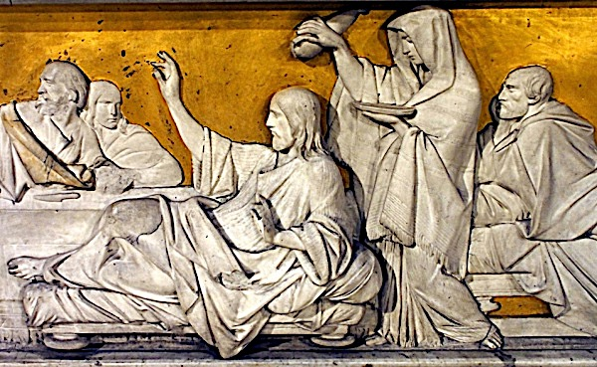
“She has done a beautiful thing.” It is good to show our adoration and praise to the Lord. He is worthy and takes pleasure in our praise. Luke 10: 38-42 offers another example where attention and time with Jesus is acknowledged. In Bethany, Mary chooses to sit at Jesus’s feet while Martha is frantically running around the house in preparation for a feast. Martha even looks to Jesus to side with her and tell Mary to get up and help her. But Jesus affirms Mary’s choice as the better option. There is a time when, in our best of intentions, we don’t know best. There is a time to set aside the pressing matters for what really matters: time at Jesus’s feet, or showering Him with the finest “oil” we can offer. His directive: Spend time with Me, it matters.

Response: What beautiful thing can you do for Jesus? He isn’t here physically to anoint with nard, but how about a dedicated time each day set aside just for Him? A time to praise Him, sit quietly and “be” in His presence. Reserve your first and best time and make Him a priority in all things.

Prayer: Lord, time with You is precious. In addition to being a blessing for me, it also is beautiful in Your eyes. What an epiphany! Thank You for revealing more and more to me each time I read Your Word. Help me to be disciplined and committed to prioritizing what really matters. Amen. - Jennifer Oliver
MARCH 18
“And he said to them, ‘This is my blood of the covenant,
which is poured out for many.’”

Text: Mark 14:12-26
¹² On the first day of the Feast of Unleavened Bread, when it was customary to sacrifice the Passover lamb, Jesus’ disciples asked him, “Where do you want us to go and make preparations for you to eat the Passover?”
¹³ So he sent two of his disciples, telling them, “Go into the city, and a man carrying a jar of water will meet you. Follow him. ¹⁴ Say to the owner of the house he enters, ‘The Teacher asks: Where is my guest room, where I may eat the Passover with my disciples?’ ¹⁵ He will show you a large upper room, furnished and ready. Make preparations for us there.”
¹⁶ The disciples left, went into the city and found things just as Jesus had told them. So they prepared the Passover.
¹⁷ When evening came, Jesus arrived with the Twelve. ¹⁸ While they were reclining at the table eating, he said, “I tell you the truth, one of you will betray me—one who is eating with me.”
¹⁹ They were saddened, and one by one they said to him, “Surely not I?”
²⁰ “It is one of the Twelve,” he replied, “one who dips bread into the bowl with me. ²¹ The Son of Man will go just as it is written about him. But woe to that man who betrays the Son of Man! It would be better for him if he had not been born.”
²² While they were eating, Jesus took bread, gave thanks and broke it, and gave it to his disciples, saying, “Take it; this is my body.”
²³ Then he took the cup, gave thanks and offered it to them, and they all drank from it.
²⁴ “This is my blood of the covenant, which is poured out for many,” he said to them. ²⁵ “I tell you the truth, I will not drink again of the fruit of the vine until that day when I drink it anew in the kingdom of God.”
²⁶ When they had sung a hymn, they went out to the Mount of Olives.
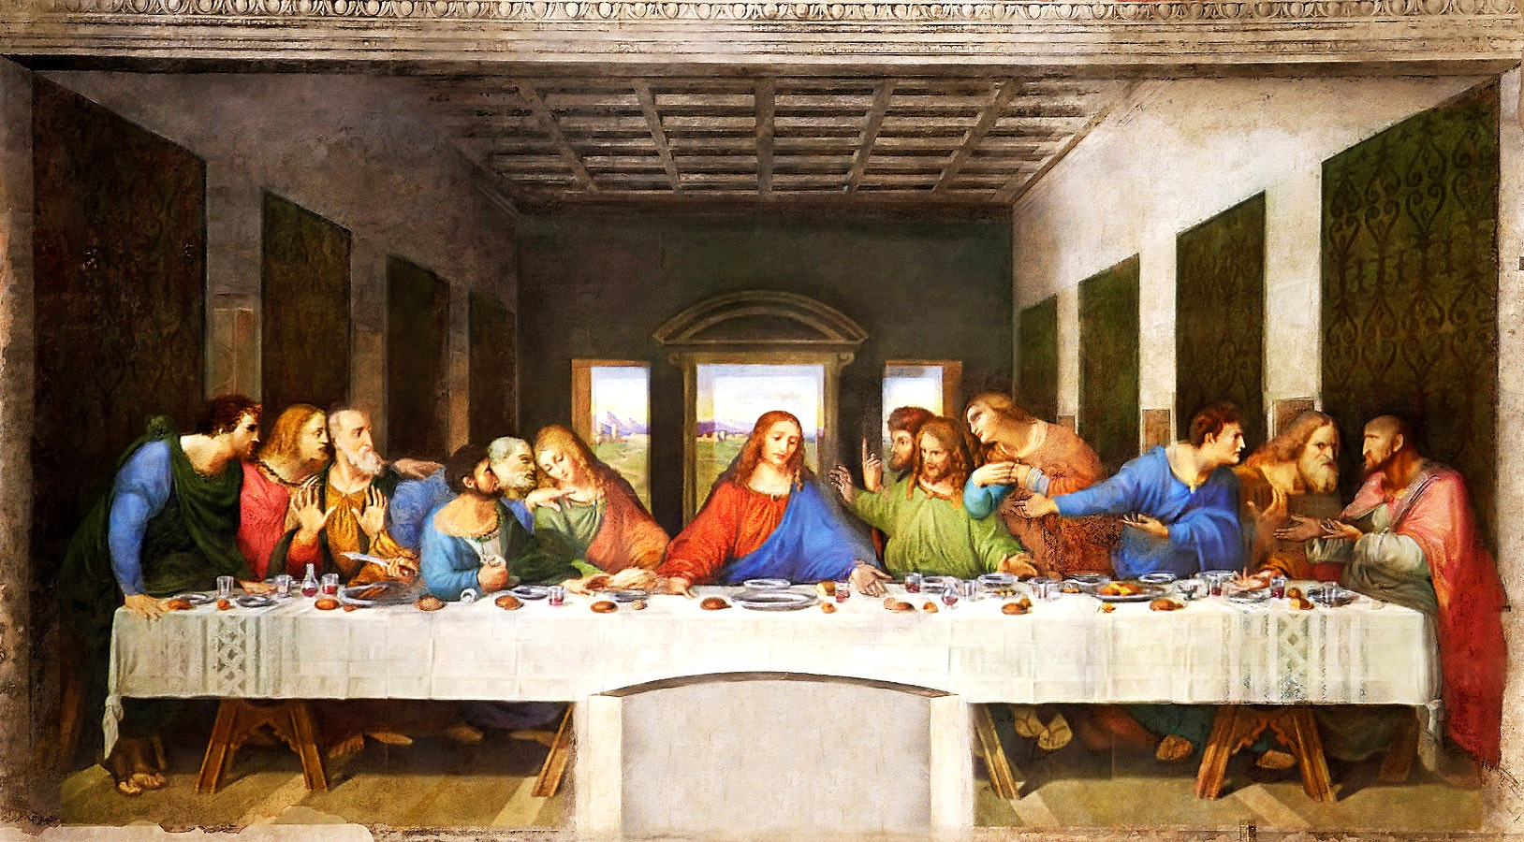
Reflection: One of the joys/frustrations of reading Scripture is that “getting it”, although a worthy and much sought after desire, will always remain an unattainable goal – in God’s economy. I would venture to say that almost every Bible “reader” has, time and time again, been awakened to a new thought, insight, or question as he/she has read a verse for the umpteenth time. When you think about it, should we expect anything less out of a Book authored by God?
In the world of sports, athletes are encouraged always to remain “hungry”: stronger/faster/better prepared. Sports, by definition, always has an opponent – and he is trying to be stronger, faster, and better prepared than you! As readers of Scripture, should we be “hungry”? If “hungry” were to describe your pursuit of Christ and His righteousness – what would that mean?
Leonardo da Vinci, The Last Supper, 1495
In the fast-paced world we live in, there’s much we don’t notice; it’s happening too fast… We can’t possibly notice everything… There’s too much competition for our time… Some things are hidden, some things are hiding! How does one make decisions in these circumstances? Will a “hungry” pursuit of Christ help?
I am using the concept of being “hungry”, or driven, because the word which jumped out to me in this passage (this time), was “prepare”. The Disciples were asked to go into town and “make preparations to eat the Passover.” Any other year this would have been a rather routine assignment, having done it many times before, but there was something “different” this year….wasn’t there? They couldn’t possibly have known what was about to take place….could they? If they had “prepared” themselves more thoroughly, would they have been better “prepared” to understand and participate in what was happening? Come on, He’d been telling them what was going to happen, hadn’t He? Well yeah, but…….
Now jump ahead 1,992+ years and think about how many “Communions” you have participated in – quite a few, huh!? How would you describe your “normal” reaction upon walking into the Sanctuary and seeing the Communion Elements presented on the Communion Table: “Oh, looks like we’re having Communion today.” Or, would a smile come across your face as you think about the “preparation” you’ve done the last few days? (Confession: I typically fall into the first category)

Response: So, what does/should “preparation” for Communion look like? What would be the goal – something for my head or my heart? How could I make it meaningful vs. something to just check off on my List? Are you willing to maximize your Communion “meeting” with God?... to prepare. I would love to hear your thoughts about this!

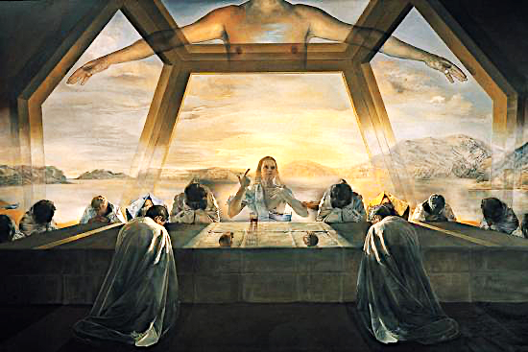
Prayer: Our Father, Holy Communion – It is one more thing which differentiates us from all the other religions of the world. Help us to grasp how important we are to You; how the death and resurrection of Your Son fits into Your perfect Plan of creation, redemption, and salvation. Use Your Holy Spirit to help us prepare for each day and those to come. Thank You for Your willingness to prepare us to receive the righteousness of Your Son.
In the name of the Holy Trinity – Father, Son, and Holy Spirit we pray. Amen. – Dan Carne

Salvador Dali, The Last Supper, 1955

MARCH 19
“Father, if you are willing, remove this cup from me.
Nevertheless, not my will, but yours, be done.”

Text: Luke 22:39-46
³⁹ Jesus went out as usual to the Mount of Olives, and his disciples followed him. ⁴⁰ On reaching the place, he said to them, “Pray that you will not fall into temptation.” ⁴¹ He withdrew about a stone’s throw beyond them, knelt down and prayed, ⁴² “Father, if you are willing, take this cup from me; yet not my will, but yours be done.” ⁴³ An angel from heaven appeared to him and strengthened him. ⁴⁴ And being in anguish, he prayed more earnestly, and his sweat was like drops of blood falling to the ground.
⁴⁵ When he rose from prayer and went back to the disciples, he found them asleep, exhausted from sorrow. ⁴⁶ “Why are you sleeping?” he asked them. “Get up and pray so that you will not fall into temptation.”

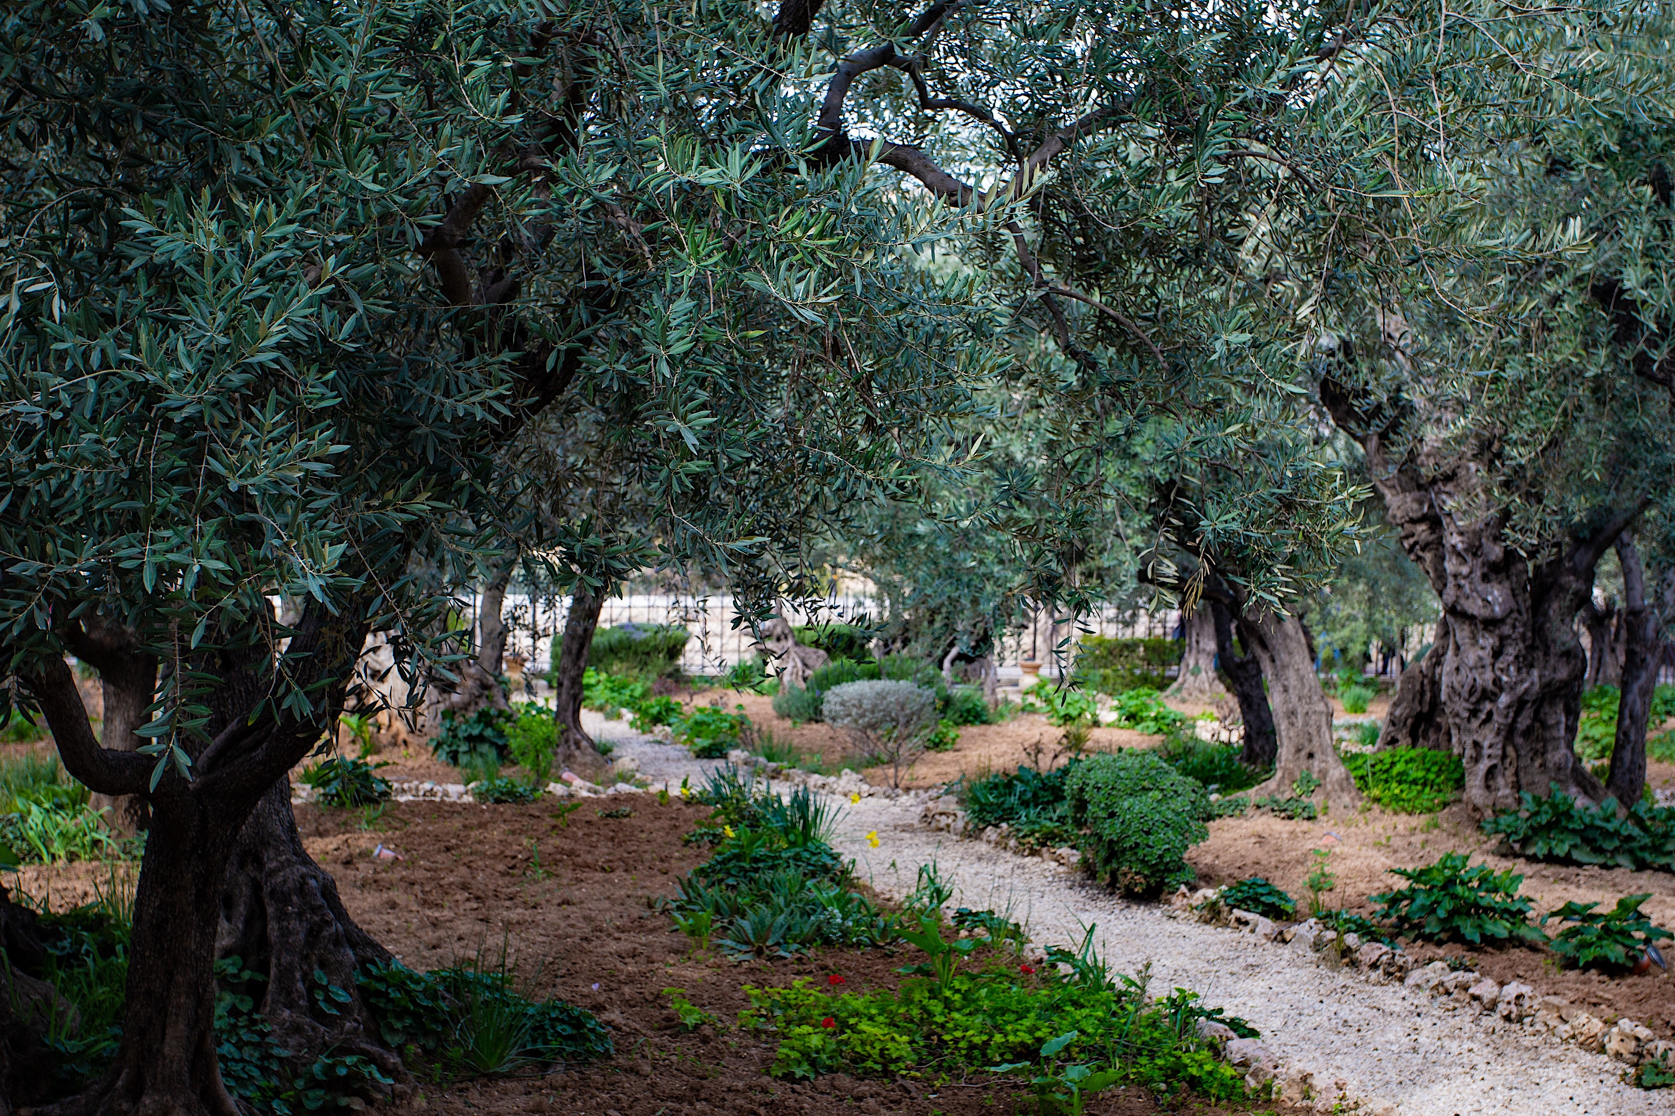
Reflection: The Garden of Gethsemane at the base of the Mount of Olives plays an important role in the ministry of Jesus in Jerusalem. It was a familiar place for his disciples as well. In a recent visit there, I was moved by the realization that I was sitting and praying in the exact place where the essence of Jesus was most deeply revealed and where the sacrifice that God made for us in Him was set into motion. It was there that the mystery of the humanity and divinity of Jesus was powerfully and dramatically demonstrated. It is no surprise that the clearest expression of his nature and his call occurred in the context of prayer with his Father. This short passage set in the Garden is the most poignant example of what the Apostle Paul describes in his familiar hymn in Philippians 2 of Jesus – “being in very nature God… he made himself nothing… being made in human likeness… he humbled himself by becoming obedient to death…”
In this passage Jesus twice encourages the disciples to “pray that you will not fall into temptation” – at the beginning and at the end. I wonder why that is in the forefront of his mind and heart? Jesus had recently prayed against Satan that Simon’s “faith may not fail.” So, his worry about temptation is undoubtedly an important concern that he has for them. I suspect he has the same concern for us as well, knowing that Satan will take advantage of events in our lives to divert our focus away from Jesus and undermine our faith.
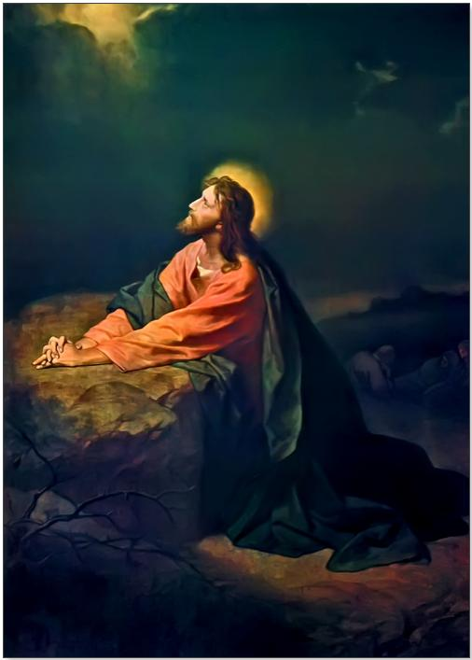
No other passage in the Gospels so aptly demonstrates the humanity of Jesus. Even after predicting the events to come, including his death, he longs to avoid such agony. Jesus prays intensely for strength to do the Father’s will - so deeply that “his sweat was like drops of blood.” And in no other passage do we see a better example of the humility of Jesus. He understands the Father’s sovereignty in saying “If you are willing…” Though Jesus participated in the authorship of creation, he forgoes his authority and submits to the Father’s will and redemptive purpose - “yet not my will, but yours be done.”
The Garden of Gethsemane Today

Response: So how do we respond to such a powerful example of humility and obedience?
- Keep our eyes on Jesus… God does not promise that we will not face any trials. The call to discipleship entails keeping our eyes on Jesus in those trials and trusting that he will lead us.
- Rely on the power and promises of God… Submitting to God’s divine will is a struggle, given the strong competing claims that we face from our human will. Even Jesus struggled between his humanity and his divinity as he faced the ultimate trial, but we can access the power and promise of God to give us hope and strength.
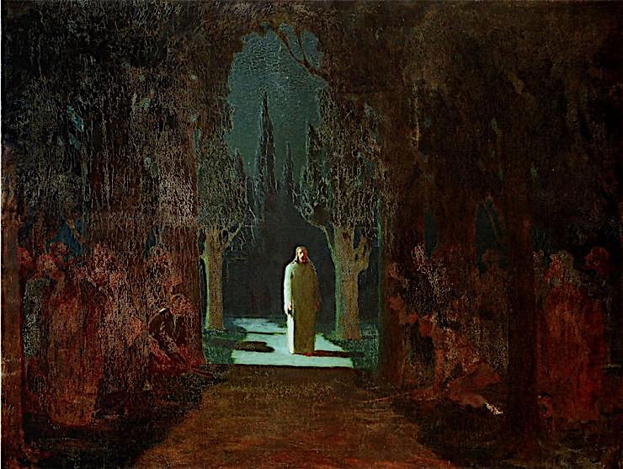
- Maintain an attitude of humility, gratitude and worship… We can have confidence that the sacrifice of Jesus was real. The suffering and anguish experienced in the whole triune Godhead is something we cannot imagine, but it was done for us. If we can grasp the reality of that, we can do nothing but respond with gratefulness and worship.
Heinrich Hofmann, Christ in Gethsemane, 1870

Prayer: Sovereign God, we do not claim to understand why we experience the challenges of life, but we do claim Your promise not to leave us or forsake us. Give us the courage and fortitude to endure trials, knowing that You will work them for our good. Protect us from the lure of the evil one and from our self-centered nature. Give us hearts of gratitude for Your ultimate act of humility and sacrifice. Help us to get a glimpse of Your purpose for us and to experience the peace of knowing that we are held at all times in Your strong and loving arms. We praise You, our Rock and our Redeemer.
- Mark Eshoff, Stated Clerk for the EPC
Presbytery of the Pacific Southwest
Arkhip Kuinji, Christ in the Garden, 1901
MARCH 20
“Judas, would you betray the Son of Man with a kiss?”

Text: Luke 22:47-53
⁴⁷ While he was still speaking a crowd came up, and the man who was called Judas, one of the Twelve, was leading them. He approached Jesus to kiss him, ⁴⁸ but Jesus asked him, “Judas, are you betraying the Son of Man with a kiss?”
⁴⁹ When Jesus’ followers saw what was going to happen, they said, “Lord, should we strike with our swords?” ⁵⁰ And one of them struck the servant of the high priest, cutting off his right ear.
⁵¹ But Jesus answered, “No more of this!” And he touched the man’s ear and healed him.
⁵² Then Jesus said to the chief priests, the officers of the temple guard, and the elders, who had come for him, “Am I leading a rebellion, that you have come with swords and clubs? ⁵³ Every day I was with you in the temple courts, and you did not lay a hand on me. But this is your hour—when darkness reigns.”

Reflection: There, but for the Grace of God, go I...
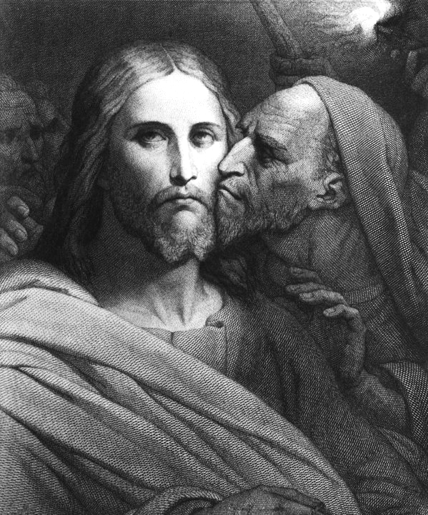
Forgive me, but I don't look forward to preparing these devotionals, because God's Word is a two-edged sword, which cuts me to pieces every time I try to impart the truth of it to others. It is hard enough for me to read, study, understand, even memorize God's Holy Word without being convicted, but it is quite another thing for me to share it with others without being fully convicted and aware that I do not strive for personal holiness the way I should. Don't misunderstand, I know salvation is God's work and I contribute nothing to it. However, the Bible reminds me that the truly regenerate respond with a desire to live a holy life out of love for God, moving forward in sanctification, not just marking time. This process of sanctification is a proof of God's saving work in them, and I see in myself failure more often than I see His victory in me. I want to live in His sanctification daily. That being said, today Luke 22:47-53 is before us.
While in the garden, our Savior is encouraging eleven of His disciples to pray and not be tempted, while the Tempter himself has the twelfth, who is Judas, leading a crowd to arrest Jesus. The sign of the One to arrest, as we all know is a kiss, which we agree is an interesting choice for a sign of betrayal. The most common way a husband and wife express affection is to draw close in an embrace and a kiss. The most common word in the New Testament for 'worship' is literally translated, “towards to kiss.” Judas came towards Jesus and kissed Him. False worship if you will. As tears well up in my eyes while typing this I think, “How many times have I offered false worship to my God and Savior?” More than I care to enumerate. Got to look pious to the crowd around you, right? Don't want to look like a betrayer... Just more proof I need a savior, and since He has saved me, I must remind myself to search out and follow the prompting of the Holy Spirit by honoring Him more and more in striving for personal holiness. How about you? Lets move on...
Ary Scheffer, Kiss of Judas, 1869
The disciples queue for battle to protect Rabbi Jesus. John's gospel (chapter 18, verse 10) tells us it was Peter who struck the High Priest's servant with a sword and severed his ear. Again, my eyes well up, as I see myself in Peter, trying rashly to solve the problem my way rather than waiting for My Savior's perfect solution! If I'm not betraying Him with false worship, I'm overreacting to the point of thinking or doing ill to others and ignoring the log in my own eye. Jesus stops the disciples and in perfect compassion heals the High Priest's servant. Then He addresses the mob... In John chapter 2, verse 4, Jesus says to His mother, “...My hour has not yet come.” This response of our Savior comes up in the gospels when presumptuous humans press Him to reveal Himself fully before His ordained time. In Luke 22:53, Jesus freely admits that now is the hour of evil and darkness. Jesus knows His 'hour' has now also come at the hands of this evil darkness, and He will obey the will of the Father and go into the valley of the shadow of death...
I imagine everyone is ready for COVID-19 to be over so we can get back to 'normal.' Unfortunately, a large part of this so-called normal is the sin, the very evil darkness, that continues to overtake the whole world, while self-righteous, self-proclaimed 'good' people reach out to embrace, even worship that very sin and call it good and normal. The “power of darkness” is stronger than ever in this world today and all those who are saved by grace, abiding in Christ's perfect love, wait, praying for, even begging for, His final victory to come quickly. It is important that we not just mark time. That is to march in place, accomplishing nothing. We are God's. He is our Savior, and our 'normal' is living for Him in a broken world no matter what, being an active testimony to His saving grace. Our desire should be for Christ and by the power of the Holy Spirit, furthering His Kingdom. I'm reminded of this old spiritual song:
“This world is not my home, I'm just' a passin' thru. My treasures are laid up, somewhere beyond the blue.
The angels beckon me from heaven's open door, and I can't feel at home in this world any more.
Oh Lord, you know I have no friend like you, If heaven's not my home, then Lord what will I do.
The angels beckon me from heaven's open door, and I can't feel at home in this world any more.”
- Mary Reeves Davis

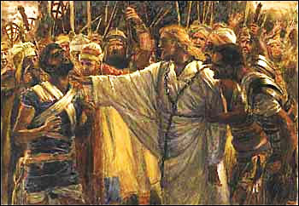
Response: As the redeemed of Jesus how do we understand, why we are here? What is our primary purpose and responsibility? What is true worship? Where is our Home? What is His absolute reality? What is truly normal? What is personal holiness? What do we take joy in? What, or rather WHO, is truly good?... The list can go on and on, and any one of our Covenant youngsters can answer correctly with, “Jesus!” We are to be all about Jesus and His glory, shining His good news to the broken around us. Do we live in personal holiness constantly seeking to be like the One who saves us, not because we have to, but because we want to? Let us immerse ourselves in God's Holy Word to find His answers to the way He desires us to live, and live it! When I compose my devotionals, like this one, I try to be as honest as possible with myself and you (and it cuts deep). To do otherwise is to be an imposter to myself, you and God. I don't type these feelings to evoke pity, but to admit I am broken and NEED the salvation of Christ's death and resurrection as much as anyone, and without Him I am a hopeless hell-bound failure. How about you?

Prayer: Father God, Jesus Christ, Holy Spirit, You save to the uttermost! And You have entrusted Your chosen with this salvation and the key to Your Kingdom; the Good News of Christ's sacrifice and resurrection which imparts Your grace to whoever will truly believe. No matter what the circumstances of our lives, the normal thing for us to do is to live completely for You, not just marking time but advancing and taking joy in knowing everything is under Your perfect plan and nothing nor anyone can thwart Your will, be it political movements, people, or pandemics. Nothing can separate us from Your love, mercy and grace. Let us always name the Name of Christ Jesus, in how we speak and live! In His matchless Name and for His Glory, Amen. - Gerry Dunlap
James Tissot, The Healing of Malchus, (1890)

MARCH 22
“And Peter remembered the saying of the Lord, how he had said to him, ‘Before the rooster crows today, you will deny me three times.’”

Text: Luke 22:54-62
⁵⁴ Then seizing him, they led him away and took him into the house of the high priest. Peter followed at a distance. ⁵⁵ But when they had kindled a fire in the middle of the courtyard and had sat down together, Peter sat down with them. ⁵⁶ A servant girl saw him seated there in the firelight. She looked closely at him and said, “This man was with him.”
⁵⁷ But he denied it. “Woman, I don’t know him,” he said.
⁵⁸ A little later someone else saw him and said, “You also are one of them.”
“Man, I am not!” Peter replied.
⁵⁹ About an hour later another asserted, “Certainly this fellow was with him, for he is a Galilean.”
⁶⁰ Peter replied, “Man, I don’t know what you’re talking about!” Just as he was speaking, the rooster crowed. ⁶¹ The Lord turned and looked straight at Peter. Then Peter remembered the word the Lord had spoken to him: “Before the rooster crows today, you will disown me three times.” ⁶² And he went outside and wept bitterly.
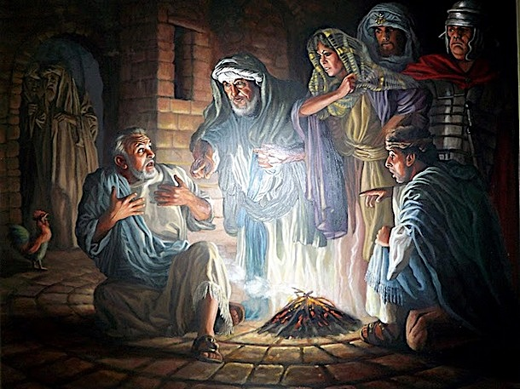
Reflection: I often play the game of ‘what if that were me’ when I read the Bible. This is one of those passages of scripture I absolutely hate to play this game with. In this passage we read of the Apostle Peter and his denial of Christ. The setting in the scripture above is that Jesus, being betrayed by Judas, was captured and taken to the high priest’s home where Peter follows. Peter is in the shadows, hiding amongst the crowds near a freshly kindled fire. Jesus is being treated as a criminal and Peter knows that to be associated with a criminal, especially at the height of this very public arrest is dangerous. It’s not a great time to be an admitted follower of Christ.
Peter is my favorite apostle in Holy Scripture because I see Peter in me. Peter often gets pretty harsh treatment and is more often than not used as an example of what Christians should not do. But I’ve always tried to give him a lot of grace. Peter can be over confident and bold at times. His boldness is not a misplaced boldness. He was a witness to Jesus and his ministry. Peter saw Jesus raise Jairus’ daughter from the dead (Mark 5:35-43). He saw Jesus heal a leper (Luke 5:12-16). He witnessed the miraculous catch of fish (Luke 5:1-11), the transfiguration (Matthew 17:1-9), and he was the only human other than Jesus who walked on water (Matthew 14:28-33). In other words, Peter had a front row seat to the person and work of Jesus Christ. He is the first to proclaim, by faith, that Jesus is the Messiah (Matthew 16:16). Peter also, though, attempts to rebuke Jesus (Matthew 16:22). I can’t imagine being so bold as to attempt to rebuke Jesus, but Peter tries, and fails quite spectacularly to the point that Jesus equates him with Satan. Boldness - check.
What about Peter’s overconfidence? A few verses before this passage, in Luke 22:33, we read of Peter saying that he will go with Christ both to prison and to death. And Jesus tells him ‘Simon, Simon, behold, Satan would have you and sift you like wheat.’ Jesus then states that Peter will deny Jesus three times, and this prophecy comes true. Peter gets weak in the knees and denies Christ three times. I find myself here, in his humanity, in his fear. What if that were me? What would I do? Could I say with any credulity that I would’t do the same? Over confidence - check.
This passage serves as a warning to us to keep us in check. For if an Apostle, a man who was a direct witness to the person and work of Jesus Christ could fall in faith and deny Christ, how easy it is for us to do the same. Overconfidence is cunning: It can rear its head in the most benign places. While driving around town I can’t help but notice the bumper stickers on cars in front of me. Some bumper stickers are so funny that you can’t help but laugh. Some are so hateful, hurtful, and/or obnoxious that they make you cringe. Then there are bumper stickers that are presumably Christian in nature. Here are some examples of what I’ve seen around town:
Funny = I believe in the Big Bang Theory, GOD spoke and BANG, it happened.
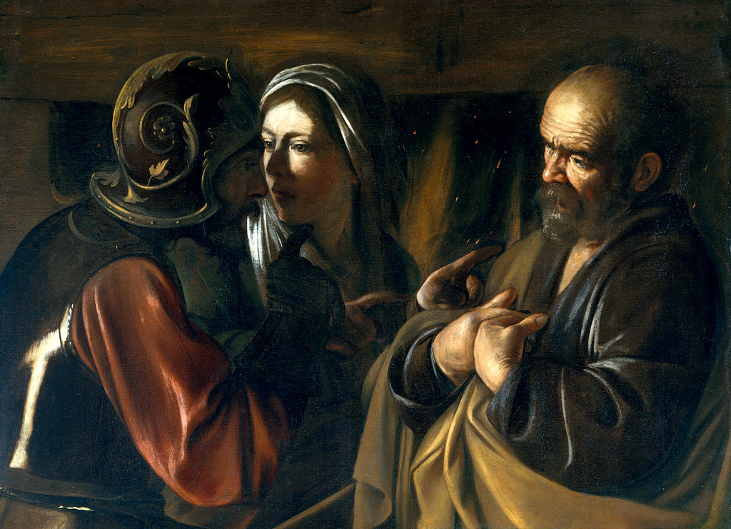
Hurtful = I can’t fix stupid, but God can.
Hateful = Try Jesus, if you don’t like him, Satan will always
take you back.
Obnoxious = Do you follow Jesus this close?
Prideful = Proud Christian <political party>.
I tend to cringe at most of these, mostly because it tends to reflect a self-serving act. The real question is what if that were me? What if I were on the other end of that bumper sticker? Would I be as confident when I have to put my own life on the line? Will that arrogant bumper sticker help me when I am given the choice to proclaim Christ as Lord or suffer? I don’t think so. “Pride goes before destruction, a haughty spirit before the fall” (Proverbs 16:18).
The key parts of Peter’s denial is shown in three phases:
- Being called out as a follower of Jesus (v.56)
Caravaggio, The Denial of St. Peter (1610)
- Being called out as one his people (v.57)
- Being called out as different (Galilean) (v.59)
It’s interesting to note that we are called out similarly. We are called to be followers of Jesus, we have been called out as his chosen people, and we are called to be different. In each case Peter denies that he knows Jesus, is a follower of Jesus, and is different because of his relationship with Jesus. No amount of his boldness or confidence came to his rescue. When things are going well, it’s easy to be bold, to be confident, to put our faith on display. When being identified as a Christian is tough or dangerous, it’s not so easy. Peter reminds us of this exact thing, and it hits me in a way that makes me run in prayer with fear and trembling.
It is with Peter in mind I am given hope and assurance that while we may fall, it is not a total and complete fall. Luke 22:31-34 highlights this. Right after Jesus tells Peter that Satan would have him and sift him like wheat, he tells Peter, ‘BUT I have prayed for you, that when you turn, not IF you turn, but WHEN you turn, strengthen the brethren.’ That passage gives me hope… to know that even when Peter denies Christ, he is still going to be there to give hope to those of the faith. Peter is still doing that for all of us today. His example, while often used as a negative, is actually a shining example of the grace of God and a reminder that in all our boldness and confidence we still need Christ.

Response: We live in a time where fundamental belief in the Christian faith is at an all-time low. Cultural Research Center at Arizona Christian University shows that 58% of Americans no longer believe that God and the Bible are a source for determining morality and truth. In the State of Theology survey run yearly by Ligonier Ministries, 30% of professing evangelicals believe that Jesus was a great teacher but he was not God. 42% of professing evangelicals believe that God accepts the worship of all religions. We are more primed today to deny Christ than in previous generations.
The Bible warns us of a great falling away that is to come. Boldness and confidence in our faith in Christ is necessary to withstand the influence of the world. It’s not going to be easy: Being different never is. Yet, God has given us examples to follow and to learn from. He has given us time to build our faith and to run to him during tough times. In this season, reflect on who Jesus is, what he did for you, and how much he sacrificed. He who was without sin became sin for us so that in him we might become the righteousness of God in Him (2 Corinthians 5:21). Remember that even though we may fall, we have an assurance of forgiveness, and when we do fall, be ready to strengthen the brethren. Though Satan would have us, Jesus won’t let his chosen utterly fail, but will get us back on our feet and return our focus back on Him.

Prayer: Our Father and our God thank You for Peter. Thank You for using human failing to set examples for our flawed natures. Let us never be arrogant in our own boldness and confidence, but to remember that we are saved by Your grace and not ourselves or our works so that no man may boast. Help us to keep our overconfidence in check, to know that we must rely on You and You alone. Help to strengthen our faith in You and to be ready bravely and boldly to declare that You are God and that we are Your people, even in the face of tough and dangerous times. Amen.
- Preston Yoshioka

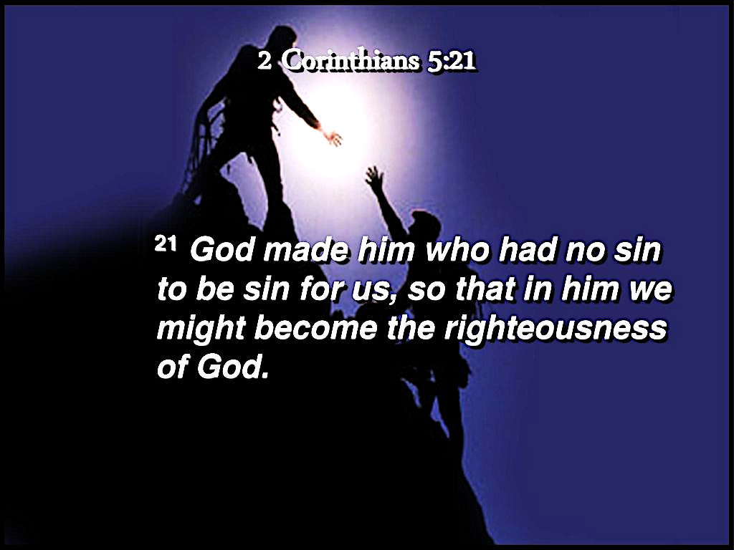

-----------------------------------------------------

When Buddha was dying, his disciples asked how they could best remember him. He told them not to bother; it was his teaching, not his person, that counted. With Jesus it is altogether different. Everything centers around him, his person. Discipleship means knowing him, loving him, believing in him, being committed to him.
- David Watson, Called and Committed, p.9

MARCH 23
“Is that how you answer the high priest?”

Text: John 18:19-24
¹⁹ Meanwhile, the high priest questioned Jesus about his disciples and his teaching.
²⁰ “I have spoken openly to the world,” Jesus replied. “I always taught in synagogues or at the temple, where all the Jews come together. I said nothing in secret. ²¹ Why question me? Ask those who heard me. Surely they know what I said.”
²² When Jesus said this, one of the officials nearby struck him in the face. “Is this the way you answer the high priest?” he demanded.
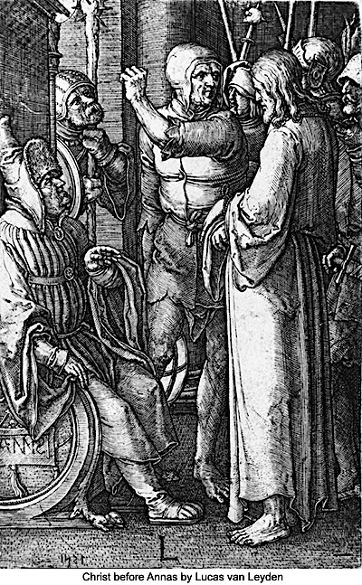
²³ “If I said something wrong,” Jesus replied, “testify as to what is wrong. But if I spoke the truth, why did you strike me?” ²⁴ Then Annas sent him, still bound, to Caiaphas the high priest.

Reflection: “Is that how you answer the High Priest?” This is perhaps one of the most misguided questions of all time. The irony is that when the officer asks the question he doesn’t understand that Jesus is the true High Priest. This may appear to have a hint of dark humor, but in the periscope that precedes this story and the one that follows, one of Jesus’ closest followers, Simon Peter, denies knowing Him. This adds to the irony because as part of His answer to the charges brought against Him Jesus says to ask those who have heard Him to be His witness. Peter, one of His closest followers and friends, is more concerned with saving his own life than bearing witness to the truth of Jesus and His ministry. Yet in just a few hours Jesus will give His life on the cross to spare Peter’s life for eternity.
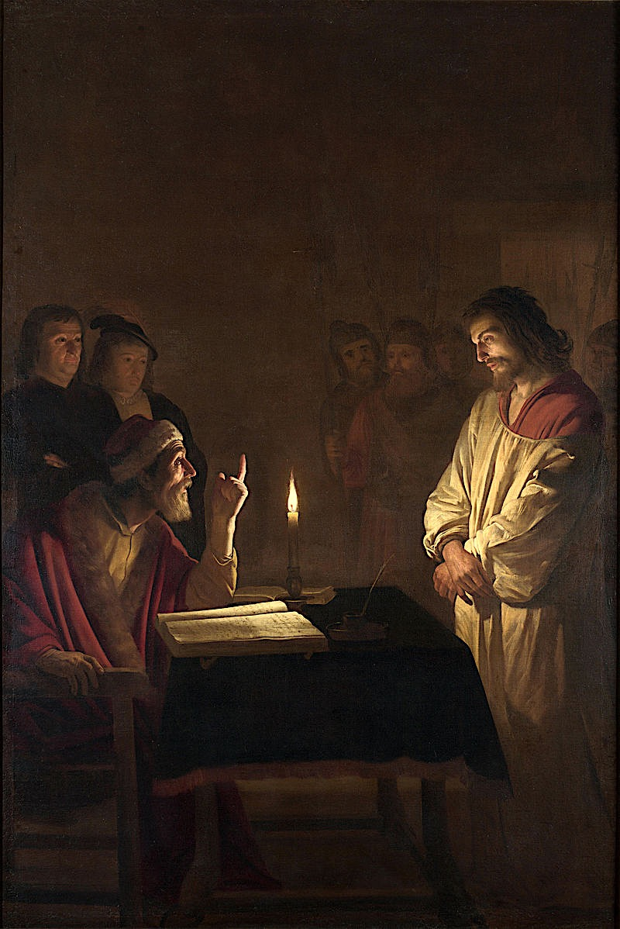
Jesus points out that He always taught openly in synagogues and the Temple where the Jews came together. He did nothing in secret. He challenges His accusers to prove Him wrong and seek the truth. Rather than call witnesses Annas gives in to his pride and sends Jesus to Caiaphas thus putting the responsibility on someone else.
Lucas van Leydan, Christ Before Annas the High Priest, 1521

Response: I think that one of the hardest things for Christians to do is to examine ourselves. We like to sing “Jesus paid it all” as loud as we can often masking our own complicity in His death. Just as Peter chose to deny Jesus we do the same when we sin. We can point to the unfairness of Jesus’ trial and crucifixion but it was for our benefit. That He was willing to do this points to His glory not our worthiness. Easter is certainly a time for us to celebrate, but before we get there we have to deal with Good Friday. A time of self examination might be in order. When confronted with the truth of Jesus, Annas refused to accept it. But Peter also denied Him. The difference is Peter repented and accepted responsibility (see John 21:15-19). As Easter approaches we need to prepare for it with some honest and enlightened self-evaluation.

Prayer: Lord Jesus, forgive us our sins. We often fail to understand all that You went through for Your people. Just as You did nothing in secret, give us the courage to do likewise and proclaim Your gospel to a lost and dying world. Amen. - Chris Rhodes
Gerard van Honthorst, Christ
Before the High Priest, 1617
MARCH 24
“Then when Judas, his betrayer, saw that Jesus was condemned,
he was seized with remorse…”

Text: Matthew 27:1-10
¹ Early in the morning, all the chief priests and the elders of the people came to the decision to put Jesus to death. ² They bound him, led him away and handed him over to Pilate, the governor.
³ When Judas, who had betrayed him, saw that Jesus was condemned, he was seized with remorse and returned the thirty silver coins to the chief priests and the elders. ⁴ “I have sinned,” he said, “for I have betrayed innocent blood.”
“What is that to us?” they replied. “That’s your responsibility.”
⁵ So Judas threw the money into the temple and left. Then he went away and hanged himself.
⁶ The chief priests picked up the coins and said, “It is against the law to put this into the treasury, since it is blood money.” ⁷ So they decided to use the money to buy the potter’s field as a burial place for foreigners. ⁸ That is why it has been called the Field of Blood to this day. ⁹ Then what was spoken by Jeremiah the prophet was fulfilled: “They took the thirty silver coins, the price set on him by the people of Israel, ¹⁰ and they used them to buy the potter’s field, as the Lord commanded me.”

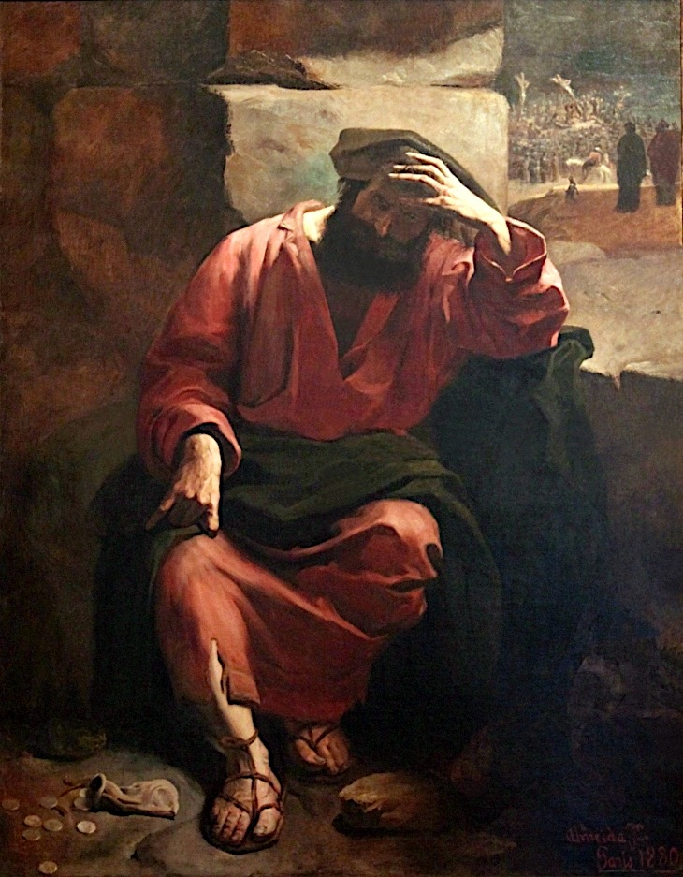
Reflection: Judas is probably one of the most well-known characters from the Bible. His name has become a synonym for “traitor,” and most people would understand what is meant when someone is called a “Judas.” The question I have is what was the need for such a person? As Jesus said during his arrest: “Every day I sat in the temple courts teaching, and you did not arrest me.” Also, the chief priests and the elders had been for a long time trying to kill Jesus. I understand that Scripture had to be fulfilled, but I try to think about him and I can’t see why he would betray Jesus. He walked with him for 3 years. He saw with his own eyes many miracles—things that no one else had done before. He heard the teaching of the Master with his own ears—things that no one else had said before. Did he not believe Jesus was the Christ? Surely, he realized Jesus was different than any other. What was going through his head? Why would he do such a thing? I have no answers.
It may be easy for any of us to look at Judas and think we could never betray Jesus. But sometimes, actually many times, when I look at my sin and think of my disobedience as a follower of Christ, I can’t stop seeing myself as a betrayer too. One of my favorite hymns is “How deep the Father’s love for us”. And the line that always hits me is “It was my sin that held Him there, until it was accomplished.” It confronts me with the weight of my sin. And I am pretty sure I still haven’t understood its full weight.
It was not until Judas saw the extent of his actions that he felt remorse. Many times we too don’t see the extent of our sin until we see the consequences of it. Until we see the damage it causes to others, to the people we love. But his change of mind, his remorse, didn’t lead him to salvation. It led him directly to death. The weight of his sin was unbearable. Yet it was necessary so that Christ would be arrested, unjustly condemned and crucified… So that the glory of God would be manifested to the whole world… So that the justice and wrath of God would be satisfied and we could be justified… So that all of us would have a way out.
Almeida Júnior, Remorse of Judas, 1880

Response: It is appropriate for us to take a deep and honest look at our sin. And we cannot do that unless we see more of God’s holiness. Just like when we enter a dark room we can’t see anything until the light is turned on. I encourage you to respond by asking God to show you more of his holiness. Ask him to turn on the light in your heart to see the depravity and damage your sin can inflict in you and in others but most importantly how it offends God. Thankfully, we can be assured by the perfect work of Christ that the repentance that this will cause will lead us not to death but to an ever-closer communion with our Lord. Make this a part of your daily prayer. And little by little in this life we’ll grow more and more grateful of His grace. “But where sin abounded, grace did much more abound” (Romans 5:20).
Prayer: Father we come to You knowing that we cannot hide any of our iniquities. We know You see every intention of our heart. You are the only one that can pierce through our facades and see us as we truly are. And yet You redeemed us. You made peace with us. You provided for Yourself the lamb for the final sacrifice, One without blemish, perfect in every way, sinless. Show us Your holiness, cast a light on the darkest places of our heart, so we can understand more and more the extent of Your love and grace… So we can be moved more and more to give You all the glory and honor You deserve. We need You. We are helpless without You. We rest in Your amazing love. Only You can change our hearts. In the name of the perfect Lamb, our Lord Jesus Christ. Amén.
– Samuel Dueñas

-----------------------------------------------------------------------------------------------------------------------

Judas’ betrayal of Jesus was taken by others to be the final word by which the fate of Judas was sealed, and with which the story of his life was written. But through Jesus Christ we know that no sin can be the final word in our life, nor can death as the consequence of sin be the final word. By his own death and resurrection, Christ has destroyed the power of death to seal our fate. Christ is the final w0rd for all humanity. No death can overturn that word, even death that is self-inflicted.
- Ray Anderson, The Gospel According to Judas, p.25

MARCH 25
“Pilate said to him, ‘What is truth?’”

Text: John 18:28-40
²⁸ Then the Jews led Jesus from Caiaphas to the palace of the Roman governor. By now it was early morning, and to avoid ceremonial uncleanness the Jews did not enter the palace; they wanted to be able to eat the Passover. ²⁹ So Pilate came out to them and asked, “What charges are you bringing against this man?”
³⁰ “If he were not a criminal,” they replied, “we would not have handed him over to you.”
³¹ Pilate said, “Take him yourselves and judge him by your own law.”
“But we have no right to execute anyone,” the Jews objected. ³² This happened so that the words Jesus had spoken indicating the kind of death he was going to die would be fulfilled.
³³ Pilate then went back inside the palace, summoned Jesus and asked him, “Are you the king of the Jews?”
³⁴ “Is that your own idea,” Jesus asked, “or did others talk to you about me?”
³⁵ “Am I a Jew?” Pilate replied. “It was your people and your chief priests who handed you over to me. What is it you have done?”
³⁶ Jesus said, “My kingdom is not of this world. If it were, my servants would fight to prevent my arrest by the Jews. But now my kingdom is from another place.”
³⁷ “You are a king, then!” said Pilate.
Jesus answered, “You are right in saying I am a king. In fact, for this reason I was born, and for this I came into the world, to testify to the truth. Everyone on the side of truth listens to me.”
³⁸ “What is truth?” Pilate asked. With this he went out again to the Jews and said, “I find no basis for a charge against him. ³⁹ But it is your custom for me to release to you one prisoner at the time of the Passover. Do you want me to release ‘the king of the Jews’?”
⁴⁰ They shouted back, “No, not him! Give us Barabbas!” Now Barabbas had taken part in a rebellion.
Reflection: At the Last Supper, Jesus had just told his disciples that He was the Truth; now He tells Pilate that He came into the world to testify to the truth. Pilate cynically asks, “What is truth?” The “truth” that Pilate observed all his life is that bribery, deceit, corruption, and injustice are the ways to achieve power and a better life. Pilate’s superstition, pretend worship of fake gods, and wholehearted commitment to Roman culture did not lead him to an awareness of any other truth.
In contrast, Jesus’ truth was and is a reflection of God Himself. The demonstrable truths of the physical universe reflect the immense and unfathomable mind of the Creator. The fidelity, consistency and trustworthiness of God’s relationship with mankind throughout history reflect the integrity of His character. The unchanging plan and purpose of God for the redemption of sinners transcend language, culture, and opposition. They reflect God’s unfailing heart of love for us, even though we are weak, temporal, made of dust, and totally unworthy. The Truth of God never changes, does not contradict itself or observable reality, and lasts forever.

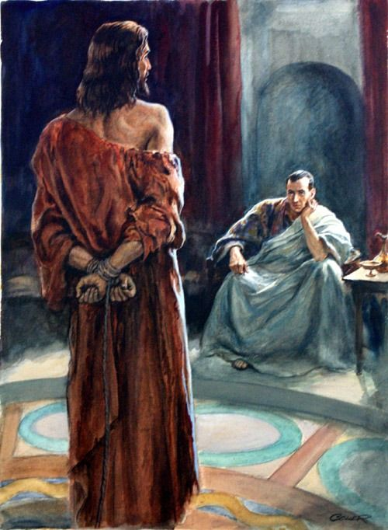
Response: Our individualistic culture promotes the idea of relative truth, that what’s true for me today may not be true for you, or even for me tomorrow. In conversations about faith I am sometimes told, “That’s really a good thing for you and I’m so glad you have that.” They rejoice with me but they want to invent their own truth for themselves. The fallacy is that truth is not invented, especially by mortal human beings: It is revealed. God revealed truth in the Old Testament through the Law and the Prophets. Later Jesus reflected God’s glory and truth in ways that could be seen, heard, and understood. God’s truth is still revealed through His word and through the Holy Spirit, who makes the word “come alive” in our hearts. The Holy Spirit also initiates “Aha Moments” where people discover some truth, some revelation not of their own making, that leads to a new understanding, a scientific advance, a great work of art, or a deeper relationship with God that changes the way we live, think, and make decisions. Whatever comes from the mind of man may seem to be true, but if it does not align with God’s truth it is a flimsy supposition or a cheap imitation. Open our eyes, Lord, we need to see Jesus.

Prayer: Heavenly Father, thank You for all the times You revealed truth to me, even the truth that I am a miserable sinner. Thank You even more for the truth that Jesus saves. Thank You for the insights, directions, corrections, and glimpses of glory. Thank You for Your unfailing love that endures forever. You are great and greatly to be praised! In Jesus’ name, Amen. - Dianne Billharz

---------------------------------------------------------------------------------

A church which abandons the truth abandons itself. – Hans Küng

MARCH 26
“His blood be on us and on our children!”

Text: Matthew 27:15-26
¹⁵ Now it was the governor’s custom at the Feast to release a prisoner chosen by the crowd. ¹⁶ At that time they had a notorious prisoner, called Barabbas. ¹⁷ So when the crowd had gathered, Pilate asked them, “Which one do you want me to release to you: Barabbas, or Jesus who is called Christ?” ¹⁸ For he knew it was out of envy that they had handed Jesus over to him.
¹⁹ While Pilate was sitting on the judge’s seat, his wife sent him this message: “Don’t have anything to do with that innocent man, for I have suffered a great deal today in a dream because of him.”
²⁰ But the chief priests and the elders persuaded the crowd to ask for Barabbas and to have Jesus executed.
²¹ “Which of the two do you want me to release to you?” asked the governor.
“Barabbas,” they answered.
²² “What shall I do, then, with Jesus who is called Christ?” Pilate asked.
They all answered, “Crucify him!”
²³ “Why? What crime has he committed?” asked Pilate.
But they shouted all the louder, “Crucify him!”
²⁴ When Pilate saw that he was getting nowhere, but that instead an uproar was starting, he took water and washed his hands in front of the crowd. “I am innocent of this man’s blood,” he said. “It is your responsibility!”
²⁵ All the people answered, “Let his blood be on us and on our children!”
²⁶ Then he released Barabbas to them. But he had Jesus flogged, and handed him over to be crucified.

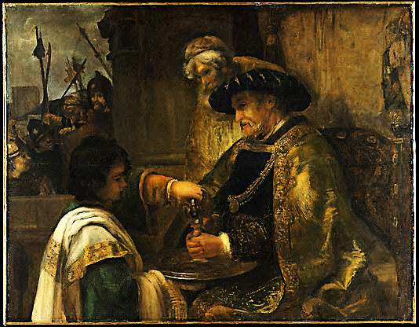
Reflection: Many people aspire to positions of power. Authority certainly has its benefits and there can be almost a romantic attraction to it. But consider this quote (there are many versions and it’s unknown who originally coined the phrase): “It is a well-known fact that those people who must want to rule people are, ipso facto, those least suited to do it... Anyone who is capable of getting themselves made President should on no account be allowed to do the job.”
When I read Matthew 27, I can’t help feeling a disdain for Pontius Pilate. Is that due to my tainted 21st-century American perspective of corrupt people who hold positions of power? Perhaps. I think, though, that what we see here is a textbook example of someone who loves the idea of being in control but who is severely ill-equipped for the position as he is reluctant actually to lead.
On one hand, there are the facts: an innocent man who has been brought up on fraudulent charges by means of an illegitimate process. To get to this point there had been outright lies, betrayal, and even blood money paid. There was the blatant manipulation on the part of the chief priests and elders and, on top of all of this, even Pilate’s wife admonished him to have nothing to do with the condemnation of this man. But the people had been incited and mob rule had taken over.
Rembrandt van Rijn, Pilate Washes His Hands, 1660
Rather than stand up for what (even he clearly knew) was right, Pilate made another opportunistic calculation and attempted an escape; he figured that perhaps he had an “out” by offering to release either Jesus or the clearly-nefarious criminal, Barabbas. He figured wrong.
And so, again, rather than stand up for what he knew was right, he washed his hands and sentenced an innocent man to death simply to appease an angry crowd. They didn’t know how true their words were when they said, “His blood be on us and on our children”—true concerning both their absolute culpability and the final answer for their utter need—and they didn’t care.

Response: Just as it was easy for Pontius Pilate to wash his hands and point the finger at the crowd as the truly unjust, so it is for you and for me to do essentially the same. We are fooling ourselves if we believe that we are
innocent of the blood of Christ; His death was necessary precisely to atone for such unrighteousness.
The lyrics to the song “How Deep The Father’s Love For Us” are ringing in my head as I write:
How deep the Father's love for us, how vast beyond all measure
That He should give His only Son, to make a wretch His treasure.
How great the pain of searing loss, the Father turns His face away
As wounds which mar the Chosen One bring many sons to glory.
Behold the man upon a cross, my sin upon His shoulders.
Ashamed, I hear my mocking voice, call out among the scoffers.
It was my sin that held Him there, until it was accomplished.
His dying breath has brought me life, I know that it is finished.
I will not boast in anything, no gifts, no power, no wisdom,
But I will boast in Jesus Christ, His death and resurrection
Why should I gain from His reward? I cannot give an answer,
But this I know with all my heart, His wounds have paid my ransom

Prayer: Father, thank You for saving me. Help me to better understand the gravity of my sin and the outrageous price that you paid. Jesus, thank You that, like a lamb to the slaughter and as a sheep is silent before the shearers, You did not open Your mouth. You died in my place; it was my sin that held You there. Holy Spirit, thank you for revealing my sin to me and for leading me into all truth. Amen. - Ian Bullard

MARCH 27
“The chief priests answered, ‘We have no king but Caesar.’”

Text: John 19:1-16
¹ Then Pilate took Jesus and had him flogged. ² The soldiers twisted together a crown of thorns and put it on his head. They clothed him in a purple robe ³ and went up to him again and again, saying, “Hail, king of the Jews!” And they struck him in the face.
⁴ Once more Pilate came out and said to the Jews, “Look, I am bringing him out to you to let you know that I find no basis for a charge against him.” ⁵ When Jesus came out wearing the crown of thorns and the purple robe, Pilate said to them, “Here is the man!”
⁶ As soon as the chief priests and their officials saw him, they shouted, “Crucify! Crucify!”
But Pilate answered, “You take him and crucify him. As for me, I find no basis for a charge against him.”
⁷ The Jews insisted, “We have a law, and according to that law he must die, because he claimed to be the Son of God.”
⁸ When Pilate heard this, he was even more afraid, ⁹ and he went back inside the palace. “Where do you come from?” he asked Jesus, but Jesus gave him no answer. ¹⁰ “Do you refuse to speak to me?” Pilate said. “Don’t you realize I have power either to free you or to crucify you?”
¹¹ Jesus answered, “You would have no power over me if it were not given to you from above. Therefore the one who handed me over to you is guilty of a greater sin.”
¹² From then on, Pilate tried to set Jesus free, but the Jews kept shouting, “If you let this man go, you are no friend of Caesar. Anyone who claims to be a king opposes Caesar.”
¹³ When Pilate heard this, he brought Jesus out and sat down on the judge’s seat at a place known as the Stone Pavement (which in Aramaic is Gabbatha). ¹⁴ It was the day of Preparation of Passover Week, about the sixth hour.
“Here is your king,” Pilate said to the Jews.
¹⁵ But they shouted, “Take him away! Take him away! Crucify him!”
“Shall I crucify your king?” Pilate asked.
“We have no king but Caesar,” the chief priests answered.
¹⁶ Finally Pilate handed him over to them to be crucified.

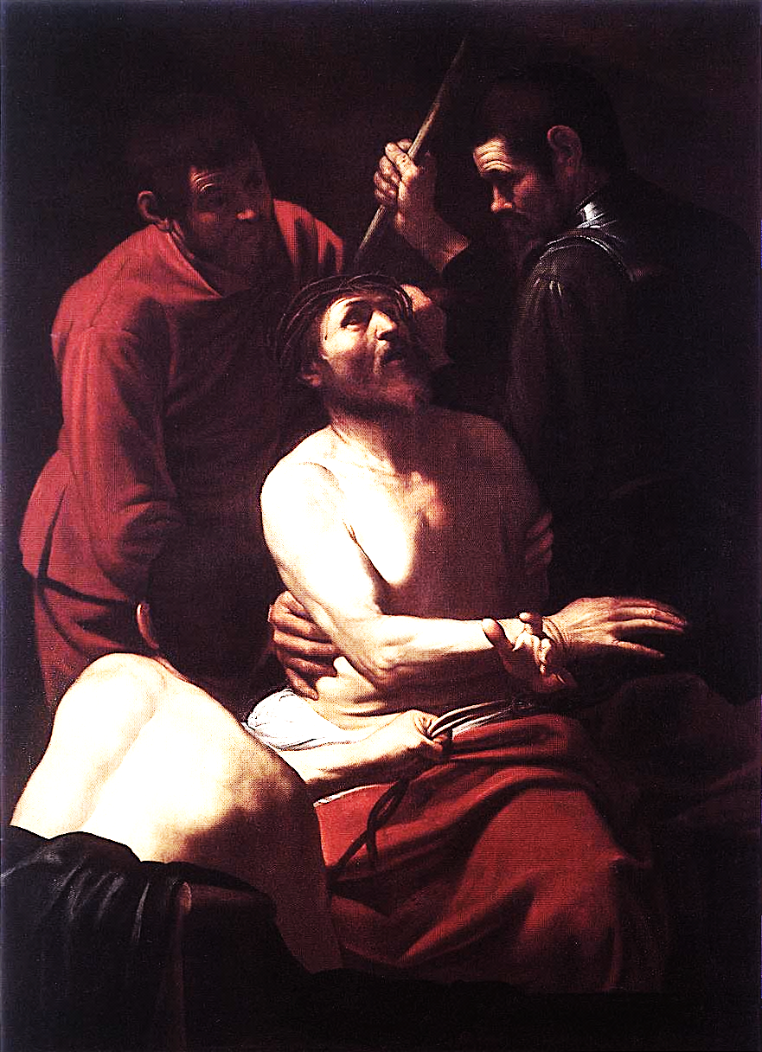
Reflection: Travel with me back in time to a day in the year AD 35. Only a few days before, we had followed Jesus during his triumphant entry into Jerusalem. However, things have dramatically changed. We are now standing in a crowd of Jews in Roman Governor Pontius Pilate’s courtyard. Interspersed among us are the Jewish chief priests and other officials. Our Jewish leaders had delivered Jesus to Pilate. He had questioned Jesus and attempted to have the Jews release Jesus, but they chose Barabbas instead. After that, to our horror, Pilate ordered Jesus scourged. He could have ordered a mere flogging, but instead Jesus has been bound in a stooping position to the Column of Flagellation and is being beaten with whips the thongs which are weighted with lead and studded with sharp pointed pieces of bone. I am horrified, but I must hold back my tears. You too? Yes. We cannot be identified by the chief priests. Look what they can do to us! I feel my heart will burst from the horror and the grief. The lacerations are frightful. Men often die from this treatment, but Jesus is still alive. Why has Pilate ordered this punishment? I do not understand.
Now the soldiers are mocking Jesus, dressing him in a royal robe and placing a crown of thorns on his head. What are they shouting? “Behold the King of the Jews!” Why would they…? Oh, God help us. I’m starting to understand….
Pilate just said that he found no guilt in Jesus. He must have hoped the severe beating would satisfy the chief priests. But now they are yelling “Crucify, crucify.” Much of the crowd in the courtyard just took up the cry, parroting the demand, incited by the chief priests. Pilate seems perplexed and is asking Jesus more questions. What now? Listen. Again Pilate is asking our leaders to release Jesus. He is now visibly shaken, taken aback as they are replying “If you release this man, you are no friend of Caesar, everyone who makes himself out to be a king opposes Caesar.” This really has set Pilate back. I can see it in his face and demeanor. There is well-known speculation that Pilate’s position as Governor is precarious and he is falling out of favor with Rome. Clearly, our Jewish leaders have found Pilate’s weak point and are trying to exploit it. God, help Pilate remain strong! I pray, but I expect the worst.
Caravaggio, The Crowning
of Thorns, 1603

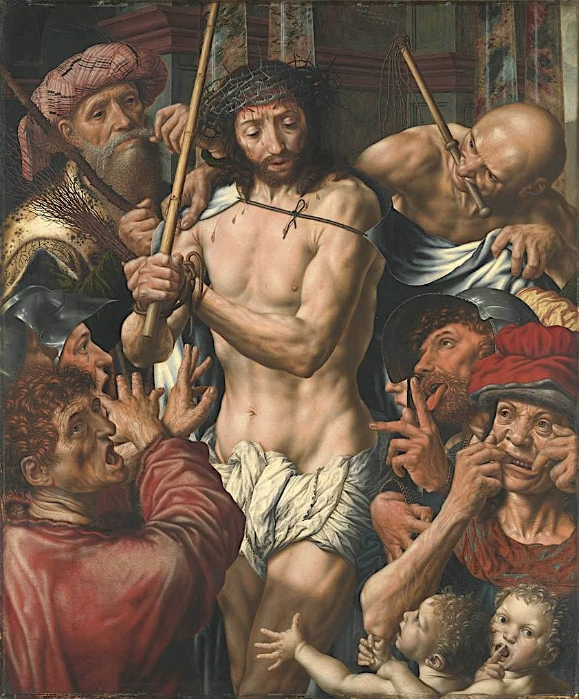
Pilate is still trying, but he is weakly fighting a losing battle… “Shall I crucify your King?” he has asked, and the chief priests have answered: “We have no king but Caesar.” What!?!! Denying we belong only to Yahweh God?!! Is there no depth of blasphemy these so-called men of God will not proclaim in order to get rid of Jesus?!!... And it has worked!!! Pilate is handing Jesus over to be crucified. Dear God, what is to become of us?
Oh, horror of horrors, we have used the Roman governor to crucify our Savior! Isn’t crucifixion reserved by the Romans only for the lowest social rank, for the worst of criminals? And for us, isn’t such “hanging on the tree” meant only for those considered cursed by God? Of course, that has been the plan of the high priests all along. This will oust any idea that Jesus can be our Messiah!... Or will it?...

Response: Being a theater buff, this chapter of John’s coverage of events leading up to Jesus’ crucifixion made me think about protagonist, antagonist, and foil. The ultimate protagonist in the Bible is God, as represented by the Father, Son, and Holy Spirit. The ultimate antagonist in the Bible is Satan. The people, religious or not and primarily chief priests and other religious leaders, served as the antagonists in the crucifixion of Jesus. Were they foils of Satan or foils in fulfilling God’s plans? In John 19, it appears the antagonists won their battle with the protagonist. But, of course they did not. The Jews fulfilled God’s plan by causing Pilate to order Jesus crucified so that He would be raised from the dead and enable mankind by faith to receive forgiveness, righteousness and everlasting life. What role did Pilate play? In plays, the foil is included to showcase the strength of the protagonist. Reading the questions put forth by Pilate and his statements to the Jews, we can see Pilate’s role, as foreordained by God. Pilate turns out to be a tragic figure in the end, but he was the catalyst that played his part as the drama careened with frightening speed on toward Jesus’ crucifixion. The Jews couldn’t crucify Jesus on their own. They needed Rome to do so. They needed Pilate to be weak, frightened and ignoble. And he played his part so well. He didn’t even seem to be acting.
Jan Sanders van Hemessen,
The Mocking of Christ, 1544

How does this message carry forward to us today? How is mankind to be classified today? By and large, mankind is still the antagonist in relationship to God and Jesus. Our society today is antagonistic against God and Jesus and their coming Kingdom. The tendency to be God’s antagonist is within each of us. But, through our acceptance of Jesus as our Savior, we become partners with God who is still today and always the real Protagonist in the continuing story of humanity and of divine redemption.

Prayer: Dear God, this chapter of the book of John is a horrifying account of the suffering that Jesus endured so that we could be saved. Jesus, You were led to an agonizing death meant for the lowest level of society—The Cross—though You were the last person ever and anywhere to deserve it. But, according to Your plan, that is what happened, and it was followed by Your resurrection and ascension back into Heaven. Jesus, You literally went through hell on earth to save us from our sins and from a life of antagonism towards You. We thank You for Your love for us and for this ultimate sacrifice and glorious resurrection by which we are saved. We pray to you in the name of our Messiah, Jesus Christ. - Jock Ochiltree

MARCH 29
“If you are the Son of God, come down from the cross.”

Text: Matthew 27:27-44
²⁷ Then the governor’s soldiers took Jesus into the Praetorium and gathered the whole company of soldiers around him. ²⁸ They stripped him and put a scarlet robe on him, ²⁹ and then twisted together a crown of thorns and set it on his head. They put a staff in his right hand and knelt in front of him and mocked him. “Hail, king of the Jews!” they said. ³⁰ They spit on him, and took the staff and struck him on the head again and again. ³¹ After they had mocked him, they took off the robe and put his own clothes on him. Then they led him away to crucify him.
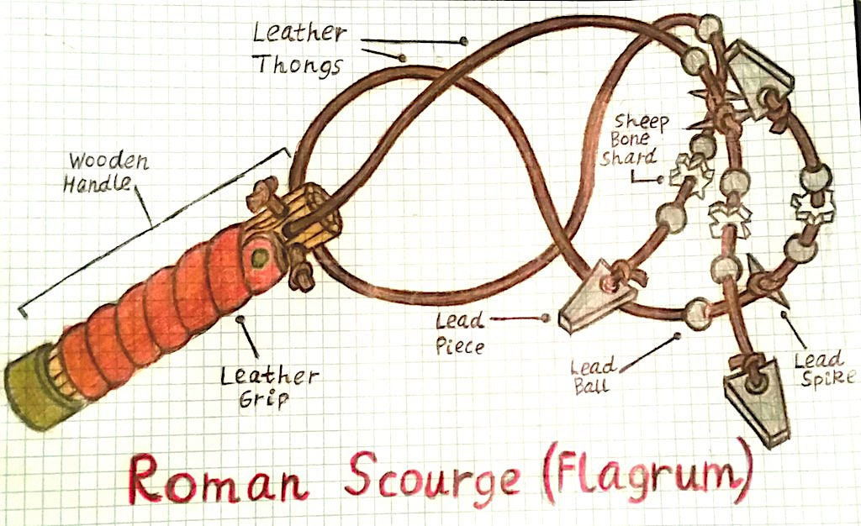
³² As they were going out, they met a man from Cyrene, named Simon, and they forced him to carry the cross. ³³ They came to a place called Golgotha (which means The Place of the Skull). ³⁴ There they offered Jesus wine to drink, mixed with gall; but after tasting it, he refused to drink it. ³⁵ When they had crucified him, they divided up his clothes by casting lots. ³⁶ And sitting down, they kept watch over him there. ³⁷ Above his head they placed the written charge against him: this is Jesus, the king of the Jews. ³⁸ Two robbers were crucified with him, one on his right and one on his left. ³⁹ Those who passed by hurled insults at him, shaking their heads ⁴⁰ and saying, “You who are going to destroy the temple and build it in three days, save yourself! Come down from the cross, if you are the Son of God!”
⁴¹ In the same way the chief priests, the teachers of the law and the elders mocked him. ⁴² “He saved others,” they said, “but he can’t save himself! He’s the King of Israel! Let him come down now from the cross, and we will believe in him. ⁴³ He trusts in God. Let God rescue him now if he wants him, for he said, ‘I am the Son of God.’ ” ⁴⁴ In the same way the robbers who were crucified with him also heaped insults on him.

Reflection: I am amazed at how Jesus responded to the people when He came down to earth to give them the good news of the Gospel message of Salvation. He allowed Himself to have human feelings, and this must have been devastatingly painful when He saw how they received His message. They not only rejected His message, and Him, but also unleashed cruelty beyond imagination upon Him, even putting Him to death, agonizing death. That is how they received His good news!
Jesus was innocent of any wrongdoing , but that did not matter.
Have you ever felt the hurt of someone rejecting information that you knew would help them? A son? A daughter? A friend? The hurt for you was awful because you cared and you knew the consequences to that loved one of their rejection. I have felt that many times, and I have also experienced some unkind responses, but no one ever wanted to kill me over it. I have a hard time wrapping my mind around how Jesus responded so graciously. He had the power to respond in kind, but he not only chose to let this happen, He also chose to forgive them. And Jesus’s forgiveness is as real as real can be. And He asks us to offer real forgiveness to others. By His example on the cross, He showed us that He places a high priority on forgiving

Response: When the Lord gives us a commandment and we do not obey it, there are consequences. Have you ever had a period in your life when someone hurt you and you chose to carry the hurt with you and not forgive? It is amazing how that resentment builds up and you become angry. In some cases, you have built up resentment toward someone who probably does not care. That resentment hurts only you.
Anger destroys relationships, with your family and with other people around you. Jesus said “I will give you a peace that the world can’t give.” In this world, we cannot have peace without forgiveness. It is hard to be happy if we are angry all the time. I had to learn this the hard way, and then I sought the Holy Spirit’s guiding wisdom to help me deal with my anger issues. Forgiving perceived and real hurts helped me to be a better person and to reestablish relationships. Through forgiveness given and received, God helped me solidify the relationships I had and that were so important in my life. In this way, God brought me to a new place of godly peace which I had never felt before.
Jesus is right. He has a special peace that only He can give. In this cultural climate there is a lot of hate and anger. God help me, help us, to remember that forgiving starts with You and me.

Prayer: Dear Heavenly Father, help me to be a more forgiving person. Holy Spirit, fill me with Your wisdom and discernment not to harbor hate, resentment and anger toward people who have hurt me. Fill my heart with the peace that only You can give. I pray this in Jesus name. Amen. - Mac McFarland

MARCH 30
“Father, forgive them, for they know not what they do.”

Text: Luke 23:26-43
²⁶ As they led him away, they seized Simon from Cyrene, who was on his way in from the country, and put the cross on him and made him carry it behind Jesus. ²⁷ A large number of people followed him, including women who mourned and wailed for him. ²⁸ Jesus turned and said to them, “Daughters of Jerusalem, do not weep for me; weep for yourselves and for your children. ²⁹ For the time will come when you will say, ‘Blessed are the barren women, the wombs that never bore and the breasts that never nursed!’ ³⁰ Then “‘they will say to the mountains, “Fall on us!” and to the hills, “Cover us!”’
³¹ For if men do these things when the tree is green, what will happen when it is dry?”
³² Two other men, both criminals, were also led out with him to be executed. ³³ When they came to the place called the Skull, there they crucified him, along with the criminals—one on his right, the other on his left. ³⁴ Jesus said, “Father, forgive them, for they do not know what they are doing.” And they divided up his clothes by casting lots.
³⁵ The people stood watching, and the rulers even sneered at him. They said, “He saved others; let him save himself if he is the Christ of God, the Chosen One.”
³⁶ The soldiers also came up and mocked him. They offered him wine vinegar ³⁷ and said, “If you are the king of the Jews, save yourself.”
³⁸ There was a written notice above him, which read: This is the King of the Jews.
³⁹ One of the criminals who hung there hurled insults at him: “Aren’t you the Christ? Save yourself and us!”
⁴⁰ But the other criminal rebuked him. “Don’t you fear God,” he said, “since you are under the same sentence? ⁴¹ We are punished justly, for we are getting what our deeds deserve. But this man has done nothing wrong.”
⁴² Then he said, “Jesus, remember me when you come into your kingdom.”
⁴³ Jesus answered him, “I tell you the truth, today you will be with me in paradise.”

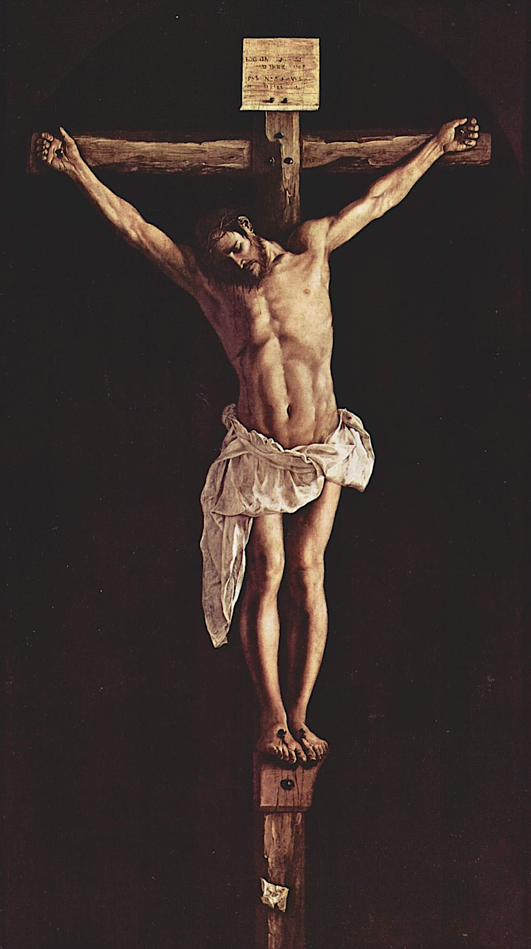
Reflection: Jesus was in effect giving the multitude following him to the crucifixion a warning that if they could wrongly punish a sinless, totally innocent man, what would happen to a guilty individual let alone the Jewish multitude without his continued guidance. Jesus foresaw the destruction of Jerusalem and the coming tribulation. He realized that His followers had no idea of what was coming. Again, He was attempting to make them realize how bad things would get. To say it would be better to be barren and never nurse, in that culture, was a horrific consequence which would be comparable in today’s culture to being handicapped in the most debilitating manner possible. Jesus later promised the criminal hanging next to Him that his sincere faith in Him would result in unearned forgiving grace and everlasting life (In short, we cannot earn our way into heaven, but through faith in Christ, He can and does guarantee our acceptance into Paradise!). After suffering the cruel ridicule of the guards, the mockery from the crown of thorns, sour wine, and the pain from crucifixion, Jesus gave up His sprit when He decided it was time to die. Even unto the end, He was always in control. His enduring love for us is simply amazing!

Response: I find it incredible that after all Jesus endured, His unrelenting love for mankind and concern about upcoming events allowed Him to fulfill prophecy without regard to personal injustice. Who among us could even begin to imagine how much of a sacrifice He so freely made? His example makes me feel very embarrassed that I fall prey to sin as frequently as I do, as I realize what He gave up for me out of His unconditional love. It certainly inspires me to do more than I am currently doing to bring the good news to those wandering aimlessly in the world and searching for something that is missing in their current life. I simply need to be more like Jesus, less like the old ignorant and selfish me, and more like the “new me” my Lord and Savior says I am and is helping me to become.
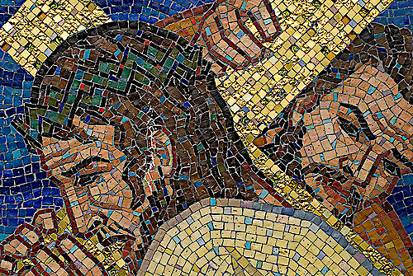
Jesus’ message and example are especially true in today’s environment of separation between those passionately preferring differing ideologies. Who these days can’t find members of their own church family that have radically differing points of view? Is it hard to see how we in the church keep failing to treat others like we would want them to treat us… Are we ignoring ongoing issues that in a Christian world should have come to resolution from observance of Scripture?… Can we see our God teaching each of us that we require undeserved grace for the foolish “anti-Christ-like” things we continue to do? Will we cooperate with God and “throw off everything that hinders and the sin that so easily entangles, and… run with perseverance the race marked out for us” (Hebrews 12:1).
Francisco de Zurbarán, Christ on the Cross (1627)

Prayer: Dear Lord, please help me follow Your ways, be patient, and listen for answers to my prayers. Help me bring others into Your flock by setting a better personal example and serving others. Please give me the strength to use the tools You have given me to do a better job evangelizing and so bring glory to You. Again, please help me be more like You and less like the old me. I ask this in the name of the Father, Son and Holy Spirit. Amen. - Brent Ford

MARCH 31
“My God, my God, why have you forsaken me?”

Text: Mark 15:33-41
³³ At the sixth hour darkness came over the whole land until the ninth hour. ³⁴ And at the ninth hour Jesus cried out in a loud voice, “Eloi, Eloi, lama sabachthani?”—which means, “My God, my God, why have you forsaken me?”
³⁵ When some of those standing near heard this, they said, “Listen, he’s calling Elijah.”
³⁶ One man ran, filled a sponge with wine vinegar, put it on a stick, and offered it to Jesus to drink. “Now leave him alone. Let’s see if Elijah comes to take him down,” he said.
³⁷ With a loud cry, Jesus breathed his last.
³⁸ The curtain of the temple was torn in two from top to bottom. ³⁹ And when the centurion, who stood there in front of Jesus, heard his cry and saw how he died, he said, “Surely this man was the Son of God!”
⁴⁰ Some women were watching from a distance. Among them were Mary Magdalene, Mary the mother of James the younger and of Joses, and Salome. ⁴¹ In Galilee these women had followed him and cared for his needs. Many other women who had come up with him to Jerusalem were also there.
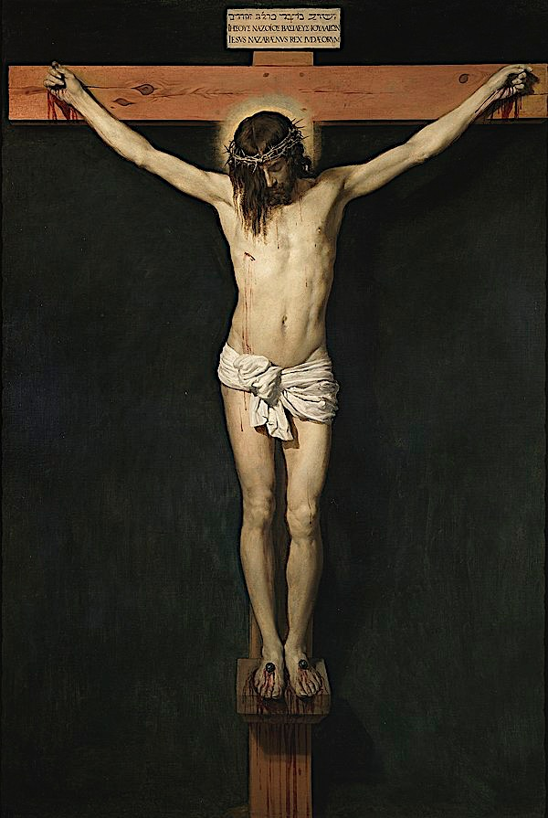
Reflection: During Lent, when we reflect on the sacrifice that Jesus made for us, it is important to spend time reflecting on what Jesus’ death would have been like spiritually and emotionally as well as physically. Obviously, none of us can know exactly what it was like, but we can see what Jesus said about it Himself.
Of course, His death was excruciating physically. The Gospel is good news for us because He paid for our sins through His death, and we rightly rejoice in what God has done to bring us to Himself. And yet, without understanding how repulsive our sin is to God, it is easy to gloss over what it means that Jesus bore our sins for us. Death is so horrendous because it separates our bodies from life; sin, when it has not been atoned for, separates our spirits from God, and this is worse.
When Jesus is hanging on the cross, toward the very end of His life, He cries out, quoting Psalm 22:1: “My God, my God, why have you forsaken me?” Forsaken is not a word that we use often in everyday conversation; Merriam-Webster’s online dictionary defines “forsake” as “to renounce or turn away from entirely.” In certain Bible translations, the word is rendered “abandoned.” When we recognize God as the source of truth, light, life, and love, then there would be nothing worse than to be completely abandoned by Him, to exist spiritually apart from Him in a state of lies and deceit, darkness, death, and the opposite of love, which, whether defined as hatred or complete indifference, is equally terrible. Jesus, who is God’s Son, has existed from all eternity in a state of perfect love and relationship with His Father and the Holy Spirit. Even during His time as a man, He knew His Father’s love and enjoyed an intimate relationship with Him. Now on the cross, He is not only abandoned, cut off from that relationship, but also horribly weighed down as He bears the wrath of God for the guilt of sin.
Diego Velásquez, The Crucifixion, 1632
Anyone who does not have a mental or spiritual illness has felt guilt at one point or another. Jesus loved us so much that He was willing to take on that guilt, bearing the (just) wrath of God as it was poured in righteous anger on Christ for our sins. I don’t think we will ever fully understand what a sacrifice this was; Jesus bore ALL the sins of the world, which we do not have to do—we feel guilt only over our own sins. We also don’t fully understand how detestable our own sins are to God, or the depth of their wrongness, and so we don’t even feel the fullness of the guilt that we could. Unlike Jesus, our spirits are not eternal and infinite, so we could never bear God’s full and righteous wrath even if we wanted.
These thoughts are sobering, but they are worth consideration because without fully thinking of what we deserve, and how much Christ bore on our behalf, we can’t fully understand the great gift that He gave us in His Son, in His becoming a mediator for us because of our sins.
And His death means that we do have a Mediator, that our sins and our guilt have been paid for and wiped away completely, because Jesus has taken care of the punishment we deserved. We can see this truth reflected in verse 38: “And the curtain of the temple was torn in two, from top to bottom.” The place where High Priests could enter only once a year to make sacrifice for the people, the place where the very presence of God dwelt, was no longer inaccessible and separated from us. Because of Jesus, we have been made right before God, and rather than living in rightful guilt, shame, and fear of God, we can come into His presence boldly (Hebrews 4:16) and as children approach a good father knowing that He loves them (Ephesians 1:5).

Response: In The Reason for God, Tim Keller writes, “The Christian Gospel is that I am so flawed that Jesus had to die for me, yet I am so loved and valued that Jesus was glad to die for me. This leads to deep humility and deep confidence at the same time. It undermines both swaggering and sniveling. I cannot feel superior to anyone, and yet I have nothing to prove to anyone. I do not think more of myself nor less of myself. Instead, I think of myself less.” Being able to love God and love others requires both this humility and confidence. When we spend our time focusing on Jesus and what He has accomplished, we are drawn into worship of a God who is both holy and loving, and this can be our strength to live lives where we follow Jesus’s example, sacrificing our own time, comfort, energy, and resources to spread this Good News and His Kingdom to those around us.

Prayer: Dear Jesus, thank You so much for bearing the weight of sin and guilt for me, for suffering separation from Your Father so that I could be part of Your family and Your kingdom. Thank You that I am allowed to approach the Father with confidence. I pray that I would remember constantly what You accomplished on my behalf, and that I would with love share this Good News with those around me. – Melissa Bullard
APRIL 1 (Maundy Thursday)
“Therefore order the tomb to be made secure until the third day, lest his
disciples go and steal him away and tell the people, ‘He has risen
from the dead,’ and the last fraud will be worse than the first.”

Text: Matthew 27:57-66
⁵⁷ As evening approached, there came a rich man from Arimathea, named Joseph, who had himself become a disciple of Jesus. ⁵⁸ Going to Pilate, he asked for Jesus’ body, and Pilate ordered that it be given to him. ⁵⁹ Joseph took the body, wrapped it in a clean linen cloth, ⁶⁰ and placed it in his own new tomb that he had cut out of the rock. He rolled a big stone in front of the entrance to the tomb and went away. ⁶¹ Mary Magdalene and the other Mary were sitting there opposite the tomb.
⁶² The next day, the one after Preparation Day, the chief priests and the Pharisees went to Pilate. ⁶³ “Sir,” they said, “we remember that while he was still alive that deceiver said, ‘After three days I will rise again.’ ⁶⁴ So give the order for the tomb to be made secure until the third day. Otherwise, his disciples may come and steal the body and tell the people that he has been raised from the dead. This last deception will be worse than the first.”
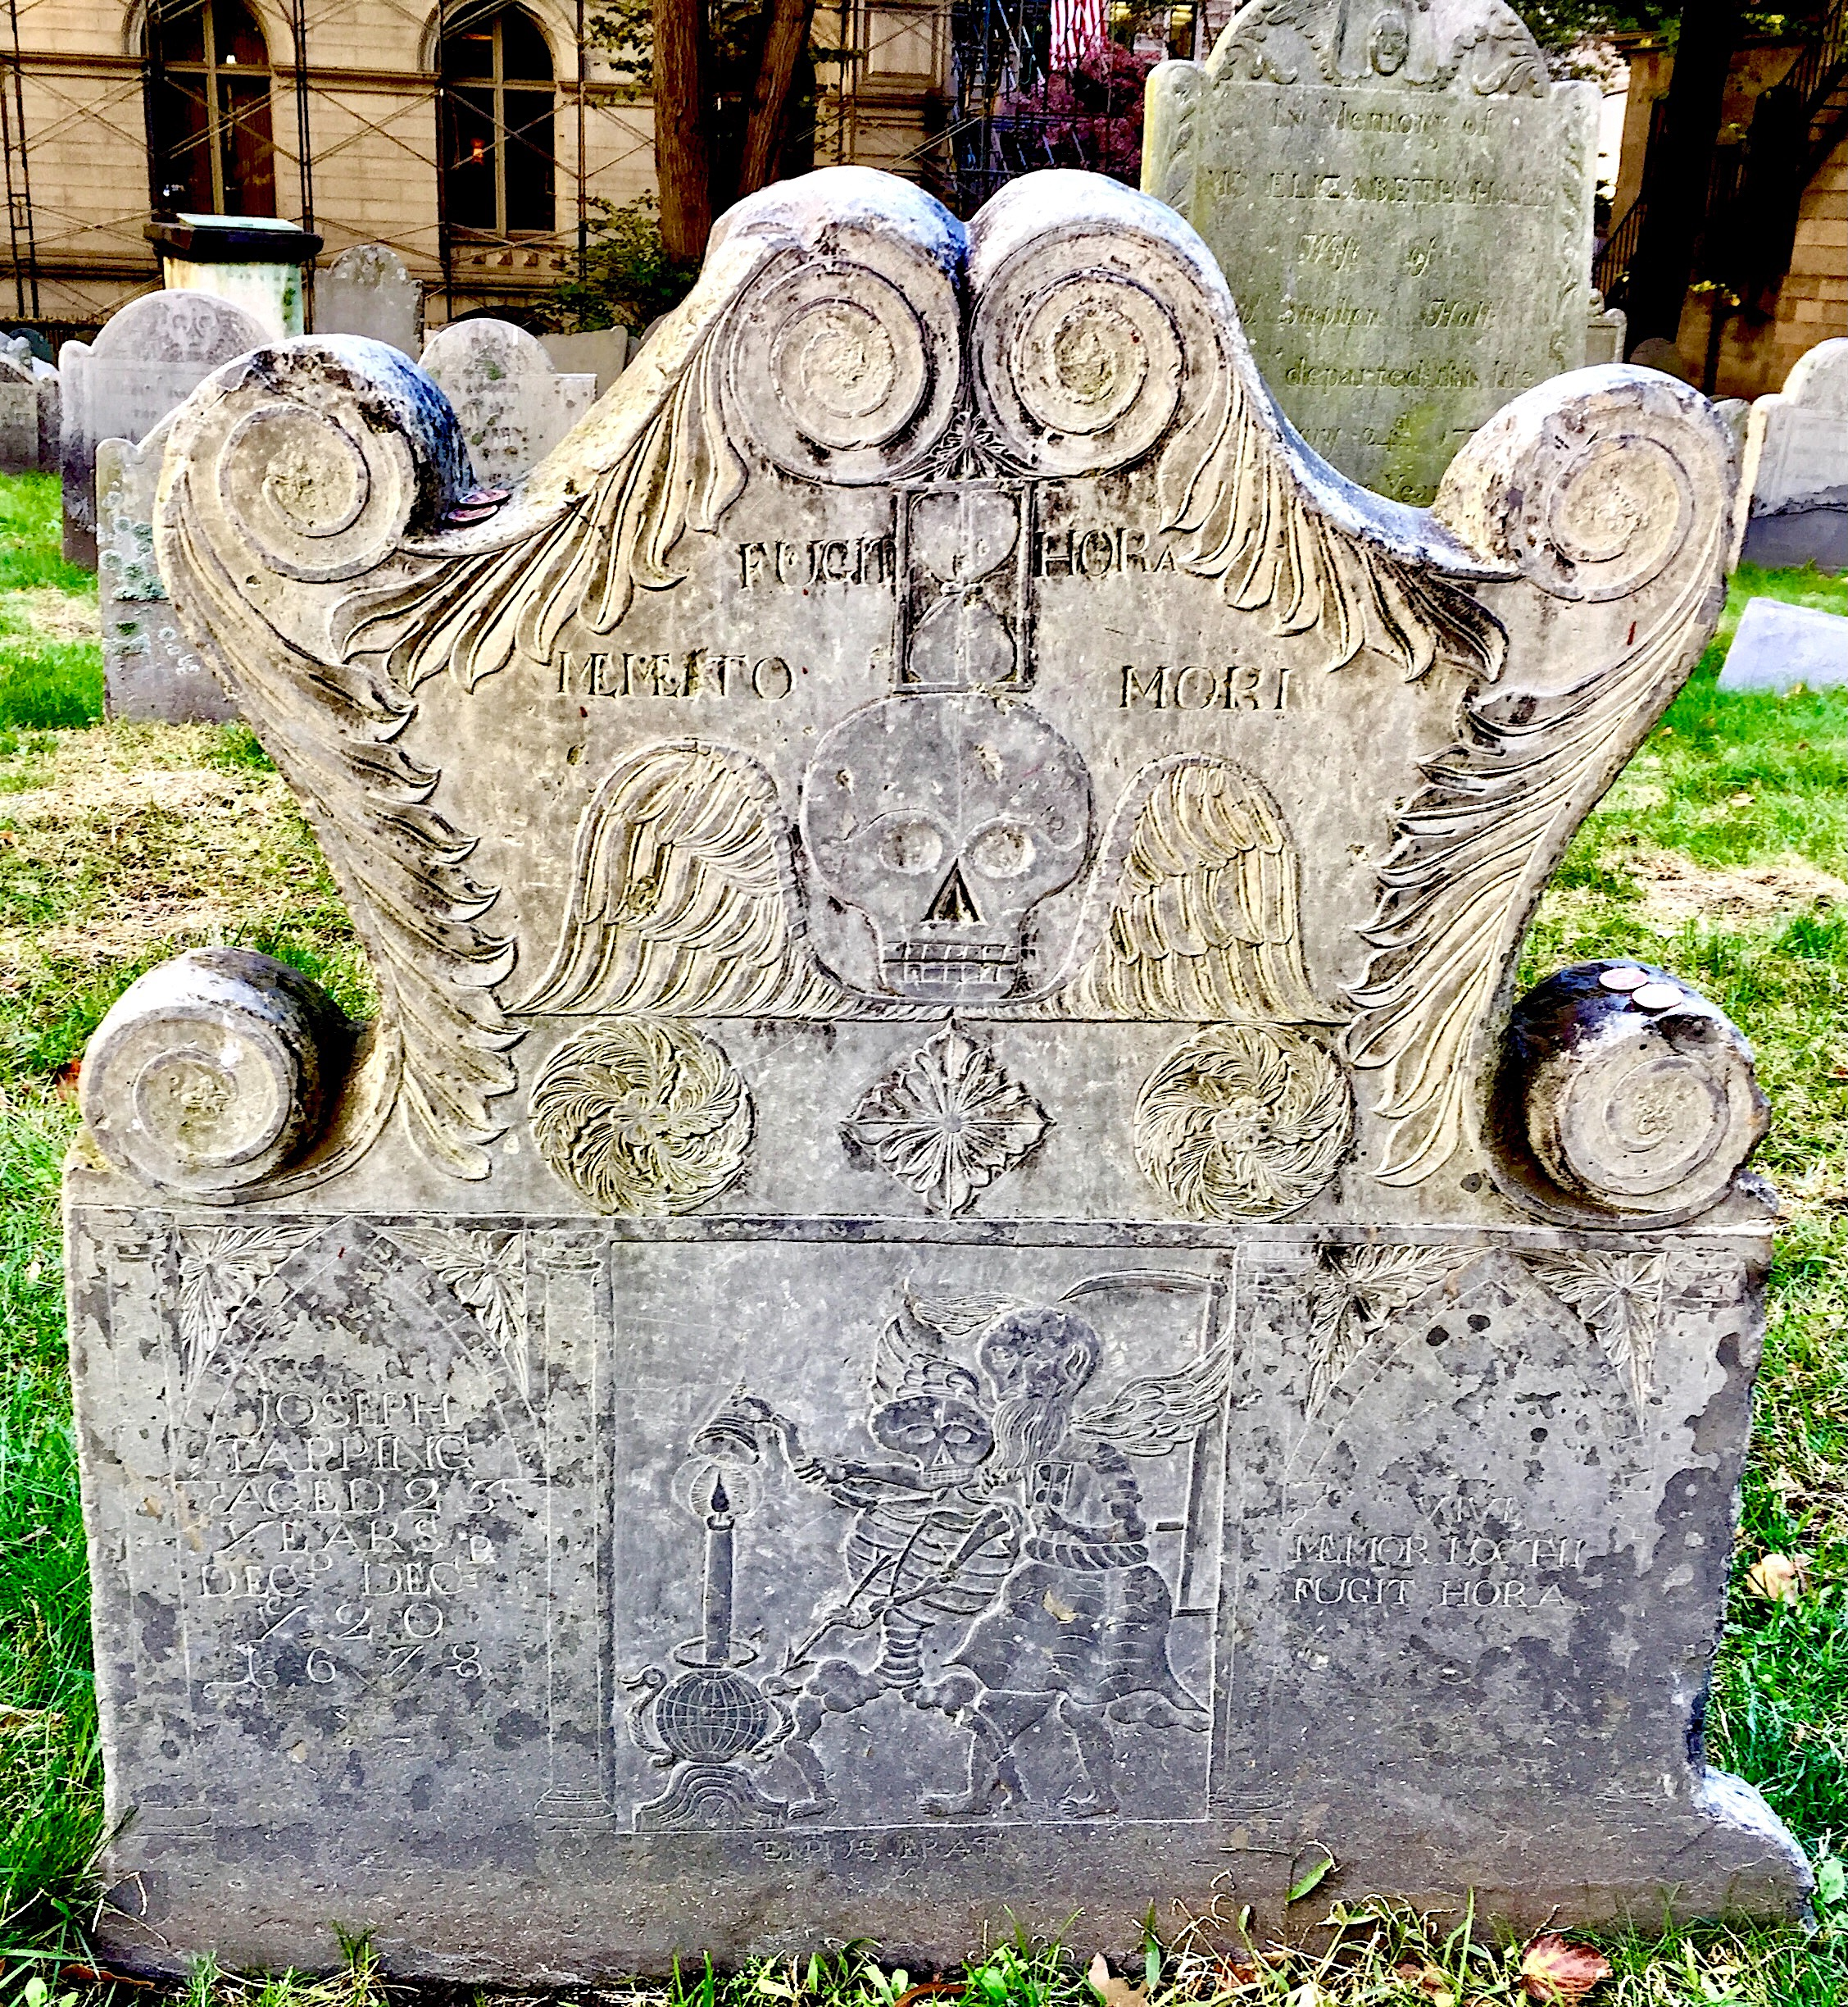
⁶⁵ “Take a guard,” Pilate answered. “Go, make the tomb as secure as you know how.” ⁶⁶ So they went and made the tomb secure by putting a seal on the stone and posting the guard.

Reflection: “Vive Memor Mortis Fugit Hora.”
In late October of 2019, we went to Framingham, Massachusetts to visit my wife Janet's niece. Danice took us to many wonderful and historical places, including the Boston Freedom Trail. During that adventure in the graveyards, we took particular notice of the 17th and early 18th century grave stones, which were carved with human skeletons snuffing out candles, Father Time with wings and an hourglass standing by and aiding them, and a variety of similar Puritan phrases in Latin like, “Vive Memor Mortis Fugit Hora” which basically means, “Live mindful of death, time hurries away.” The Puritans believed their response to saving grace was to live in personal holiness before Almighty God and the world, because they knew they could meet their Savior at any time and they must testify of Christ while they had time, especially during the 1721 Boston smallpox epidemic when over 6,000 souls were infected and some 1,200 died, many children among them. Time, after all, is the one thing that once it is spent can never be retrieved. Once it is gone, it is gone... What do we live mindful of? How do we spend our time?
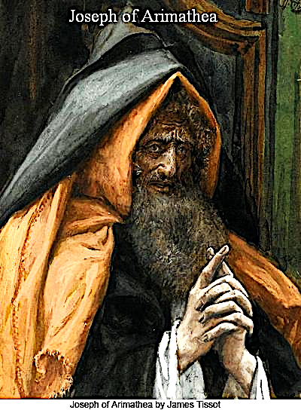
Joseph of Arimathea is a well-known name in Christianity. Mentioned in all four Gospels, he was rich, a member of the Sanhedrin, and a secret disciple of Jesus... It is believed he was Mary's uncle, and so Jesus' great uncle. He was referred to as 'Nobilis Decurio' or Minister of Mines to the Roman Government. Joseph of Arimathea was also mindful of death. Every Jew's dream was to be buried in the Holy Land, especially in or near Jerusalem. When Joseph purchased land there, per his rank and Jewish custom, he cut a burial tomb into the rock on his property, a reminder every day that he, like all of us, leave this corporeal existence to stand before YHWH God. He believed in YHWH and that Ya'shua (Jesus) was the Messiah. When “push came to shove” his secret was revealed when he took a stand above all others, and with Pilate's permission, and in loving faith and deep respect, removed Christ's body from the cross, wrapped His body and placed it in his own tomb, rolling the tombstone in place, knowing full well he would probably lose his place on the Sanhedrin and in the synagogue by proving he was a disciple of Christ, most likely then becoming a byword to other devout Jews. It is believed he may have even spent time in prison for his support of Jesus.
When push comes to shove, where do we stand? (Yes, I am crying right now.)
On the other hand, after the day of Preparation, the chief priests and Pharisees, pridefully protecting their powerful political position under Pilate, blasphemed The Christ before Pilate and YHWH by calling Jesus 'imposter' and claiming His disciples would steal His body and make a phony claim of 'resurrection,' thus perpetrating a 'greater fraud.' They would accuse Christ's disciples of grave robbery, which in fact would desecrate His grave which was unthinkable for a Jew, but apparently not for prideful, pious powerful people protecting political position. So, Christ's tomb was sealed and guarded... Just the way God the Father wanted it. After all, nothing happens outside of God's perfect will... I think of times I have called Jesus imposter through my disrespectful unholy words and actions. I am so very thankful for His mercy, grace and forgiveness.
What do we pridefully protect?
I admit that I spend some time on Facebook, and in this last election season I have had to comment to many friends that I would not preach the false 'gospel' of politics (for no mere man or party can save us), but rather, Jesus Christ, God's Eternal Son, crucified, risen, a Savior to all who will truly believe and live for Him. I believe God has appointed the very day of our death, and there is no one and nothing that can change that, so let us live for Christ boldly! I have been reading God's Word and following the news for over half a century and I have seen this coming. I am convinced that this time is critical, but like all earthly “times” it is not ultimate. We must always be mindful of our eternal future, because it is all we truly have. The sinful world is running toward destruction at breakneck speed, believing what people are doing is right because it is good in their own eyes. We must boldly take a stand for Christ and for Him alone, or be branded “imposter.” We must diligently teach God's Word to our children and grandchildren because I believe they must stand the worst of what is surely to come. They must be fitted with Christ's salvation and be seekers of personal holiness, living lives mindful of preparing to spend eternity with Almighty God in glory. The Apostle Paul wrote, “Look carefully then how you walk, not as unwise but as wise, making the best of your time, because the days are evil. Therefore, do not be foolish, but understand what the will of the Lord is.” (Ephesians 5:15-17) The Puritans knew and lived this. If we truly proclaim Christ we must know it and live it as well, and say like Job, “Though He slay me, I will hope in Him.” (Job 13:15a)
James Tissot, Joseph of Arimathea, ca.1890
So, once again, where do we stand?

Response: Let us sing and, as God gives us strength, live with conviction the words of Edward Mote:
My hope is built on nothing less than Jesus' blood and righteousness;
I dare not trust the sweetest frame* but wholly lean on Jesus' name.
On Christ the solid Rock, I stand; all other ground is sinking sand. All other ground is sinking sand.
His oath, His covenant, His blood support me in the whelming flood;
When all around my soul gives way, He then is all my hope and stay.
On Christ the solid Rock, I stand; all other ground is sinking sand. All other ground is sinking sand.
*[best possible human ever]

Prayer: Father God, Jesus Christ, Holy Spirit. You Alone ARE The One True God, not so the false gods of worldly religion, work, politics, social unity, human achievement, science, human knowledge, choice, etc... Make us truly mindful of our future with You, in this life and for the life to come. Don't let us waste any time, because we know that You have numbered our days on this planet, but the glorious days to come with You are eternal and everlasting. Give us boldness in living for You alone here and now. In the matchless Name of Jesus, and for His Glory, Amen.
- Gerry Dunlap
APRIL 2 (Good Friday)
“Jesus said to her, ‘Mary.’”

Text: John 20:1-18
¹ Early on the first day of the week, while it was still dark, Mary Magdalene went to the tomb and saw that the stone had been removed from the entrance. ² So she came running to Simon Peter and the other disciple, the one Jesus loved, and said, “They have taken the Lord out of the tomb, and we don’t know where they have put him!”
³ So Peter and the other disciple started for the tomb. ⁴ Both were running, but the other disciple outran Peter and reached the tomb first. ⁵ He bent over and looked in at the strips of linen lying there but did not go in. ⁶ Then Simon Peter, who was behind him, arrived and went into the tomb. He saw the strips of linen lying there, ⁷ as well as the burial cloth that had been around Jesus’ head. The cloth was folded up by itself, separate from the linen. ⁸ Finally the other disciple, who had reached the tomb first, also went inside. He saw and believed. ⁹ (They still did not understand from Scripture that Jesus had to rise from the dead.)
¹⁰ Then the disciples went back to their homes, ¹¹ but Mary stood outside the tomb crying. As she wept, she bent over to look into the tomb ¹² and saw two angels in white, seated where Jesus’ body had been, one at the head and the other at the foot.
¹³ They asked her, “Woman, why are you crying?”
“They have taken my Lord away,” she said, “and I don’t know where they have put him.” ¹⁴ At this, she turned around and saw Jesus standing there, but she did not realize that it was Jesus.
¹⁵ “Woman,” he said, “why are you crying? Who is it you are looking for?”
Thinking he was the gardener, she said, “Sir, if you have carried him away, tell me where you have put him, and I will get him.”
¹⁶ Jesus said to her, “Mary.”
She turned toward him and cried out in Aramaic, “Rabboni!” (which means Teacher).
¹⁷ Jesus said, “Do not hold on to me, for I have not yet returned to the Father. Go instead to my brothers and tell them, ‘I am returning to my Father and your Father, to my God and your God.’ ”
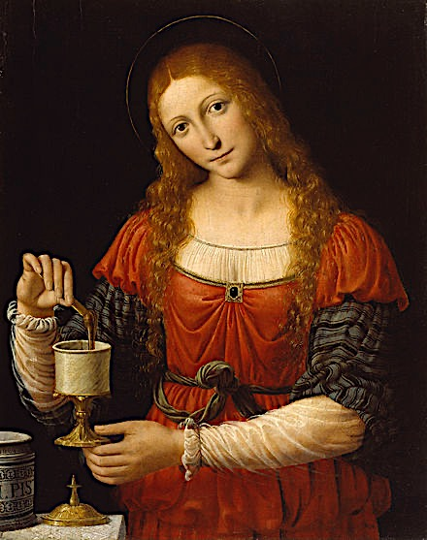
¹⁸ Mary Magdalene went to the disciples with the news: “I have seen the Lord!” And she told them that he had said these things to her.

Reflection: Near the end of our Lenten devotions, we arrive at one of the passages that confirms the resurrection. This scripture is rich in drama. All the characters rush to the tomb, full of concern, confusion, and preconceptions. There is much to be gained by considering John’s and Peter’s reactions and their parts in this drama. But today we will focus on Mary.
Mary’s vision as she arrives at the tomb is limited to earthly realities. She expects Jesus to be in the tomb. He is not, so she presumes someone has taken him and shares her presumption with the angels. Still focused on earthly explanations for the empty tomb, she mistakes Jesus for the gardener who she concludes must have moved the body. Her earnest searching for the Lord is rewarded with Jesus’ first post-resurrection word. A simple, single word. Her name. “Mary.” That is all she needs to hear. Jesus, the Good Shepherd, calls her by name and she knows his voice (see John 10). Suddenly, the resurrection is real.
Andrea Solari, Mary Magdalene (1524)
Mary, or perhaps another Jesus-follower by that name that she knew of, had once before heard Jesus utter a name, “Lazarus,” summoning him from the grave to resume his earthly existence. How natural for Mary to assume the resurrected Jesus would resume communal living among His followers. She embraces Him with great joy and deep respect. Jesus lets her know He will not be staying with the disciples, giving her the first apostolic commission - to tell the others that His resurrection is but a waypoint on the way to His ascension. Within the message He entrusts to her is also an amazing elevation of Jesus’ relationship with the disciples. Far from upbraiding them for deserting Him at his trial and not yet believing in His promise of resurrection, Jesus tells Mary to take his message to His “brothers.” A few nights before at the Passover meal He told them He no longer considered them servants, but friends. On Easter morning, they are now His brothers, and He is headed to be with “their,” not just “His” Father.

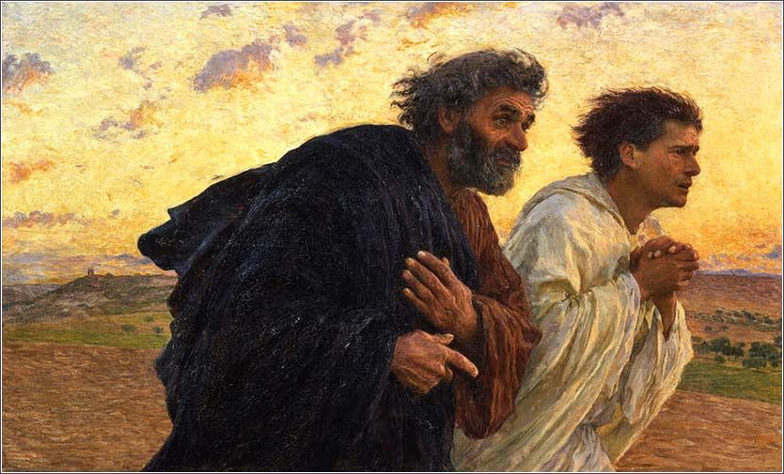
Response: How unlikely that this woman with a sketchy past would be cast in such an important role at this, the pivotal moment in all history. Mary is the first to the tomb; first to share what she finds; the one who stays by the tomb while Peter and John look and leave; the first to see the risen Christ; the first to whom He speaks; the first to be entrusted with the resurrection message; the one to assure the disciples of Christ’s abiding love and care for them. The power of a new life in Christ is encapsulated in all that is entrusted to Mary by our Lord. The way Jesus called Mary from her former life, His welcoming her into his inner circle, and His blessing her with His first post-resurrection appearance and message – these are all evidence of a powerful transformation. No matter what our pasts hold, Jesus tenderly calls us by name, considers us His family and trusts us to continue His work on earth.

Prayer: Praise You Lord for the resurrection! And for the many levels of Your love for us that we find as we study Your Word. In these next few days as we contemplate Your sacrifice on Good Friday and Your triumph on Easter Sunday, prepare our hearts to receive the assurance of salvation and the mission You have for each one of us. Let us clearly hear You calling our name, and by the power of Your Spirit, equip us to go where You lead us, and declare the message You want us to share with those to whom You send us. In the name of our resurrected Lord Jesus, Amen. - Janet Goodman
Eugene Burnand, Peter & John Running to the Tomb, 1898

---------------------------------------------------------------------------------

Jesus lives, and so shall I: Death, they sting is gone forever!
He for me hath deigned to die, Lives the bands of death to sever.
He shall raise me from the dust: Jesus is my hope and trust.

Jesus lives and reigns supreme: And, His kingdom still remaining,
I shall also be with Him, Ever living, ever reigning.
God has promised—be it must: Jesus is my hope and trust.

Jesus lives—and death is now, But my entrance into glory;
Courage, then, my soul, for thou, Hast a crown of life before thee.
Thou will find thy hopes were just: Jesus is my hope and trust.
- Hymn “Jesu, Meine Zuversicht” by Christian F. Gellert

APRIL 3
“Go therefore and make disciples of all nations…”

Text: Matthew 28:16-20
¹⁶ Then the eleven disciples went to Galilee, to the mountain where Jesus had told them to go. ¹⁷ When they saw him, they worshiped him; but some doubted. ¹⁸ Then Jesus came to them and said, “All authority in heaven and on earth has been given to me. ¹⁹ Therefore go and make disciples of all nations, baptizing them in the name of the Father and of the Son and of the Holy Spirit, ²⁰ and teaching them to obey everything I have commanded you. And surely I am with you always, to the very end of the age.”

Reflection: I was ready to write about “righteousness.” I was worried I might write too much. I could relate to the passages about Peter and Judas and their less-than-acceptable examples of righteousness. However, I was asked to switch assignments and write about the Great Commission. Out of all the passages in this book, this is the one least desirable for me because I’m not doing a good job of obeying the Great Commission.
This turn of events reminded me how unconsciously I am focused on self-righteousness. I don’t purposely try to show off my righteousness, but I am built that way and it creeps up without knowing. How can I write about the Great Commission when I know that I am not doing a very good job of sharing the gospel? However, this has also served to remind me that God already knows that I’m not good at it. Actually, I am pretty sure there is more danger when I feel good about things. There is a reason why Jesus is strong when I am weak. When I feel good about something, there is a good chance that my less-than-acceptable self-righteousness comes out, not my Lord and Savior’s real Righteousness.
This opportunity to write about the Great Commission made me see some things I didn’t see before. It’s the same passage I have read before many times; however, I could see that there were still doubters among the disciples and yet Jesus commissioned them to share the gospel. Why did he do that? Perhaps it is because Jesus Himself is going to do the work, not the disciples. They will be the vessels Jesus uses, but the real power to work will come from Him because Jesus has ALL authority on heaven and on earth. Our power and best effort could be a hindrance. No, not could be, they are a hindrance.
Peter was destined to deny Jesus three times because he didn’t know who he was and relied on his own righteousness. Jesus tells his disciples to go and make disciples, baptizing and teaching even though they have doubts because Jesus Himself is doing the work. Hence, the “therefore” and “baptizing them in the name of the Father and of the Son and of the Holy Spirit.” All we need to do is rely on Jesus for His authority and then watch His power at work.
Sometimes I wonder what a disciple is supposed to be, and if I am one. For the sake of this reflection, I just want to focus on what the passage says. A disciple is made by baptizing and teaching to obey Jesus’ commandments. What were Jesus’ commandments? They are summed up by “Love the Lord your God with all your heart and with all your soul and with all your mind and love your neighbor as yourself.” The key is loving. It’s not self-righteous obedience like that of the Pharisees: It’s self-forgetting love offered by broken people like the “sinners and tax collectors” Jesus knew. In my observation, the cult groups make disciples who fervently seek to earn their salvation. They do it like the Pharisees. How about us? It’s time to recover our first love.

Response: Before we think about taking on the Great Commission, we ought to think about ourselves. Are we making our children disciples? Are we making our church members disciples? Am I a disciple? Am I open to share my life with someone to be a disciple and to make disciples?
The good news is that Jesus is with us always. He wants to commune with us and share His life. As we celebrate Easter, may Jesus resurrect our lives in personal ways and revive our relationship with Him so that we may go with love for Him, in His power and in partnership with Him, to make disciples.

Prayer: Abba Father, Creator of the heaven and earth, God of Abraham, Isaac and Jacob, thank You for including me in Your covenant and patiently working within me even when I’m slow in growing. Make me a closer disciple as You reveal deeper sins within me and greater love to cover me so that I may obey Your teachings in the way the sinners of old obeyed. Amen. - Tim Kwon

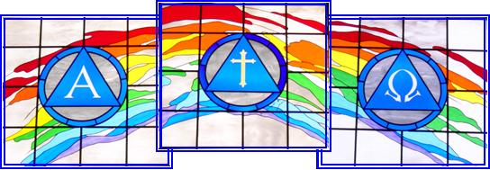

Covenant Presbyterian Church
6695 Mae Anne Avenue
Reno, NV 89523
Phone: 775-746-8118
Fax: 775-746-8195
E-mail: CPC@covenant-reno.org

